Chapter 10.4
Capillary Fluid Exchange

Capillary Fluid Exchange
• Capillaries provide cells with _________________________________
and are associated with fluid exchange between the ______________________________________________________________________________________________________________________
- blood travels the following circuit: arteries ?
- blood moves through capillary very ____________________
- this allows time for exchange of materials between blood and tissue fluid (ECF)
- ________ and __________ move in and out of capillary by process of ______________________
- water moves out of arteriole and carries sugar, amino acids, wastes, hormones, vitamins
- these diffuse into tissue as well

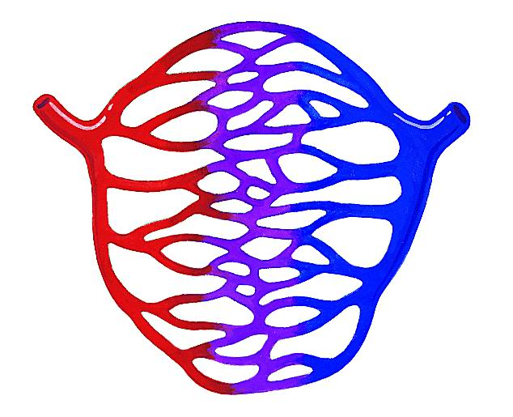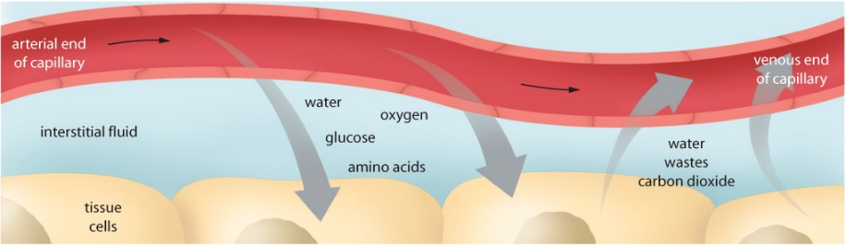

• ______________________________________________________________________________________regulate water between
- the blood and ECF
- 1. osmotic pressure:
- moves water from tissue fluid into blood
- osmotic pressure constant: 25 mm of Hg (millimeters of mercury)
- 2. blood pressure:
- moves water from blood into tissue fluid
- blood pressure is :
  - 35-40 mmHg at the arteriole end of capillary
  - 10-15 mm Hg at the venule end

• Water moves from an area of _____________________________________________________________________________________________________________________
• The outward flow of water and small mineral ions is known as
__________________
• Capillaries are selectively permeable ______________________________________________________________________________________________________________________
• Fluid in and out of the capillaries must _________________________

• Large proteins are ______________________________________________________
___________________________________draws water back into the capillaries
• _______________________________________________________are responsiblefor the movement of fluids into the capillaries
• Movement of fluid into capillaries is called_________________
• Concentration of solutes in the blood can _________________________________________________________________________________________________________________________________________________________________________________

• The figure down below shows the application of the capillary
exchange that models adjustments that help maintain
equilibrium between osmotic pressure and fluid pressure.

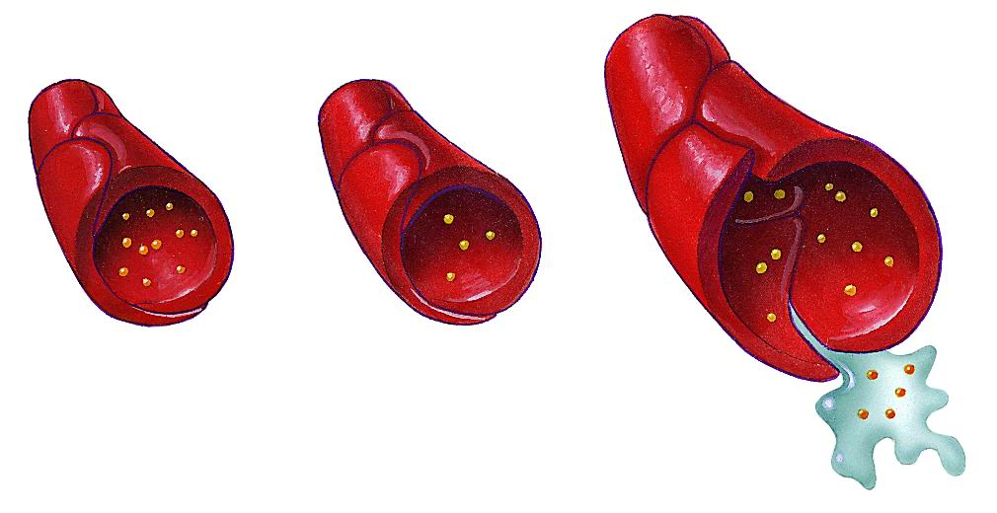

Lymphatic System
• Slow leakage of proteins from capillaries into _________________________________________________________________________________________________________________________________________________________________________________
• Proteins are drained from the ECF and returned to the
______________________________________________________________________________________________________________________

- lymphatic vessels capture:
  - excess fluids leaked from capillaries
  - collect products of fat digestion (glycerol, fatty acids, and fat soluble vitamins) from small intestine
- fluid is called lymph and is and dumped into veins
- flows one way only
- lymph vessels called lacteals are in villi in small intestine

• Lymph- _________________________________________________________________________________________________________________________________________________________________________________ • Operates by slow muscle contractions against the vessels,
which are supplied with flap like valves that prevent the
backflow of fluids.
• Lymph is _____________________________________________________________________________________________________________________________
• Lymph Nodes a mass of _________________________________________________________________________________________________________________________________________________ Found at intervals along lymph vessels.
• Lymphocyte- ______________________________________________
• When our throat is sore your lymph nodes swell in your neck.

Lymphoid Organs
• Red Bone Marrow- _______________________________________.
• Stem Cells (found in marrow)- _______________________________ __________________________________________________________
• In children red bone marrow is found in most bones; where as
In adults it is found primarily in the _______________________________ __________________________________________________________
• Spleen-largest lymphoid organs. Upper left side of the

• Spleen-___________________________________________________ __________________________________________________________
• The spleen releases red blood cells ______________________________________________________________________________________________________________________
• Thymus gland- _____________________________________________ ___________________________________________________________
• T lymphocytes or T cells mature.
• T-cells ___________________________________________________ _________________________________________________________________________
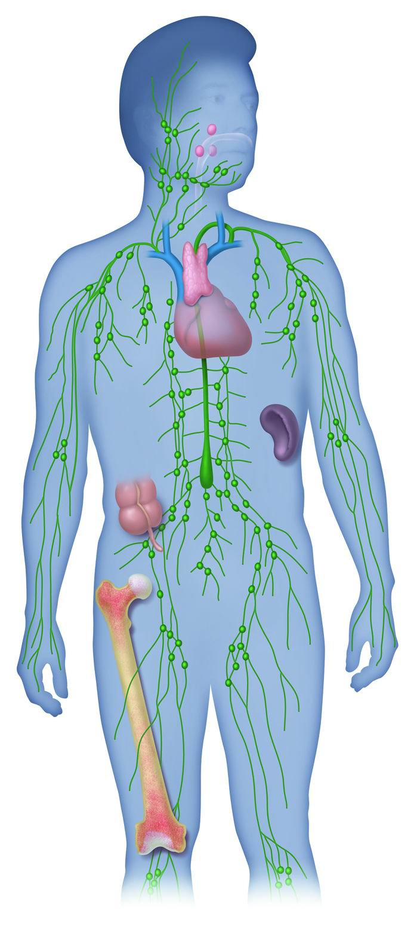

Review Questions
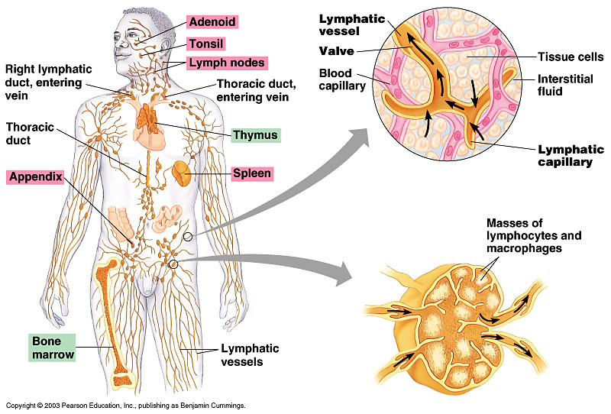
• Pg 339 # 1-7

