Blood and Immunity: 11.1 Power Point Notes
Blood
- Although blood appears to be a thick, homogenous solution, the microscope reveals that it has ____________________________________________________________
- Blood is a specialized type of connective tissue in which ____________________________________________________________________________________________________________________________________________________________
Components of Blood
- Blood is broken into 3 main components
  - ____________________________________________ (it is approximately 90% water, 10% blood proteins (albumins, globulins, fibrinogens), glucose, vitamins, minerals, dissolved gases, and waste products
  - less than 1% __________________________________
  - _____________________________________________________________________
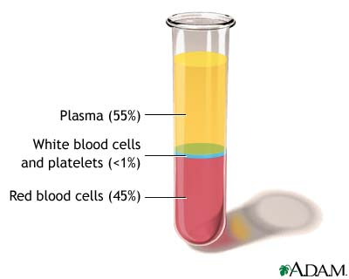
Plasma Proteins
- Your plasma also contains three important proteins
- __________________________________________________________________
- __________________________________________________________________
- __________________________________________________________________

Erythrocytes
- Erythrocytes (red blood cells) are_______________________________________________________________________________________________________.
- Erythrocytes have _______________________________________________________which increases the capacity of blood to carry __________________________
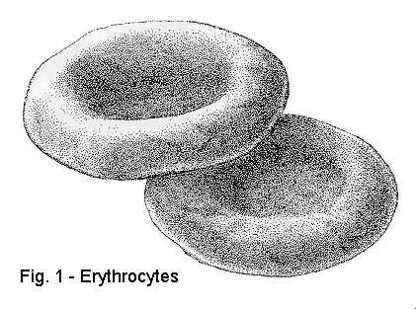
- Erythrocytes are also enucleated (________________________________________________) and as a result do not have to carry out cellular functions
- Erythrocytes are replaced by the _____________________________approximately every 120-130 days
Leucocytes
White Blood Cells
- White Blood Cells (WCB) are ________________________________________________________________of any kind. They are killed to make pus
- New white blood cells are formed in the ______________________________________
WBC’s
- There are five main types of white blood cells
  - _________________________________- general granulocyte
  - __________________________________- make macrophages to engulf invaders
  - ___________________________________- granulocyte which kills parasites
  - ____________________________________- granulocyte which releases histamines
  - ______________________________________- make B and T cells
- ALL HELP IN THE FIGHT AGAINST DISEASE
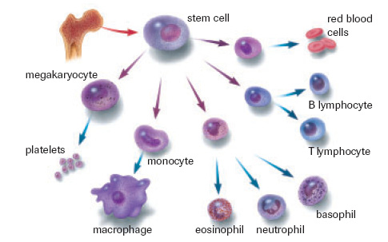

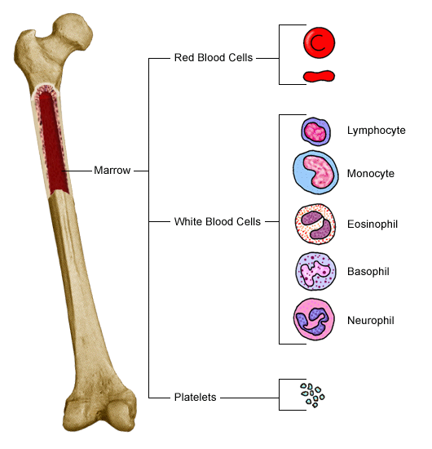

Platelets
- Platelets are cytoplasmic fragments that break off from unusually large cells found in the bone marrow
They play an essential role in _____________________________________________________________
The Functions of Blood
- Blood is the most abundant fluid in our bodies. It does a number of jobs to keep us healthy and strong including_________________________________________________, _______________________________________________and ____________________________________________________________
Distribution
- Delivering ____________________________________________________________________________________________________________________________________________________________
- Transporting ________________________________________________from cells to elimination sites
- Transporting __________________________________________________________
Regulation
- Maintain ___________________________________________________by vasoconstriction and vasodialiation
- Maintain ___________________________________________
  - blood proteins act as buffers
  - reservoir of bicarbonate ions
- Maintain adequate _____________________________________in the circulatory system
  - salts and blood proteins prevent excess fluid loss

PROTECTION
1. Protects our bodies against ______________________________________________________________________________
2. Protection against foreign invaders through the lines of defense of the immune system’s _________________________________________________________________
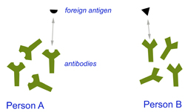

Blood Disorders
- Anemia- ____________________________________________________________________________________________________________________________________________________________
- Causes include
  - insufficient ______________________________
  - ______________________________________________ (no iron hemoglobin RBC)
  - ______________________________________________ (ie: Sickle cell anemia)

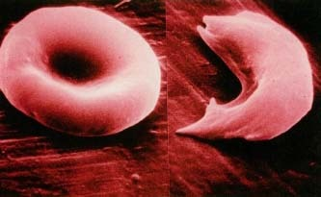

Leukemia
- Refers to a group of _______________________________________________________________which remain unspecialized and mitotic, and suppress or impair normal bone marrow functioning
- WBC have __________________________________________________________________________
- They ___________________________________________________needed by healthy cells

Hemophilia
- Do not have ________________________________________________________
- Increased occurrence ______________________________________
- Simple injuries_______________________________________________, need to be treated with transfusion or clotting agents
- Many contract AIDS when there were improper screening practices in place
Blood and Immunity
- Clotting
- Blood Types
- Rh Factor
Blood Clotting
- Blood clotting maintains homeostasis by preventing the________________________________________________________________________________________________________________________. They also provide additional support to weakened blood vessels that have been injured so they do not rupture.
Blood Clotting
- When you are injured often the vessel is torn and jagged. _______________________________________________________________________________________________________________________________________.
- When platelets rupture they release _____________________________________________________
- Thromboplastin will, along with plasma factors like calcium, activate _________________________________________________________________________________________________________________
- Prothrombin will then be transformed into ____________________________________
- Thrombin then will act as an enzyme and will _________________________________________________________________________________________________________________________________________________________
- Fibrin is very______________________________________________________________, sticking to it and to each other sealing the skin with a clot.
- This clot blocks microbes but allows WBC’s to gain access
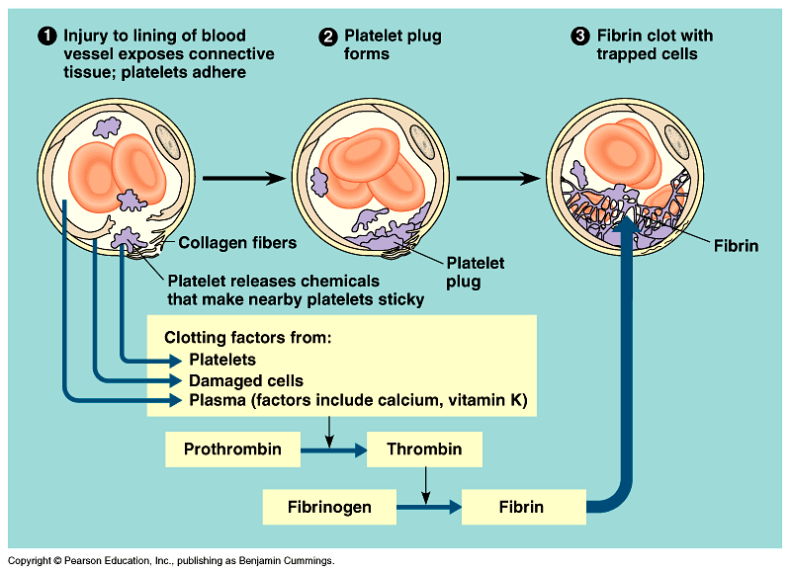

Problem
- Why does getting cut with a sharp knife hurt less but always bleed more than getting cut with a dull knife?
Solution:
Because when you cut yourself with a sharp knife, there are clean edges to the cut and the platelets have nothing to snag on. Bleeding occurs for longer but hurts less because there is no rough tearing of vessels
Problems with Clotting
- Sometimes clots can seal blood vessels. This blockage, called a_____________________________________________, will prevent local tissues from getting oxygen and nutrients
- If a clot should__________________________________________________________________. This may become lodged in vital organs
  - blockages in the brain _____________________________________________________
  - blockages in the heart _____________________________________________________
Blood Groups
Create a list of the pro’s and con’s of using Artificial Blood (pg. 353 text)
Pro’s Con’s

- Jean Baptiste Denis was the first to perform a blood transfusion. He injected lamb blood into a young boy successfully. A repeat experiment on an older man proved disastrous though, the man died almost immediately.
- He lacked the crucial information that there are different blood groups
Blood Typing
- _____________________________________________discovered the secret to transfusions. There are special markers ________________________________________________________found on the membrane of the red blood cells
- The blood contains _____________________________________________________________________________
- If two incompatible blood types are mixed during a transfusion, the antibodies cause the cells with the ‘wrong’ surface markers ______________________________________________________________________________

ABO Blood Typing
- Type A blood has ___________________________________________________
- Type B blood has ___________________________________________________
- Type AB blood has _____________________________________________(universal recipient)
- Type O blood has _____________________________________________but _______________________________________________________________(universal donor)
ABO Blood Groups
 | Antigen | Antibody | Donate to | Receive from
A
B
AB
O

Blood Type Frequencies
 | Af Am | Cau | As | Am In | Chin
A | 27 | 41 | 28 | 8 | 25
B | 20 | 9 | 27 | 1 | 35
AB | 4 | 3 | 5 | 0 | 10
O | 49 | 47 | 40 | 92 | 30

Rh Factor
- The __________________________________is another marker (antigen) that is found on your blood.
- If you are _________________________________________________________and you DO NOT MAKE antibodies against yourself
- If you are ___________________________________________________________________________________________________________________________________________
Rh Pregnancy Problems
- A mother with ______________________________is at risk in her second pregnancy if her first child is Rh+
- The first child produces cells with the ____________________________________________________________________________
- The mother’s immune system produces ____________________________________________
- 1st baby is OK because they are born by this time
- If the second fetus is Rh+, the mother’s antibodies will ___________________________________________________________________________
- These___________________________________________________________, whereas the antibodies for blood types cannot
- Mothers are given a ______________________________________________________________after a Rh+ birth to help out
- If the mother is not given this shot, _______________________________________________can occur.
- This is the death of the fetus
  - blood is being occupied in ________________________
  - ___________________________________________in baby’s body
  - baby will _____________________________________________
  - _________________________________________________________________

