**4.5 Changes in Ecosystems  
 pgs. 113 – 121**

**Deforestation**

* Slash and Burn – ______________________________________________________________
* Clear cutting – the removal of _____________________________________________________________
* Selective cutting – the ____________________________________________from an area

**Negative Effects**

* ________________________________________________________________
* _________________________________________________are carried into streams and ponds, increasing ________________________________________________
* Loss of _________________________________________
* Replanting can take ______________________________________________________________

More details can be found on pg 114

**Fire**

* Fire is an important and ______________________________________________________in an ecosystem

**Effects of Fire**

* Creates and maintains a variety of __________________________________________________
* Essential in the germination of certain seeds
* Allows for ____________________________________in an old growth forest

**Questions pg. 115**

Do Practice Questions #1-3

**Changes in Lake Ecosystems**

* Oligotrophic Lakes – ____________________________________________________________
* Eutrophic Lakes – generally shallow, warmer and high in nutrient levels
* Eutrophication – _______________________________________________________________

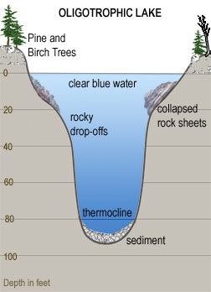 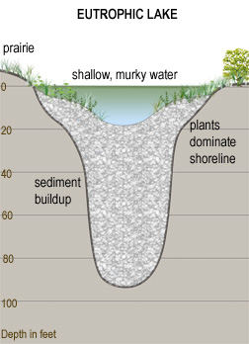

**Water Pollution**

* ______________________________________________
* _______________________________________
* ___________________________________________________________
* _____________________________________________ (heated water)
* Water pollution is _____________________________________________________________in surface water or ground water that can ______________________________________________
* See pg 116 for details

**Indicators of Water Quality**

* Detection of ____________________________________________________(naturally occurring bacteria found in the intestines of humans and animals) would also indicate the _____________________________________________________________________________________________________________________________________

**Biological Oxygen Demand (BOD)**

* BOD – a measure of the ________________________________________________________needed by _________________________________________(bacteria) to ______________________________________________________in a sample of water at 20 C over 5 days
* As the _________________________________________________________________

High numbers of organisms = High BOD

High numbers of organisms = Less dissolved oxygen

**Question pg. 118**

* Do Practice Question #5 and 6

C:\Documents and Settings\mcaine\Local Settings\Temporary Internet Files\Content.IE5\MRG18BIB\MCj04300610000[1].wmf

**Changes in Alberta Lakes**

* Watershed – ____________________________________________________________________________________________________________________________________________________________

**Effects of Cottage Dwellers on Alberta Lakes**

* Making sandy beaches ________________________________________
* Planting lawns ___________________________________________________________runoff from fertilizers
* ______________________________________________________takes away a filtering system for harmful chemicals moving from the land to the lake, decreases shade and thus affects water temperatures near the shore
* __________________________________________________________________cause increased bacteria activity (less oxygen)
* Human sewage seeping from outhouses cause ______________________________________________________________________________

**Questions**

* **Do Practice Questions pg. 120 #7 and 8**

C:\Documents and Settings\mcaine\Local Settings\Temporary Internet Files\Content.IE5\UFKNE7CJ\MCj02389950000[1].wmf