Biology 20 Name: ________________________________
Chapter 8: Nutrients, Enzymes and the Digestive System
8.1 : Essential Nutrients (page 242-253)

Essential Nutrients
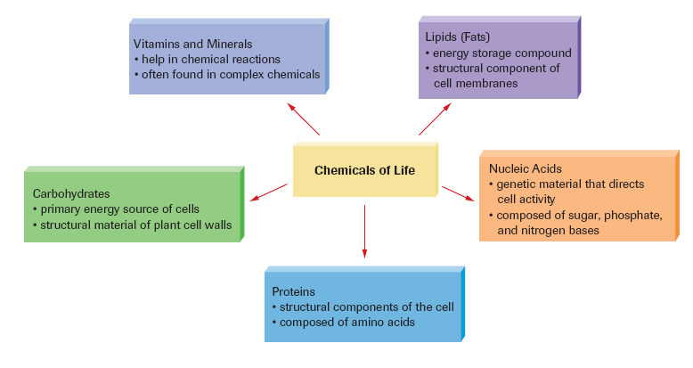

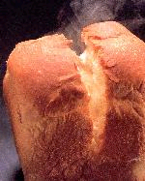
Carbohydrates
- The human body is not able to make _________________________________________
- We rely on plants to produce carbohydrates through ________________________________
- Carbohydrates are in foods such as potatoes, pasta, rice, bread, corn, and fruit etc.
- Carbohydrates provide our bodies with a with a fast source of ____________but excess amounts of carbohydrates turn into _________________________

Carbohydrate Chemistry
- Carbohydrates are made up of simple sugar units containing____________, ______________ and ____________ in the ratio of 1:2:1
- eg. triose C₃H₆O₃, glucose (in human blood) fructose C₆H₁₂O₆ (plant sugar in fruits)
- Carbohydrates are classified according to the number of __________________units they contain

Types of Carbohydrates
A. Monosaccharide: _____________simple sugar unit (monomer), with a 1:2:1 ratio
example – glucose, fructose, ribulose, and glactose
- Glucose (C₆H₁₂O₆)
- ______________________________________________________________________
- our primary energy source
- excess is _____________________________________________ and muscles as glycogen (a polymer of glucose)
- amount in blood is influenced by __________________________ which is a hormone produced by the pancreas

- 2. Fructose
- _________________________________________________________________________________________
- very sweet, added to cereals for flavour
- an ___________________ of glucose
3. Ribulose
- part of ______________ molecule and forms part of our ______________

4. Galactose
- The sugar found in ________________
- an ___________________ of glucose
B. Disaccharides
- Disaccharide: are made up of ______________ sugar units
- ______________________ are bound together by a process called _______________________________________: in which a water molecule is removed from two monosaccharide molecules. (glucose + glucose = maltose + water)
- The opposite reaction (splitting disaccharides) releases water and is called ________________________________
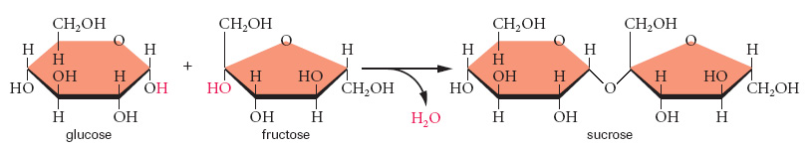

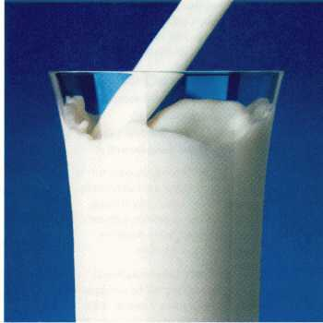
1.Maltose (brown sugar):
- composed of ______________ glucose molecules
- glucose + glucose → maltose + H₂O

2. Sucrose (table sugar):
- composed of a ______________ and a__________________
- glucose + fructose → sucrose + H₂O

3. Lactose (milk):
- composed of a ______________and a _________________
- glucose + galactose → lactose + H₂O

C) Polysaccharide
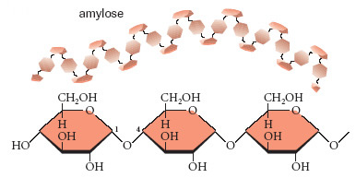
- Polysaccharide: a carbohydrate consisting _____________________________________ (100’s to 1000’s) bonded together.

1.Starch: a ________________________, the main storage unit of glucose in plants (potatoes, grains)
- Two types of starch:
- amylose: contains up to 1000 or more glucose molecules
- amylopectin: 1000-6000 glucose molecules, branched like a tree with 24-36 glucose units long branches
2. Glycogen: an ___________________________ similar to starch
- Tasteless
- _________________________________________________________________________________
- Easily converted back into glucose if needed

3. Cellulose: 50% off all organic matter is cellulose
- __________________________________________________________________________________________
- More tightly bound than starch
- __________________________________________ without the assistance of micro-organisms that can convert cellulose into glucose.

Lipids
Characteristics:
- __________________________ compounds that are insoluble in polar solvents like water (they float!)
- lipids are made up of two structural units
- _______________and __________________________
glycerol - is an _______________
fatty acid - molecules are long _______________ chains
- Lipids are formed through dehydrolysis synthesis.

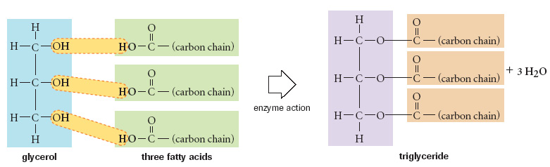

Use of Lipids
- Lipids are used to _____________________________ (excess sugars are converted to fats, very compact) Lipids provide twice as many calories as carbohydrates.
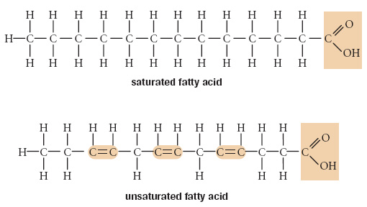
- ________________________ (love handles protect kidneys, second chin protects carotid artery)
- Important part of _____________________
- Carry __________________ A, D, E, and K.
- ____________________ (blubber, subcutaneous fat). Eskimos eat the blubber of whales which also contains vitamin C. You will never see an Eskimo with scurvy.

Types of Lipid Molecules
1) Triglycerides – glycerol and three fatty acids
- two main types of triglycerides
– __________________________________________________________________

a) Saturated: a molecule that ______________ take in more hydrogen or other atoms.
- most of the fatty acids in ________________________________ are saturated.
- very ___________________________bonding structure (single covalent bonds: C-C-C-C-…)
- No _________________bonds.
- this stability makes saturated fats ____________________________ to break down
- ________________________________ at 20ºC; this leads to clogging of arteries

b) Unsaturated: a molecule that can take in some ____________hydrogen atoms.
- described as either monounsaturated or polyunsaturated
- most ____________ oils are unsaturated
- characterized as having a ____________________________ bond within the carbon chain
- are generally _______________________, therefore can be _____________________broken down
- most are _____________________at room temperature
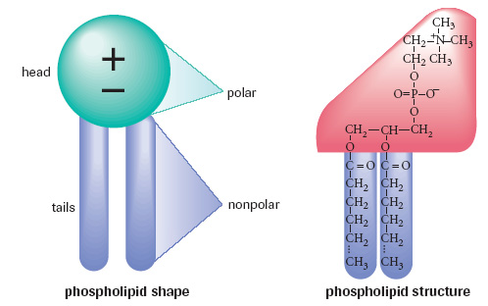
2) Phospholipids – have a ________________ group bound to a glycerol backbone
-the main component in cell membranes

3) Waxes – long chain fatty acids are joined to long chain alcohols or to carbon rings
- wax is ______________________ and ____________________, making it well suited as a water proof coating

Practice questions : page 247- Questions 7 - 10
Proteins
- Proteins are ____________________________________ they are used to make cell structures and to repair any damages.
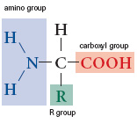
- Made up of 100’s to 1000’s of _______________________. Amino acids are composed of nitrogen, carbon, hydrogen, and oxygen atoms. The order, sequence, and number of amino acids determine the type of protein.

Amino Acids
- There are ____________different kinds of amino acids. The body can only make some of these. The others must be supplied by the diet; these are called the essential amino acids.

Use of Proteins
- Essential for the ______________, ________________, and __________________ of body tissues.
- Are needed to make enzymes, ________________________________, and hormones.
- Maintain the ______________________________ in the body
- Can supply body with energy if no other resources are present.
- Just like carbohydrates and lipids, proteins are also formed through _______________________________________.
- The bonds that are formed are called ______________________________: covalent bonds between the acid group of one amino acid and the amino group of the joining amino acid.
- Proteins are also called ___________________________ because of the peptide bonds.

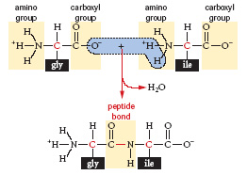

Structure of Proteins
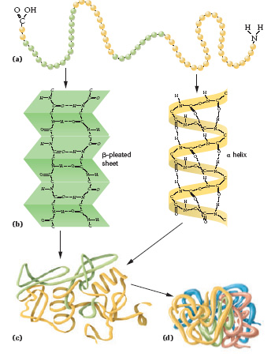
- A proteins shape or structure determines its function
- There are four levels of protein structures;
a) __________________________
b) ___________________________
c) _______________________
d) _____________________________

- Primary – ________________sequence of amino acids
- Secondary – depends on the primary structure, hydrogen bonds cause the protein to bend in a pleated shape or a helix
- Tertiary – more folding and twisting due to _________________ interactions
- Quaternary – large globular proteins (hemoglobin)

Denaturation – a _________________ change in the structure of the proteins as a result of ______________, _________________ or _____________________________.
Coagulation – __________________ change in the structure of the protein as a result of heat, radiation or changes in pH.

