Biology 20 Name: _________________________
8.2 Enzymes
Enzymes
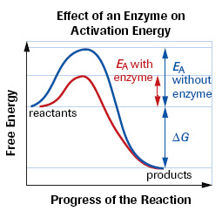
- Chemical reactions are continually occurring in our bodies to keep us alive.
- These chemical reactions must occur at _________________________
__________________________________________________________
- _____________________ – are chemicals that increase the rate of reactions without increasing the temperature or changing the substance being made
- _____________________________ that act as catalysts are called enzymes.

- Enzymes also ___________________________________ at a lower energy level.
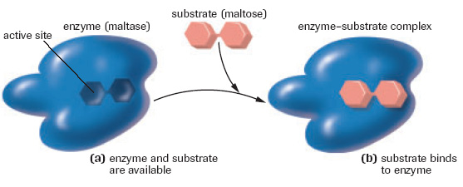
- Enzymes are _________________________________________.
- Enzymes can be identified by an “ase” ending (protease, lipase)

- The structure the enzyme binds to is called the _________________.
- The area on the enzyme where the substrate binds is called the ___________________________
- There is a different active site for every enzyme – substrate combination
- ______________________________________________________________________________________________________________________________________________________________________________________________

Enzyme Helpers
- Cofactors and coenzymes are ________________________________________.
- They help the enzyme bind to the substrate
- Cofactors are ___________________________ – iron, zinc, potassium
- _____________________ are organic – made from vitamins

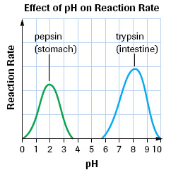
Factors Affecting Enzyme Reaction
pH
- different enzymes function the best at different pH levels, there is a range for each enzyme
- if the solution is too acidic (high H+ levels), or too basic (high OH - ) the ____________________ that determine the enzymes structure will change.
- ___________________________________________________________
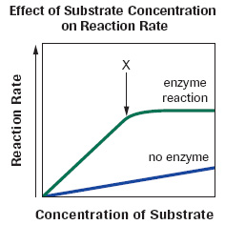
Substrate Molecule Concentration
- The greater the number of substrates the __________________________
___________________________ (more substrates will bind with enzymes)
- This increase will ______________________________________________
____________________________________________________________

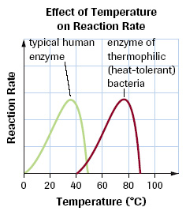
Temperature
- As the temperature ________________________________________________
_______________________________________ and more products are made
- In humans the temperature cannot exceed ______◦
- why do you think this is the case?
- _______________________________________________________________
________________________________________________________________

Competitive Inhibitors
- Competitive inhibitors ________________________________________
- The ____________________________________________, preventing the enzyme from binding to the substrate
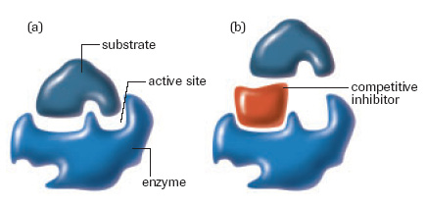

Regulation of Enzyme Activity
- The production of chemicals in our bodies (e.g. hormones) follows a metabolic pathway with enzymes helping along the way
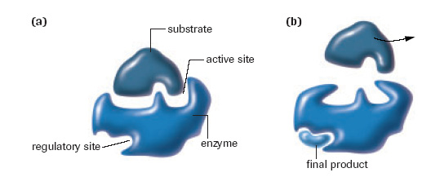
- The production of chemicals in our body is regulated by our bodies need for that chemical

- Feedback Inhibition – the inhibition (stopping) of an _____________________________________ by the final product of the pathway.
- The _______________________________ of the enzyme preventing it from binding to any more substrates

- Precursor activity – the activation of the last enzyme in a metabolic pathway by the initial substrate
- This occurs to help ____________________________________________________________________________
- The binding of the initial substrate to the enzyme ___________________________________________________
Note: both feedback inhibition and precursor activity involve molecules binding to the regulatory sight of the enzyme
- Both feedback inhibition and precursor activity are called ____________________________________________.
- Allosteric activity – ____________________________________________________________________________

