Gas Exchange and Transport
9.2 pages: 288-291

- Dalton’s Law of Partial Pressure
Each gas in a mixture exerts ____________________________________________________________________________________________________________________________
- Gases diffuse from an area of ______________________________________________________________________
- The highest partial pressure of oxygen is found in_________________________________________________.
- Oxygen diffuses from the air ___________________________into the lungs ____________________________________________________________
Gas moves from high pressure to low pressure
High pressure of O₂ in __________________________________________________________________________
High pressure of CO₂ __________________________________________________________

Oxygen moves from ______________________________________________________________

Oxygen Transport
- Oxygen from the atmosphere alveoli blood
- Hemoglobin – ______________________________________________________________
- When oxygen dissolves into the plasma, ____________________________________________________________molecule to form _________________________________________________

- This can allow the blood to carry _____________________________________________

- Blood diffusing __________________________________________________drops pressure to about 5.3 kPa from about 13.3 kPa in the lungs
- This drop in partial pressure causes the ____________________________________________________________________________________________________________________________________________________________

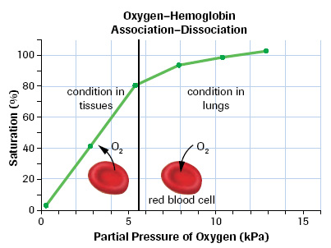

Carbon Dioxide Transport
- ___________of CO₂ is carried in red blood cells
- ___________of CO₂ is converted by _______________________________to ______________________________H₂CO₃
- ___________is in the plasma
- converting CO₂ into carbonic acid (H₂CO₃) decreases the concentration of CO₂ in the blood so that CO₂ will continue to move into the blood . . BUT . . it __________________________________________________________________

Hemoglobin as a Buffer
- Carbonic acid H₂CO₃ __________________________________________________

- Hemoglobin picks up the H⁺ ions, working to _________________________________________

- When the hemoglobin reaches the lungs _________________________________________

- The H⁺ is converted back into an________________________________________________, this increase in CO₂ concentration is __________________________________________________

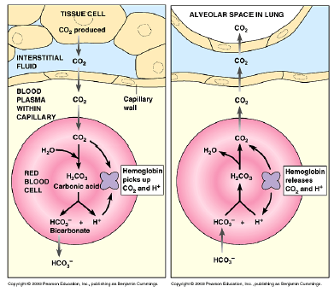

Practice Questions pg. 288 # 1 and 2

Practice Questions pg. 291 # 1-3 and 5

