**Absolute Value and Reciprocal Functions Review**

1. Mary has two bank accounts, one for her savings and one for her student loan. The amount of money in her savings account, *a*, can be found by taking two times the square of her student loan, *s*. Come up with an equation for this scenario where *s* is isolated on one side.
2. Sketch the graph of each function. State the intercepts, and the domain and range.

**a)** *f* (*x*)  | 2*x*  1 | **b)** *f* (*x*)  | *x* 2  3|

1. Solve each equation and verify your solutions.
2.  b) 
3. For each function
4. State the zeros
5. Write the reciprocal function
6. State the equation(s) of the vertical asymptote(s)
7. *f(x)*= *x*2 - 8*x* +16 b) *f(x)*= *x*2 - 16
8. Sketch the graph of the reciprocal function, 

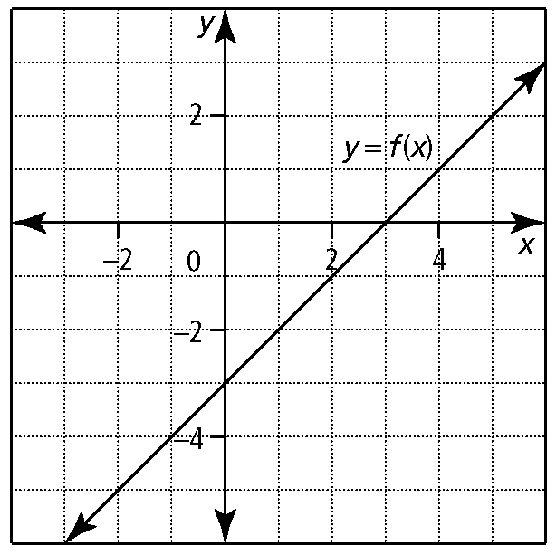

1. Sketch the graph of *y*  *f* (*x*).

