Answers for Final Review

Sequence and Series

1. t1= -4, d+ -3, t10=-31
2. 5
3. 72
4. 370
5. 26
6. $577 500
7. $750 251.06
8. 6.25
9. 158.35
10. a) 156 cm b) 170.9 cm c) 300 cm

Trigonometry

1. a) 4 b) 80
2. a) 17 b) -0.47
3. a)  b)  c) 
4. 315
5. 
6. 6.3 m
7. 5.9 m
8. 4.3 cm

Quadratics

1. a)6 (x-5)(x+5)

b) (0.9x +0.5y)(0.9x – 0.5y)

c) ½ (x-6)(x+2)

d)(2x-1)(x+6)

e) (5x-6y+28)(5x +6y -8)

2. x- int = (-2,0) and (-4, 0) y-int= (0, -16)

3. vertex(-1, -4), axis of symmetry x=-1, x-int (1,0) and (-3,0), opens up, minimum= -4, domain xϵR, range y≥-4, y= x2 + 2x -3

4. x = -2

5. a)  b) no solution

6. 9 and 12

7. 28 and 84

8. 

9. 

Radicals and Rational Expressions and Equations

1. a) 2 b) 
2. 
3. a)  b)  c) 
4. a) y=4 b) x=3
5. -5 is extraneous
6. 30
7. a) b) 
8. a)  b) 
9. 
10. a)  b) 
11. 
12. -5

Absolute Value and Reciprocal Functions

1. 
2. a) y-int = 1, x-int= - ½ , domain xϵR, range y≥0

b) y-int = 3, x-int= ±3, domain xϵR, range y≥0

3. a) x =2 (extraneous) and x=0 b) x= 1 or -9

4. a) i) x=4, ii) iii) x=4 b) i)x=±4 ii) iii) x=±4

5. 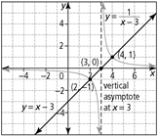 6. 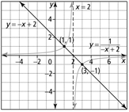

Systems of Equations and Inequalities

1. a) (3, 7) and (4, 9) b) (-4, 10) and (2, 4)
2. a) (, 7) and (-1, 7) b (5, 0) and (-2, 7)
3. a) 7x +y=47 b) 5x2 –x-10y=0 c) x=5 and y=12
4. a)  b) 
5. a) x=-2 or -3 b) -3<x<-2 c) x<-3 or x>-2
6. 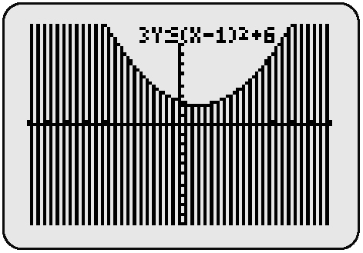a) x<-5 or x>1 b) x<2 or x> 
7. a)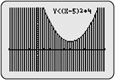b)