Pancreas
- The pancreas is between the kidneys and the duodenum and provides digestive juices and endocrine functions.
- Pancreatic Islets of Langerhans secrete:
- - insulin, from the beta cells, which lowers the blood glucose level
- - insulin makes cells more permeable to glucose
- - glucagon, from the alpha cells, which increases the blood glucose level
- - glucagon causes the conversion of glycogen to glucose
Regulation of blood glucose level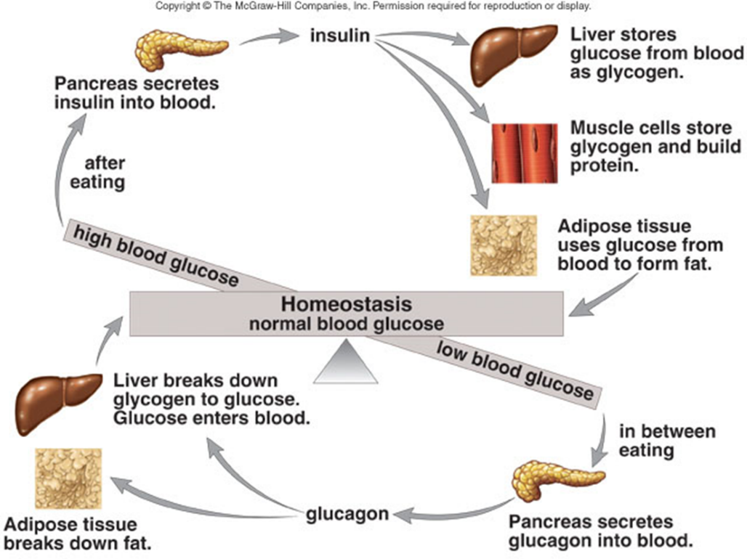

Diabetes Mellitus:
- Lack of insulin due to the failure of the pancreas to produce insulin or the inability of the body cells to take it up.
- Hyperglycemia symptoms develop, and glucose appears in the urine.
- Produce urine with sugar (kidneys are unable to reabsorb all the sugar)
- High glucose concentration draws water from nephron by osmosis
    - Large volumes of urine, often thirsty
- Juvenile onset: (by about age 6) ~10% of diabetes cases
      - Often called type I (insulin dependent) caused by lack of insulin production in pancreas
      - Genetic: hereditary but may skip generations
      - Treatment: insulin injections/pump
- Maturity onset: diagnosed in adulthood ~90% of diabetes cases
      - Often called Type II where the pancreas produces insulin but the body cells do not respond.
      - Beta cells slow down production of insulin
      - Or, ineffective use of insulin by the body
      - More common
      - Treatment: Diet & Exercise primarily
3) Gestational: Pregnant woman (2-4% of pregnancies)
      - Controlled by diet mostly
      - Increases the risk of both mother and child ending up with type II diabetes later in life
- must monitor both hypoglycemia (need glucagon or glucose) and hyperglycemia (need insulin)

Diabetes Incipidus – lack of ADH
- Nothing to do with the pancreas!
- Relationship is blood glucose levels because….
  - Lack of ADH causes you to lose lots of water
    - Therefore, your blood glucose concentration is higher
  - Constant thirst
  - Blood becomes hypertonic
  - Treatment: Take an antidiuretic drug
- To Do : Lab 15.A pg. 483 # 1- 8 (textbook)

