Synaptic Transmission:
- Neurons are _________________________________ to each other.
- The ________________________________________________ cannot jump the synaptic cleft (or synapse).
- Synaptic transmission is entirely _________________ in nature.

- At the end of axons, tiny ____________________ contain ______________________
- When an impulse reaches the end of an axon, these synaptic vesicles migrate ________________________________________________________________
- They then release their neurotransmitter and it ______________ across the synaptic cleft
- Neurotransmitters attach to _________________________________ and causes _____________________ to open resulting in a depolarization in the membrane.
- An _______________________ is created and the impulse travels down the neuron.
- Diffusion takes time, so the _______ synapses involved, the ________ the response.

- Synaptic transmission can only occur __________________________________.
- Since only _____________________ neurons contain synaptic vesicles, and only ________________________neurons have receptor sites for them, the messages cant be sent in the other direction
- This explains why impulses can only travel from ______________________ to _____________________ to ___________________ and never in the other direction
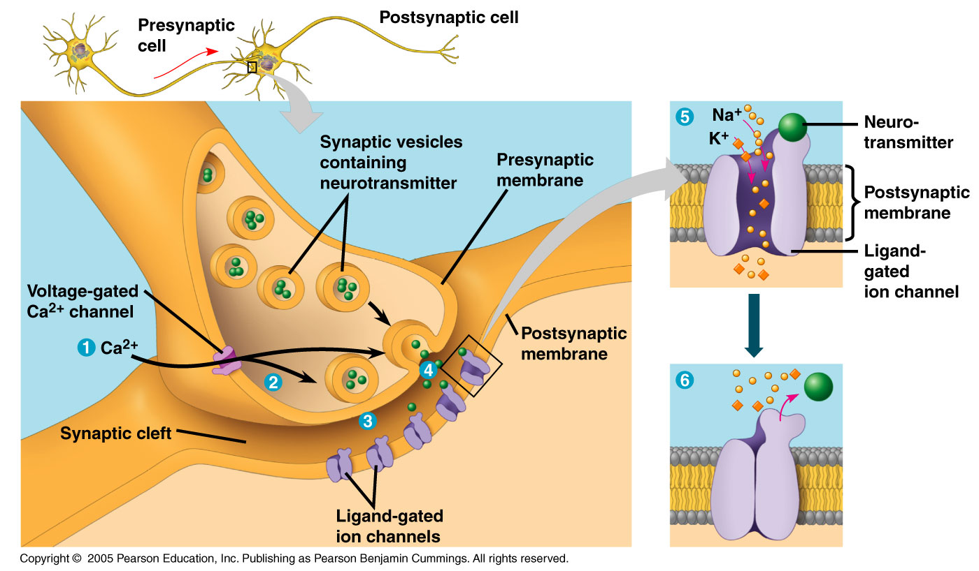

Neurotransmitters:

Acetylcholine: (________________________________________________)
  - neurotransmitter produced in the __________________________________ and stored in ____________.
  - when an ____________________ reaches the pre-synaptic knob the vesicles _______________ releasing their contents (acetylcholine) into the ____________
  - The acetylcholine ______________ across the synapse and __________________ ____________________ on the post-synaptic knob.

How do we stop the message?
  - Before another message can cross the cleft, it must be cleaned (_______________ __________________________)
  - The enzyme ______________________________________ removes acetylcholine from the receptor sites and breaks it into _________________________________
  - the acetic acid & choline are _____________________ into the ________________ ____________ to be reused

Neurotransmitters can be:
  - excitatory - ________________________________________________________ __________________________________________________________________
  - Inhibitory – ________________________________________________________ __________________________________________________________________

- Often it takes ________________________ neuron releasing its neurotransmitter into the synaptic cleft to _______________________ in the post synaptic neuron.
  - This is referred to as _________________________

(See figure 11 p. 422)

