20.3 DNA & Biotechnology
Definitions:
- Genetic Transformation: __________________________________________________________ ______________________________________________________________________________
- Recombinant DNA: ______________________________________________________________ ____________________________________________________________________________________________________________________________________________________________

- All cells have a group of enzymes called ______________________ - _________________
- Bacteria – have special endonucleases called _______________________________

Restriction Enzymes (R.E.)
- act like ________________________ that cut foreign DNA at specific _________________________ (4-8 base pairs, palindromes) i.e., _______________________
- over 200 R.E.’s have been isolated
- named for the bacteria they come from
- The cut DNA has “______________________” (draw picture)
- these sticky ends are now __________________________________ for foreign DNA to be spliced in
- ___________________ acts like a “______________________” that bonds foreign DNA to host DNA
Example of Using R.E.’s
- _____________________________________________________________________________

Methylases
- enzyme that adds a methyl (-_________) group to one nucleotide on a restriction enzyme recognition site
  - ________________________________________________________________________
- in bacteria, methylases prevent digestion of DNA by it’s own R.E.’s
- in Eukaryotic cells (non-bacteria) they occur to ________________________________________

Polymerase Chain Reaction (PCR)
- Technique used to make _______________________________ from extremely small quantities
- ____________________ + ______________________________ + ____________________ __ (A, C, G, T) + ________________in PCR machine
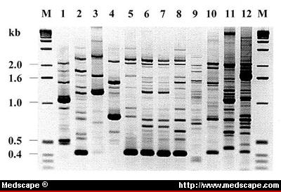
- PCR machine cycles _______________________________
- each cycle ___________________ the number of DNA molecules
- PCR Steps (Figure 7 pg 682)

DNA Fingerprinting (gel electrophoresis)
- Developed in 1975 by Sanger, Maxim & Gilbert
- Use restriction enzymes to cut DNA into fragments of varying lengths
- Steps:
  - Small sample of DNA
  - PCR to replicate DNA
  - R.E.’s cut DNA
  - place fragmented DNA on an agarose gel
  - run electrical current through gel
  - x-ray agarose gel = banding pattern
- Uses: ____________________________ or __________________________________

Human Genome Project:
- Race to determine ____________________________________________________
- timeline – table 1 page 678
- published in 2001 and 2003
- Know ___________________________________________________ specific genes are located.

Gene Therapy
- Method to try to treat or cure genetic diseases
- i.e., hemophilia, cystic fibrosis, sickle cell anemia, huntingtons disease, tay-saches disease
- ______________________________________________________
- being done on viruses
  - vector – __________________________________________________
- i.e., Bacterial

