20.2 Gene Expression & Protein Synthesis
Protein:
- A long chain of _________________________________
- Every protein has to be coded for in DNA
- The function of a protein is dependent on its shape
Uses: muscle, enzymes, hormones, cell membrane, etc

2 main stages: Transcription & Translation
- Diagram:

RNA – ribonucleic acid
Comparing DNA to RNA
 | DNA | RNA
Sugar type
Bases
Structure
Location

Types of RNA
mRNA: ______________ – takes code from nucleus to cytoplasm; single stranded
tRNA: _______________ – carries specific amino acids to the ribosome (20 different tRNA molecules, each specific to an a.a.)

mRNA codon: a _______________ of nitrogen bases (nucleotides)
    - This is how DNA is “read”

Transcription
- Initiation – ____________________________ binds to DNA at a specific site near the beginning of a gene (____________________ – sequence of A & T)
- Elongation – RNA polymerase builds single-stranded _________ in a ___________ direction
  - Transcribed DNA strand = ___________________
- Termination – synthesis of mRNA continues until a termination sequences is reached then mRNA disconnects
  - mRNA moves into the __________________
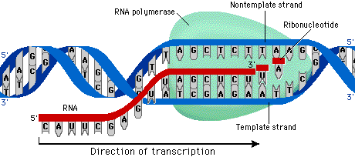
Translation
- Initiation:
  - a ____________________ binds to mRNA - 2 subunits clamp mRNA between it
  - Ribosome moves in a ____________ direction until it finds a ________________
- Elongation:
- __________ with complementary to start codon attaches to mRNA
- Next in line enters the next site
- _________________ bond forms between two a.a’s
- Ribosome shifts over one codon
- Termination:
- when a __________codon is reached the ribosome - mRNA complex breaks apart, releasing the _____________________

