17.2: Applications of the Cell Cycle
- Cloning is the process of forming ___________________identical offspring from a single cell or tissue.
  - i.e., asexual reproduction or identical twins
Types of Cloning:
- Strawberries –___________________ = clones of parent plant
- Hydra – reproduce _____________________ by _________________. The bud break off to form genetically identical organisms
Fredrick Stewart – Carrots (cloning) [late 50’s]
- any carrot cell can be used to clone another carrot
- cells of a carrot remain ________________________
- trick – how do we ____________________ specialization or differentiation processes that occur in cells?
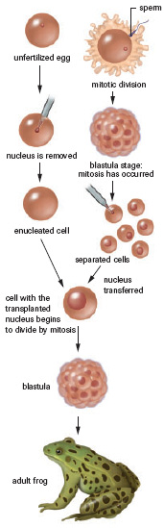
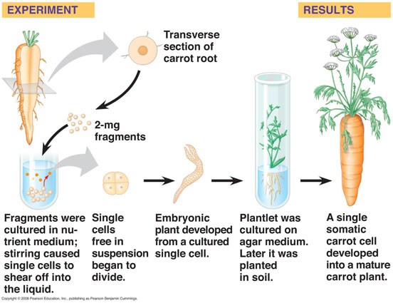

Robert Brigs & Thomas King
- pioneers in animal cloning
- nuclear ____________________________ in frogs
steps:
- extracted a nucleus from an unfertilized egg cell (_______________)
- next they extracted a nucleus of a frog cell in the ____________________stage
- inserted this nucleus into the enucleated egg cell.

Terms:
- Totipotent: any nucleus that is able to bring a cell from egg to adult (i.e., ____________)
- Pluripotent: Can become almost any type of cell (i.e____________________________)
- Multipotent: Can become a limited range of cells (i.e., ______________________, ______________________________, etc)

Cloning Mammals:
- mammal cells are not totipotent, ___________________ cells are
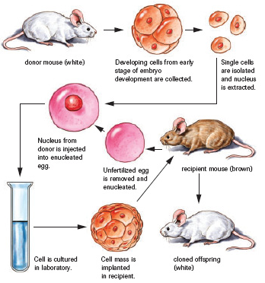
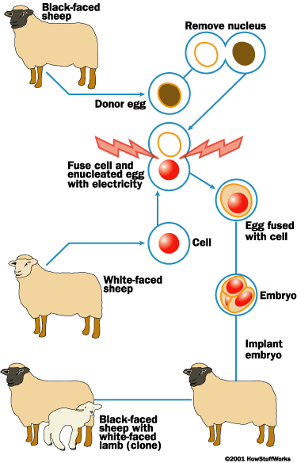
- in humans – identical twins (monozygotic)

Dolly the Sheep:
- nucleus of a cell from an _____________________ was inserted into an egg cell of another cell that had been enucleated (_______________________ removed)
- Then, stimulated with electricity to ________________________________
- at the blastocyst stage, its _____________________ into a _______________________

Cancer
- Cancerous cells are regular cells that have a decreased interphase
  - What are the ramifications of a short interphase? Why is it problematic?
  - __________________________________________________________

