Chapter 10
circulatory system
Pgs. 310 - 339
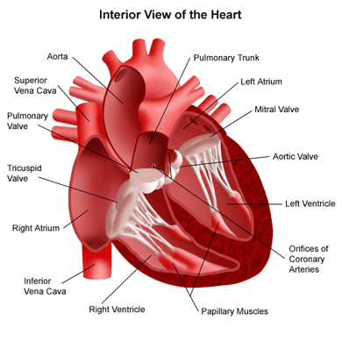
10.1 – Blood Vessels
Arteries and Arterioles
- Arteries
* Carry blood ___________________________________________
* _______________________________________composed of distinct layers
* Outer and inner layers primarily made of ______________________________
* Middle layers made up of ______________________________________________________________________tissue
* ____________________________________to accommodate the inrush of blood

Pulse
- Change in the __________________________________________following heart contractions
- Can be felt near your _____________and on ________________________________________________________________
- Arterioles – _________________________________________
- Autonomic nervous system – the part of the nervous system that controls the motor nerves that regulate equilibrium, and that is ___________________________________________
- Vasoconstriction –___________________________________________, allowing less blood to the tissues
example: becoming pale when frightened – constriction of the arteriolar muscles diverts blood away from the outer capillaries of the skin toward the muscles.
- Vasodilation –___________________________________________, allowing more blood to the tissues
Example: blushing – vasodilation of arterioles leading to skin capillaries and red blood cells close to the surface of the skin produces a pink color
- Artherosclerosis – a degeneration of blood vessels caused by the ______________________________________________________________in the inner wall
- Arteriosclerosis _____________________________________________that cause the blood to ____________________________________________________________
* Can ______________________________arteries
* Can cause ____________________________________________
* Blood clots ______________________________________________
* In the heart, narrowed or blocked arteries can lead to _____________________________________________________________________________________

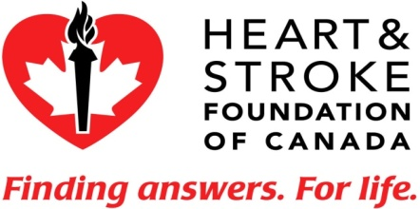

Heart Disease
* Every year___________________________________________________________________.
* ____________________________________________________are keys to prevention.

- Aneurysm –____________________________________________________________________________________________________________________________________________________________
* Most common sites: ____________________________________________________________________________________________________________________________________________________________________
* Most commonly caused by- __________________________________________________
* An aneurysm in ___________________________is one of the conditions that can cause a ___________________________________________.
Five Signs of Stroke
- Stroke can be treated. That’s why it is so important to recognize and respond to the warning signs.
- Weakness - Sudden loss of strength or sudden numbness in the face, arm or leg, even if temporary.
- Trouble speaking - Sudden difficulty speaking or understanding or sudden confusion, even if temporary.
- Vision problems - Sudden trouble with vision, even if temporary.
- Headache - Sudden severe and unusual headache.
- Dizziness - Sudden loss of balance, especially with any of the above signs.
- If you experience any of these symptoms, CALL 9-1-1 or your local emergency number immediately.
Capillaries
- _____________________________________ (red blood cells must travel through capillaries in single file)
- Only _______________________________thick
- Site of ______________________________________________between blood and body cells
- Capillary beds are ____________________________________________________________________________
- __________________________(oxygen rich) blood appears ___________________
- ____________________________________(oxygen poor) blood appears __________________________________________
- Deoxygenated blood collects in small veins called _____________________and is carried ___________________________________________________
Veins and Venules
- Walls contain _________________________________
- Venules merge into _________________________________________________________
- As blood flows from arteries to arterioles to capillaries, blood flow ________________________________and blood pressure in these smaller vessels ________________________________________
- The pressure is not great enough to ________________________________________________
- Veins have________________________________________________, steering blood back to the heart
- Skeletal muscles aide in blood flow in veins by _____________________________________________directing blood flow toward the heart.

Questions
Page 316 # 1-3
Page 318 # 3, 5 - 9

