* Mathematics 20-1
* Unit Three
* Functions and Equations
* Chapter 3 Worksheet

Name_______________

Date________________

Solve for the following questions in the space provided. Marks will be given for work shown so be sure to show your work at all times.

**1.** Explain how the graph of each function can be obtained from the graph of *f* (*x*) = *x*2. For each graph, identify the vertex, the equation of axis of symmetry, direction of opening, whether it has a maximum or a minimum value, domain, range, and the number of *x*-intercepts..

**a)** f(x)=3(*x* – 5)2 + 1**b)** *f* (*x*) = –5*x*2 + 3

vertex: vertex:

equation of axis of symmetry: equation of axis of symmetry:

direction of opening: direction of opening:

a maximum or a minimum value: a maximum or a minimum value:

domain: domain:

range: range:

number of x-intercepts: number of x-intercepts:

2. Determine a quadratic function in vertex form that has the given characteristics.

**a)** its vertex at (2, 0) and passes through the point (1, 3)

**b)** its vertex at (3, –2) and has an *x*-intercept of (5, 0)

3. Determine a quadratic function in vertex form for the parabola.

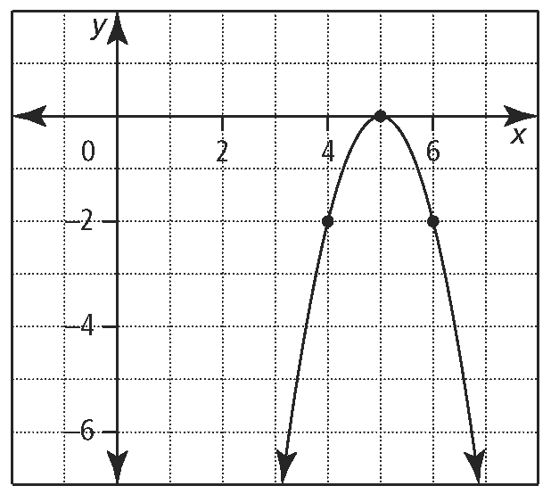

4. Which functions are quadratic? Explain why.

**a)** *f* (*x*) = (*x* + 4)(*x* – 4) **b)** *V*(*w*) = *w*(*w* + 3)(*w* – 1)

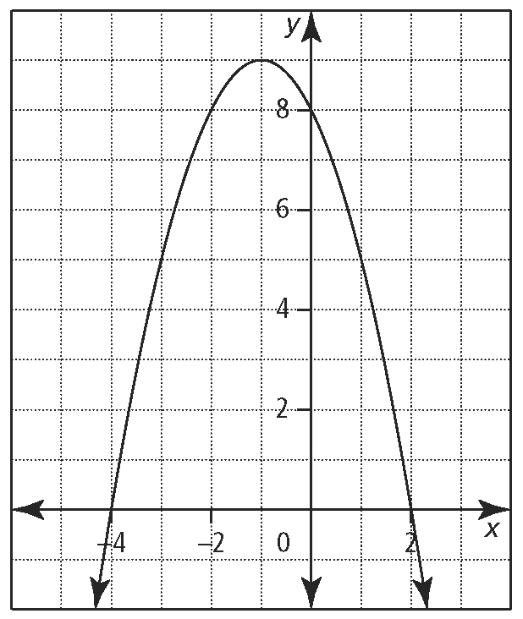**5.**  For the graph, identify the following:

* the coordinates of the vertex are___________
* the equation of the axis of symmetry is ___________
* the *x*-intercept(s) _________and *y*-intercept__________
* the direction of opening____________
* the maximum or minimum value_______________
* the domain_____________ and range______________

the quadratic function in Standard form

6. Write each quadratic function in standard form, *y* = *ax*2 + *bx* + *c*.

**a)** *h*(*t*) = –9(*t* + 1)2 + 50 **b)***f* (*x*) = (2*x* + 5)(6 – 3*x*)

7. A farmer has 200 m of fencing material to enclose a rectangular field adjacent to a river. No fencing is required along the river.

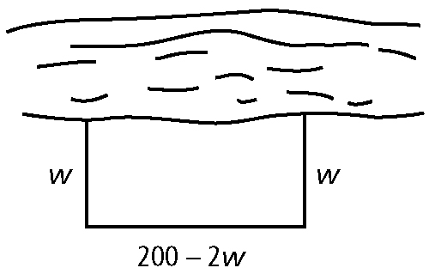

1. Write a function that can be used to represent the area of the field.
2. Determine the maximum area of the field.

**c)** Determine the dimensions of the region that give the maximum area.

**8.**  Write each function in vertex form by completing the square. Use your answer to identify the vertex of the function.

**a)** *y* = *x*2 – 6*x* + 13 **b)***y* = 3*x*2 – 12*x* + 13

**9.**  Convert each function to the form *y* = *a*(*x* – *p*)2 + *q*. State the coordinates of the vertex, axis of symmetry, maximum or minimum value, domain, and range.

**a)** *y* = *x*2 + 10*x* + 16 **b)** *y* = –3*x*2 – 6*x* + 3

**10.** If a farmer harvests his crop today, he will have 1200 bushels worth $6 per bushel. Every week he waits, the crop yield increases by 100 bushels, but the price drops 30¢ per bushel.

**a)** Whatquadratic function can be used to model this situation?

**b)** When should the farmer harvest his crop to maximize his revenue? What is the maximum revenue?