* Mathematics 20-1
* Unit Three
* Functions and Equations
* Chapter 4 Worksheet

Name_______________

Date________________

Solve for the following questions in the space provided. Marks will be given for work shown so be sure to show your work at all times.

1. How many *x*-intercepts does the graph of each quadratic function have? What are the roots of the quadratic equations graphed?

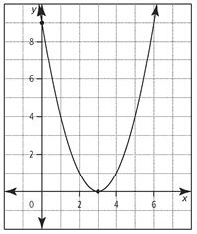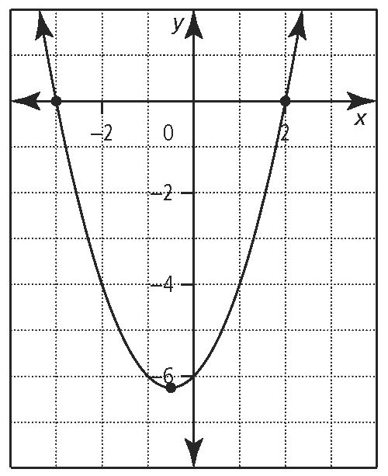

1. b.
2. For what values of *m* would the equation *x*2 + 8*x* + *m* = 0 have
3. one real root or two equal real roots?
4. two real distinct roots?
5. no real roots?
6. An object is launched at 21.5 m/s from a height of 2.4 m. The equation for the object’s height, *h*, measured in metres, *t* seconds after launch is *h* = –4.9*t*2 + 21.5*t* + 2.4. After how many seconds will the object hit the ground? Express your answer to the nearest tenth of a second.
7. Factor.

**a)** (*x* – 1)2 – 2(*x* – 1) – 35  **b)** 

1. Determine the real roots to each quadratic equation by factoring.

**a)** *x*2 – 2*x* – 15 = 0 **b)**2*x*2 + 8*x* = 64 **c)**

**d)** 7*x*2 – 28 = 0 **e)**6*x*2 + 2*x* – 4 = 0 **f)**10*x*2 – 45*x* + 20 = 0

**g)**  **h)**18*x*2 = 3*x* + 3  **i)** 6*x*2 – 5*x* = 4

1. Two numbers have a sum of 22. What are the numbers if their product is 96? You must use a quadratic equation to solve this question.
2. Use the quadratic formula to solve each quadratic equation. Express answers as exact values in simplest form.

**a)** *x*2 – 10*x* + 23 = 0 **b)**4*x*2 – 28*x* + 46 = 0 **c)**9*x*2 – 12*x* = – 4

**6.** Solve each quadratic equation using any appropriate method. Express your answers as exact values. Justify your choice of method.

**a)** *x*2 + 4*x* + 10 = 0 **b)***x*2 + 7*x* = 0 **c)**4*x*2 + 20*x* + 25 = 0

**d)** (*x* + 4)2 = 3 **e)**6*x*2 + 2*x* – 1 = 0