

**In this unit: Lesson 4.1 Square Roots and Cube Roots**

**Lesson 4.2 Integral Exponents**

**Lesson 4.3 Rational Exponents**

**Lesson 4.4 Number Systems and Irrational Numbers**

|  |  |
| --- | --- |
| **General Goal** | **Specific Goal** |
| Develop algebraic reasoning and  number sense. | 1. Demonstrate an understanding of factors of whole numbers by  determining the:  • prime factors  • greatest common factor  • least common multiple  • square root  • cube root.  2. Demonstrate an understanding of irrational numbers by:  • representing, identifying and simplifying irrational numbers  • ordering irrational numbers.  3. Demonstrate an understanding of powers with integral and rational  exponents. |

**Lesson 4.1 Square Roots and Cube Roots**

**Key Terms-** With your partner, determine the meaning of the following

**Power-**

**Base-**

**Exponent-**

**Product-**

**Quotient-**

Investigate Square Roots and Cube Roots

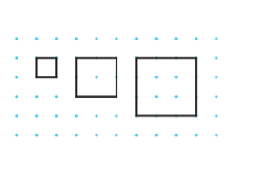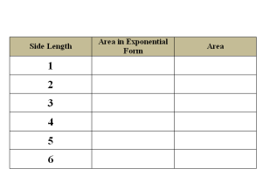Determine the area of each square shown. Record the information in a table.

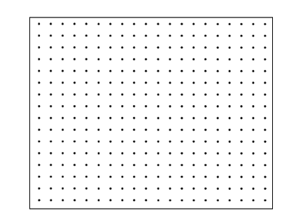Extend the pattern for squares with dimensions of 4, 5 and 6 units.

What is the relationship between the side length of a square and the

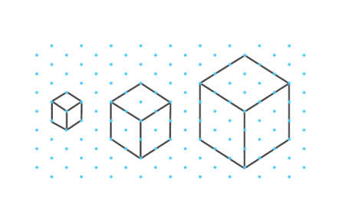

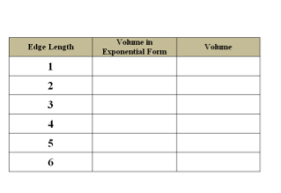Determine the volume of each cube shown. Record the information in a table.

Extend the pattern with cubes with 4, 5 or 6 units.



What is the relationship between the edge length of a cube and the volume of a cube?

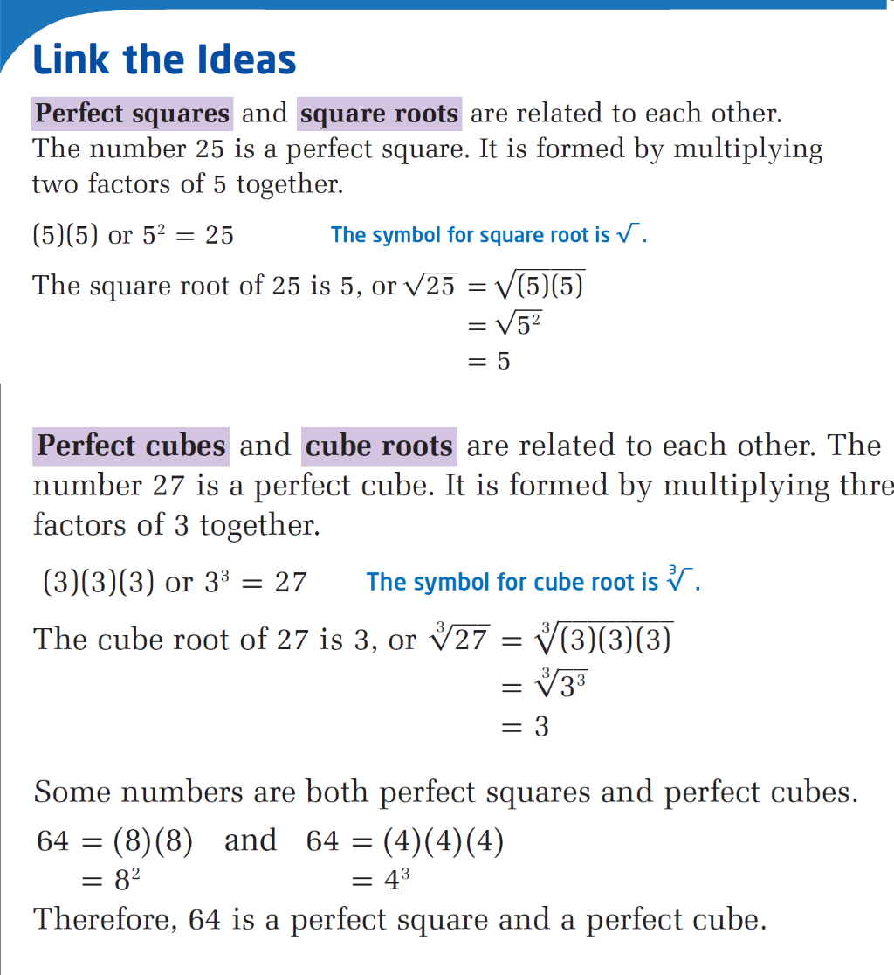

**Example 1 Identify Perfect Squares and Perfect Cubes**

State whether each of the following numbers is a perfect square, a perfect cube, both or neither.

1. 121 b) 729 c)356

**Your Turn**

State whether each number is a perfect square, a perfect cube, both or neither. Use a variety of methods.

1. 125 b) 196 c) 4096

**Example 2**

The uranium that Saskatchewan produces in a year has a volume of about 512 m3. If this volume were made into a single cube, what would be the dimensions of the cube?

**Your Turn**

1. A floor mat for gymnastics is a square with an area of 196 m2.
2. The volume of a cubic box is 27 000 in3. Use two methods to determine its dimensions.

End of Lesson

**Assignment:** Page 158 #1-12, 14, 16, 17, 20

**Challenge:** Page 158 #18,19

**Lesson 4.2 Integral Exponents**

**Investigating Negative Exponents**

**1.** On a sheet of paper, draw a line 16 cm long and mark it as shown.

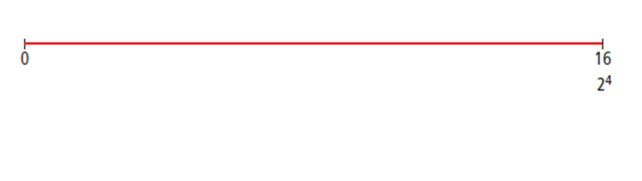

**2.** Mark a point halfway between 0 and 16. Label the point with its value and its equivalent value in exponential form (2x). Repeat this procedure until you reach a value of 1 cm.

**a)** How many times did you halve the line segment to reach 1 cm?

**b)** What do you notice about the exponents as you keep reducing the line segment by half?

**3. a)** Mark the halfway point between 0 and 1. What fraction does this represent?

**b)** Using the pattern established in step 2, what is the exponential form of the fraction?

**c)** Halve the remaining line segment two more times.

**4.** Use a table to summarize the line segment lengths and the

equivalent exponential form in base 2.

**5. Reflect and Respond**

**a)** Describe the pattern you observe in the exponents as the distance is halved.

**b)** Is there a way to rewrite each fraction so that it is expressed as a power with a positive exponent? Try it.

Compare this form to the equivalent power with a negative exponent. What is the pattern?

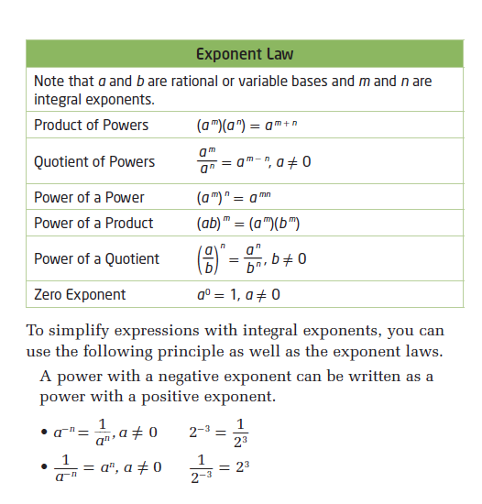

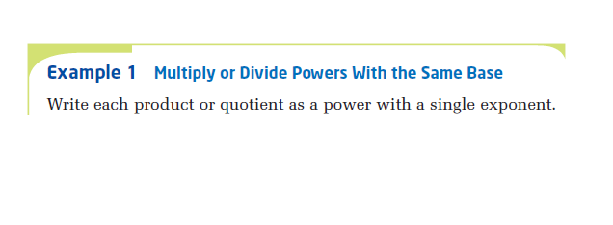

 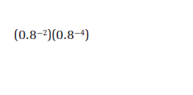

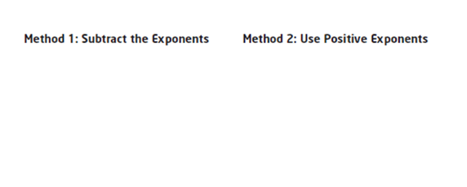

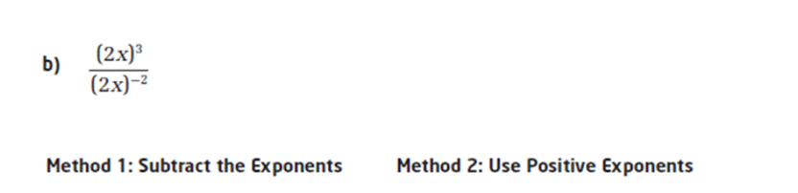

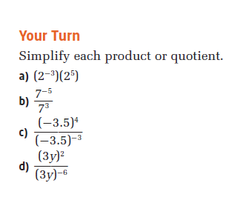

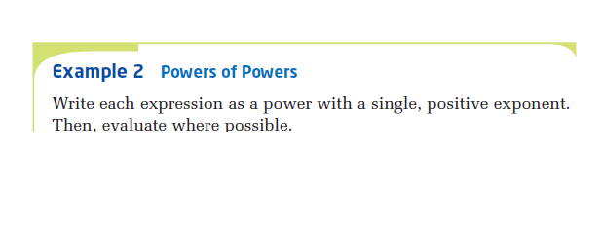

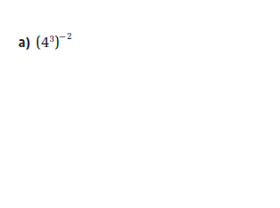

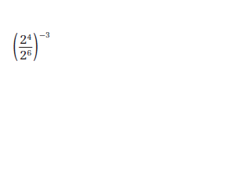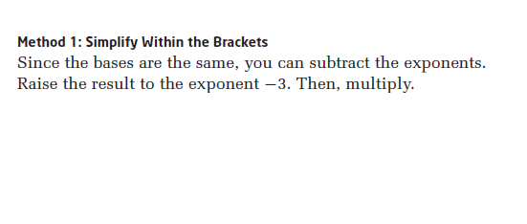

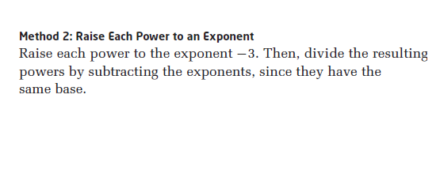

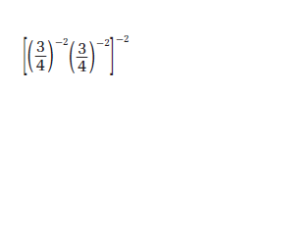

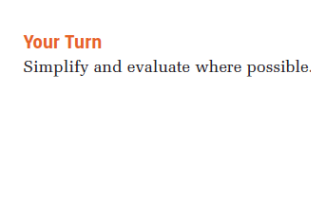

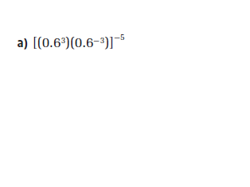 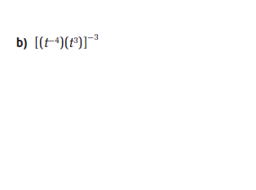

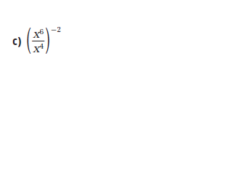 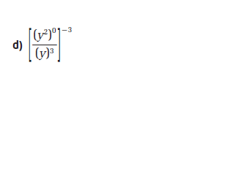

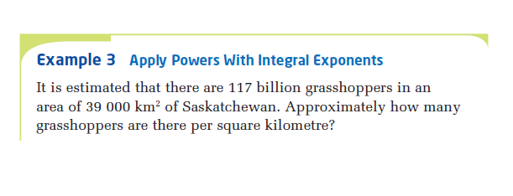

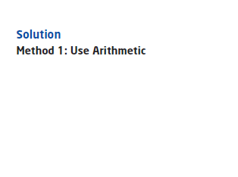 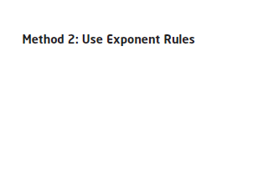

End of Lesson

**Assignment:** Page 169 #2,4(odd letters), 5(odd letters), 6 a-c, 7,8,10,11,13,19

**Challenge:** Page 169 #20,22,24

**Lesson 4.3 Rational Exponents**

**Try This**

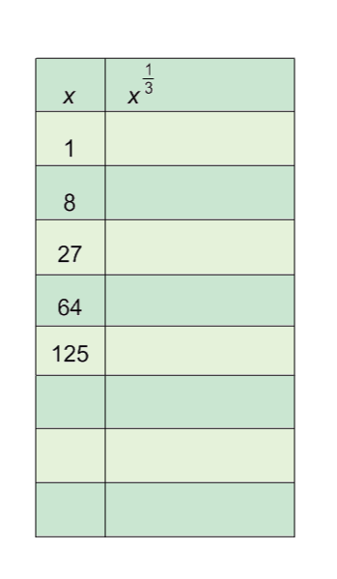Complete each table. Use a calculator to complete the second column for each table.

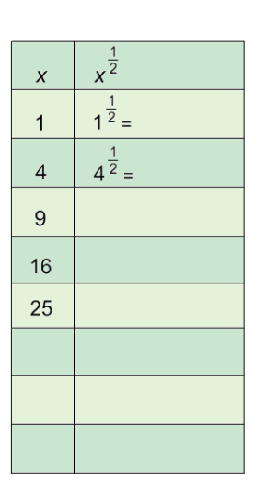

First Table:

What do you notice about the numbers in the first column?

Compare the numbers in the first and second columns. What conclusions can you make?

What do you think the exponent ½ means?

What do you think mean? Explain your reasoning.

Second Table:

What do you notice about the numbers in the first column?

Compare the numbers in the first and second columns. What conclusions can you make?

What do you think the exponent  means?

What do you think and mean?

We know from our *Product of Powers* exponent law that:

If we choose to multiply 9½ by itself we get:

But what number, multiplied by itself, will equal 9? That is, if:

Another way to demonstrate rational exponents is to use the *Power of a Power* law

For example, the number 9 can be written as

Because

And we also know that

Predict values for

4½  16½ 36½ 49½

Predict the value of

  

**Example 1 -** Simplifying Expressions with Rational Exponents

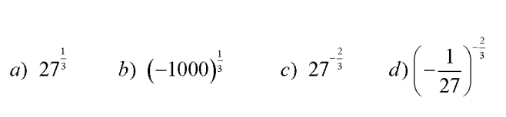

**Example 2** - Multiplying or Dividing Powers with the Same Base

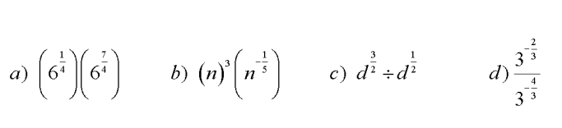

Multiplying or dividing powers with different bases

In order to solve these questions, you will need to convert the questions so that they have the same bases

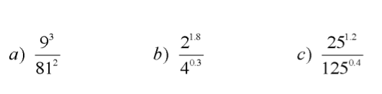

**Example 3**- Simplifying Powers with Rational Exponents

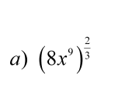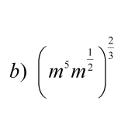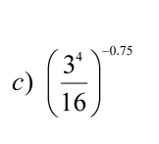

**Example 4** - Applying Powers with Rational Exponents

The price of a vintage video game with the box and instructions doubles every 20 years. The video game initially cost $60.00. The present value of the game came can be modelled using the formula

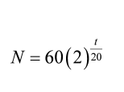

where *N* is the value of the games after *t* years.

1. What does that value 2 in the formula mean?
2. What is the value of the video game after 20 years?
3. What is the value of the video game after 4 years?
4. What is the value of the video game after 33 years?

End of Lesson

**Assignment:** Page 180 #1,-5, 7, 8, 10, 12, 14, 15

**Challenge:** Page #16, 17

**Lesson 4.4 Number Systems and Irrational Numbers**

**Work in groups to answer the next three questions.**

1. Given a table with a selection of rational and irrational numbers, what generalizations can you make about rational and irrational numbers based on the values provided below.

|  |  |
| --- | --- |
| **Rational** | **Irrational Numbers** |
|  |  |

1. Define real numbers, integers, whole numbers and natural numbers.
2. Given the following numbers:

, , , , .

* Classify each number as being rational or irrational.
* Order the numbers from lowest to highest.
* Locate them on a number line.

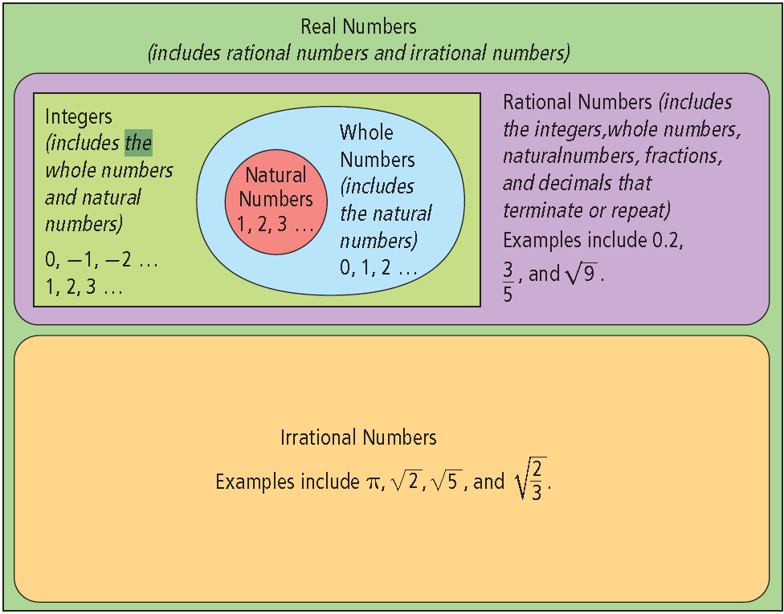

**Activity:** Work with a partner. Create a number line with  and  as the extreme values. Find 7 different numbers with values between those extremes and place them on their number line. Try to use exact values.

**Working with Irrational Numbers**

Example 1

Express each power as an equivalent radical.

**a)** 

**b)** 

**c)** 

Example 2

Express each radical as a power with a rational exponent.

**a)** 

**b)** 

**c)** 

Just as with fractions, equivalent expressions for any number have the same value.

 is equivalent to ·  because:

 and  · 

= = 4 · 3

=12 =12

■ Similarly,  is equivalent to · because:

 and 

**Multiplication Property of Radicals**



where *n* is a natural number, and *a* and *b* are real numbers

**Example 3 Convert Mixed Radicals to Entire Radicals**

Express each **mixed radical** as an equivalent **entire radical**

**a)** 

**b)** 

**c)** 

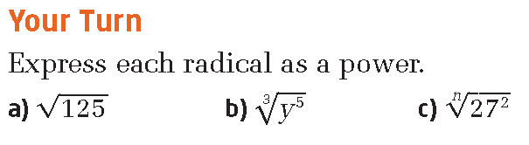

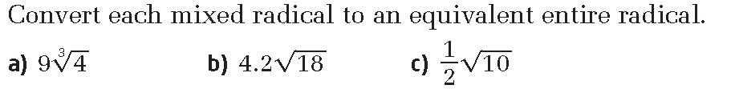

Recall the Perfect Square Numbers are:

Recall the perfect cube numbers are:

**Example 4 Convert Entire Radicals to Mixed Radicals**

Express each entire radical as an equivalent mixed radical.



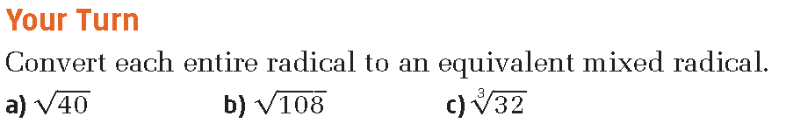

**Example 5 Order Irrational Numbers**

Order these irrational numbers from least to greatest: 

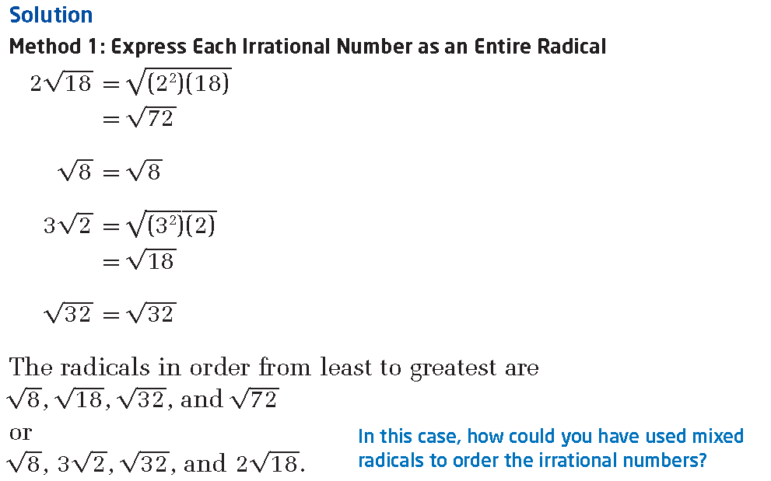

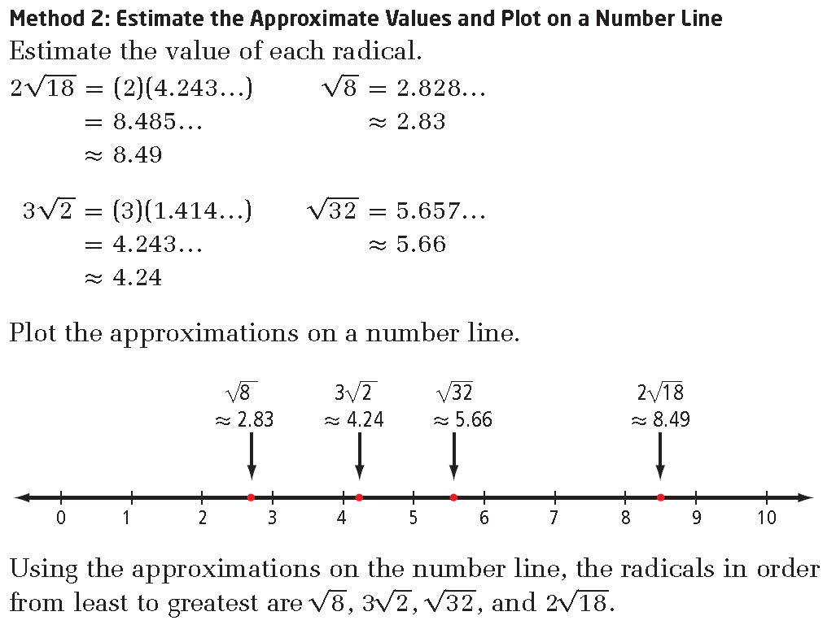

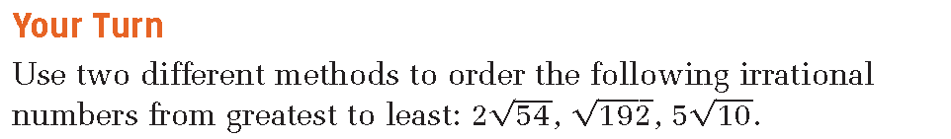

|  |  |  |  |
| --- | --- | --- | --- |
| **Entire Radical Form** | **Prime Factorization Method** | **Factor Form** | **Mixed Radical Form** |
|  | =  = | or |  |
|  |  |  |  |
|  |  |  |  |
|  |  |  |  |

End of Lesson

**Assignment:** Page 192 #1-8 odd letters (a, c, e, …) and 9, 15, 16

**Challenge:** Page #19, 20