Domain and Range

- For each relation below:
• Determine whether the relation is a function. Justify your answer.
• Identify the domain and range of each relation that is a function.
- A relation that associates a number with a prime factor of the number:
{(4, 2), (6, 2), (6, 3), (8, 2), (9, 3)}

2. The table shows the costs of student bus tickets, C dollars, for different numbers
of tickets, n.

Number of Tickets,  n | Cost, C ($)
1 | 1.75
2 | 3.50
3 | 5.25
4 | 7.00
5 | 8.75

- Why is this relation also a function?

- Identify the independent variable and the dependent variable. Justify your choices.

c) Write the domain and range.

3. The equation C = 25n + 1000 represents the cost, C dollars, for a feast following an Arctic sports competition, where n is the number of people attending.
a) Describe the function. Write the equation in function notation.

b)Determine the value of C(100). What does this number represent?

c) Determine the value of n when C(n) = 5000. What does this number represent?
4. Which of these graphs represents a function? Justify your answer.
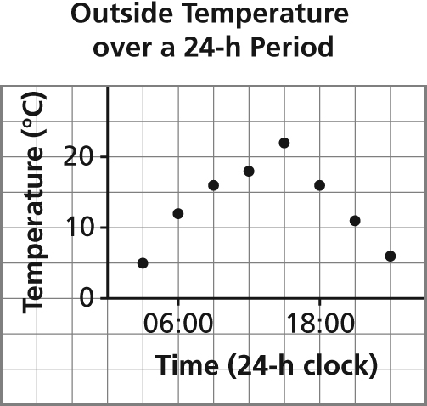
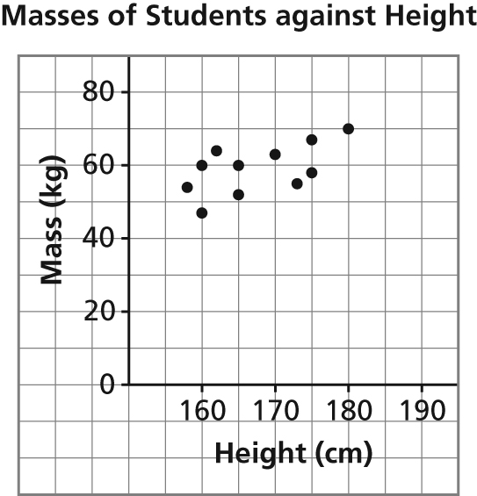
a) b)

5. Determine the domain and range of the graph of each function.
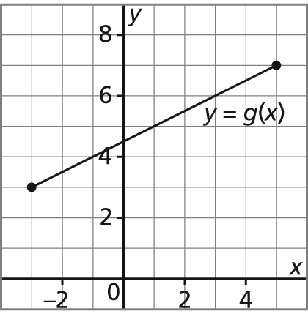
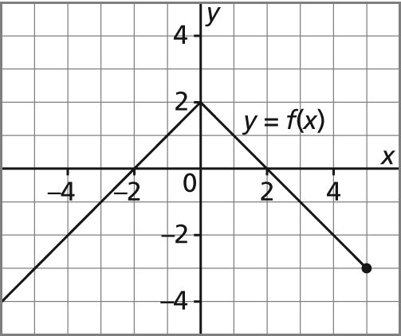
a) b)

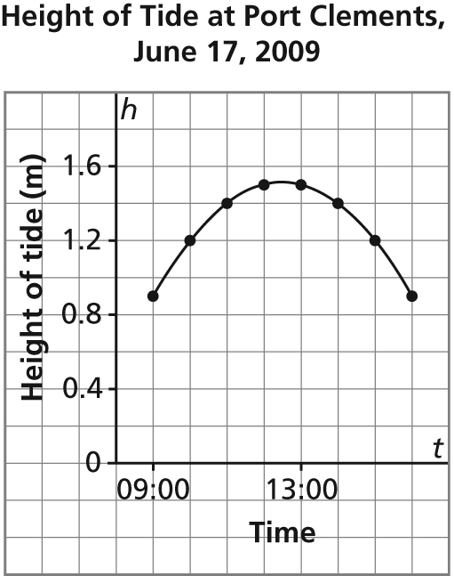
6. This graph shows the approximate height of the tide, h metres,
as a function of time, t, at Port Clements, Haida Gwaii on June 17, 2009.

- Identify the dependent variable and the independent variable. Justify your choices.

- Why are the points on the graph connected? Explain.

c) Determine the domain and range of the graph.
7. Here is a graph of the function g(x) = 4x – 3.
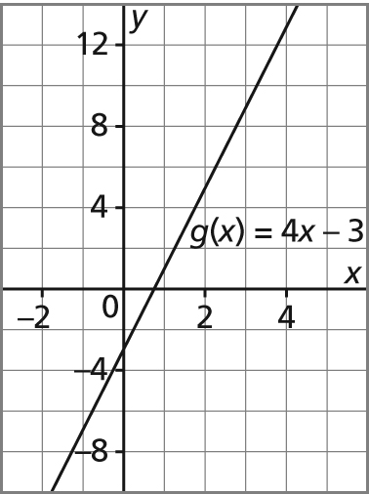

- Determine the range value when the domain value is 3.

b) Determine the domain value when the range value is –7.

8. Which table of values represents a linear relation? Justify your answer.
a) The relation between the number of bacteria in a culture, n, and time, t minutes.
t | n
0 | 1
20 | 2
40 | 4
60 | 8
80 | 16
100 | 32

b) The relation between the amount of goods and services tax charged, T dollars, and the amount of the purchase, A dollars
A | T
60 | 3
120 | 6
180 | 9
240 | 12
300 | 15

