Ingestion 8.3
Pgs. 259-263

- Four components of the digestive process
1. Ingestion- _____________________________________________________________________________________________________________________________________________________
2. Digestion- _____________________________________________________________________________________________________________________________________________________
3. Absorption- ______________________________________________________________________________________________________________________________________________________
4. Egestion-______________________________________________________________________________________________________________________________________________________
- Digestive tract in adults is 6.5 – 9 m long
- 2 forms of digestion; Physical and Chemical
- Physical digestion (mechanical) –_________________________________________ _____________________________________________________ Physical digestion breaks food into smaller pieces- _______________________________________________________.
- Salivary Glands
- Produces watery fluid (saliva)- ___________________________________________ __________________________________________________________________
- We detect flavor when saliva dissolves food particles and they ___________________________________________________________
- Different receptors respond to different flavors. Chemical compounds with specific shapes bond to receptor sites with similar shapes – this allows for the sense of different tastes.

- Teeth- _____________________________________________________________
- 8- ________________________________________________________________
- Incisors are bordered by ____________________________________________________
- Premolars are next to them, _______________________________________
- Then there are molars which are used for _________________________.
- Lastly you have your wisdom teeth, these do not appear until 16-20 years old and usually need to be removed
- Enamel covers the teeth __________________________________________________.
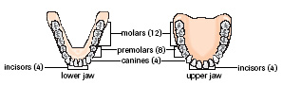
- Esophagus
- ________________________________________________________ via the esophagus.
- The bolus stretches the walls of the esophagus which ___________________________ _____________________________________________________________________
- This is ____________________________- which moves food down the gastrointestinal tract.
- STOMACH
- __________________________________________________ digestion take place here.
- There are 3 layers of muscle which allows _________________________________.
- Movement of food to and from the stomach is regulated by _________________ ____________________________________________________
- Contraction of the lower esophageal sphincter (______) closes the opening to the stomach, while relaxation allows food to enter. The LES helps to prevent food and acid from being regurgitated into the esophagus (heart burn)
- The second sphincter, the _________________________ sphincter, regulates food and acid as it moves into the small intestine.
Label using Figure 5 pg 261

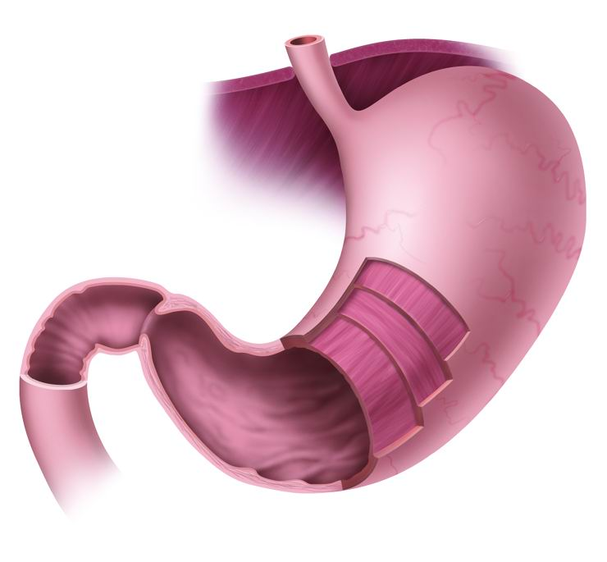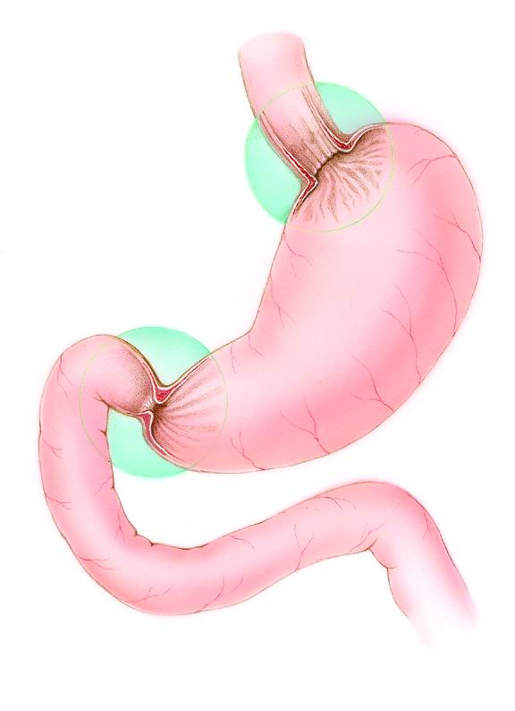
- The stomach is J shaped and _______________________________________________ – can hold approx. 1.5 litres of food. Millions of cells line the stomach’s wall which help ___________________________________________________________which aid in digestion.
- Muscle ________________________________________ together.
- Therefore both ______________________________________________ place.
- Approx 500 ml of these fluids are secreted per 1 large meal.
- Gastric ______________________________________________________________ and other substances.
- HCI kills harmful substances _________________________________________________ (a protein digesting enzyme). It breaks amino acid chains into shorter ones called _________________________.
- The pH in the stomach ranges from __________________________________________
- Acids with pH of 2.0 can dissolve rugs.
- A layer of _________________________________________ lining from being dissolved.
- The esophagus does not _________________________________________________ ________________________________________and damage it.
- This can cause heart burn.
- Peptic Ulcers
- When the stomach’s lining breaks down _______________________________________________________________________________________________________________________________________________
- Beneath the stomach’s cell walls are blood vessels. As the acid irritates the stomach lining there is an increase in blood flow and acid secretions. This causes tissue t burn and blood vessels to break down.
- Most Ulcers are from _______________________________________________called Helicobacter pylori (H.pylori).

- Initially, scientists were sceptical since it was believed that bacteria would not be able to live in such__________________________________. However, using a simple breath test it is determined that is correct.

- If found early antibiotics can be used as treatment. If not treated, surgery could be required.

Questions Pg.263
1-7, 9, 10, 11, and 13

