**Unit 2- Trigonometry___________________________________________**

**Lesson 2.1: Angles in Standard Position**

Specific Outcome **1.** Demonstrate an understanding of angles in standard

position [0° to 360°].

This section of the course has a lot of terminology that we will use. It is expected that you will be able to use and understand the terminology given when answering questions. As such, it is important that you can use these terms throughout this unit.

1. **Angles in Standard Position – Terminology**

Up to this point, we have really only dealt with trigonometric ratios for angles between  and . Using the *Cartesian plane*, however, we can find the trigonometric ratios for any angle.

**Definition:** Angles on the Cartesian plane is called a **____________________________**. The **rotation angle** is found by rotating the **___________________________** through an angle of  about a fixed point. It ends at the **_________________________**.

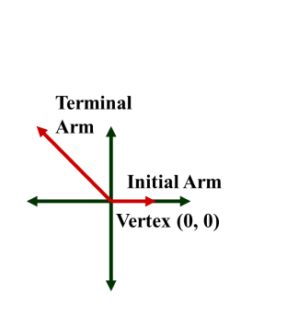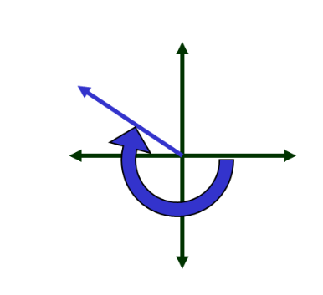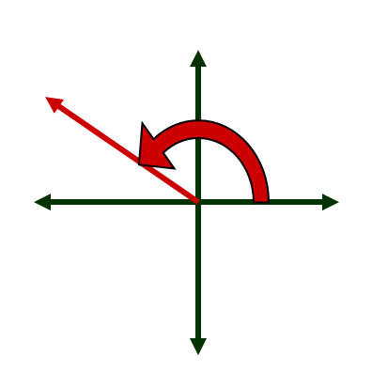**Definition:** An angle is said to be in **_________________________** if its initial arm is on the *positive x-axis* and the vertex is at (0, 0).

**An angle is __________**

**when the rotation is**

**_______________.**

**An angle is __________**

**when the rotation is**

**____________________.**

Angles in standard position are always shown on the Cartesian plane. The *x*-axis and the *y*-axis divide the plane into four quadrants, like so:

**Quadrant**

**____**

**Quadrant**

**____**

**Quadrant**

**____**

**Quadrant**

**____**

**Example 1:**

Sketch the rotation angle in standard position and state the quadrant in which the angle  terminates.

**Example 2:**

Sketch the rotation angle in standard position and state the quadrant in which the angle  terminates.

**Example 3:**

Sketch the rotation angle in standard position and state the quadrant in which the angle  terminates.

**Definition:** The **__________________** is the smallest positive rotation angle measured from the positive *x*-axis to the terminal arm. It is always between  and .

**Definition:** A **__________________** is the _______________*angle* between the *terminal arm and the closest x-axis*. It is always measured as a *positive angle and is always less than .*

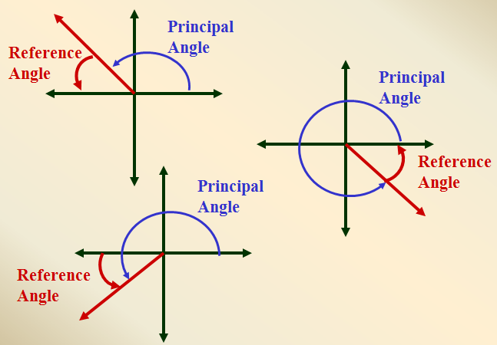 In the examples below, both the principal angle and the reference angle are shown:

Example 4:

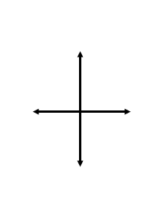Sketch the following angles and list the reference and principal angles.

1. 120° B) -120° C) 80° D) 240°

**A) 1200**

Principal Angle: ____ Principal Angle: ____ Principal Angle: ____ Principal Angle: ____

Reference Angle: ____ Reference Angle: ____ Reference Angle: ____ Reference Angle: ____

**The Relationship between the Cartesian Plane and Principal Angles**

We can identify the location of the principal angle (and its subsequent reference angle) if we are given the coordinates of a point on the terminal arm. For right now, all we will do is draw the angle. In future lessons we will be able to do more.

**Example 5:**

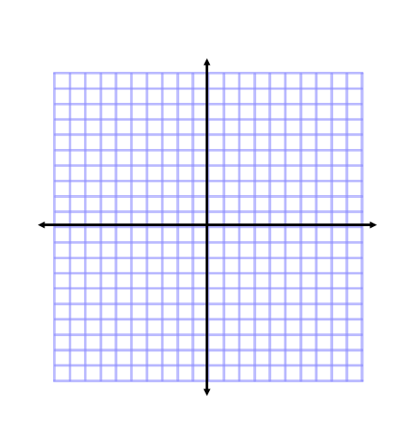The point  lies on the terminal arm of the angle . Draw the angle  in standard position.

**Related angles** are *_______________* that have the _________________________________. These angles will also have the same trigonometric ratios, which we will explore later in this unit.

For example, the following three principal angles are related angles because all three of them have a reference angle of 30°.

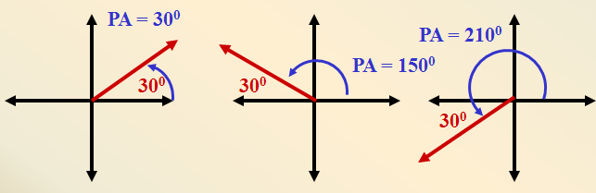

**Example 6:**

Given that the reference angle is  state what the 4 possible principal angles could be.

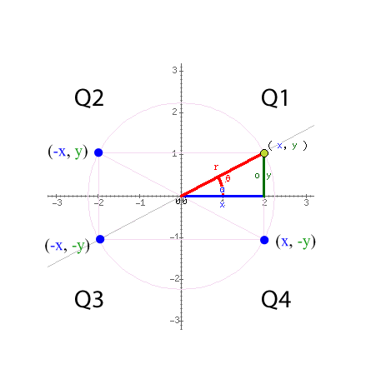Linking what we learned in the last section with this information allows us to realize that reflections about the *x*- and *y*-axis will result in reference angles that are the same. For example, if we were to draw (2, 5), (-2, 5), (2, -5), and (-2, -5) we should realize that these would all have the same reference angle.

**Example 7:**

Let  be a point on the terminal arm of the rotation angle in Quadrant I. State the coordinates of the other three points which would have the same reference angle in Quadrants II, III, and IV.

**Assignment:** Pg. 83 questions 1-3 (odd letters ex. a,c,e) 5-7 (odd letters)

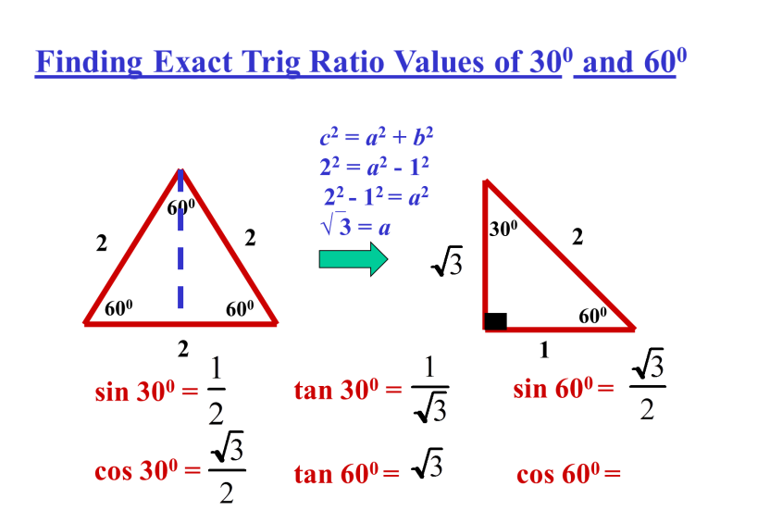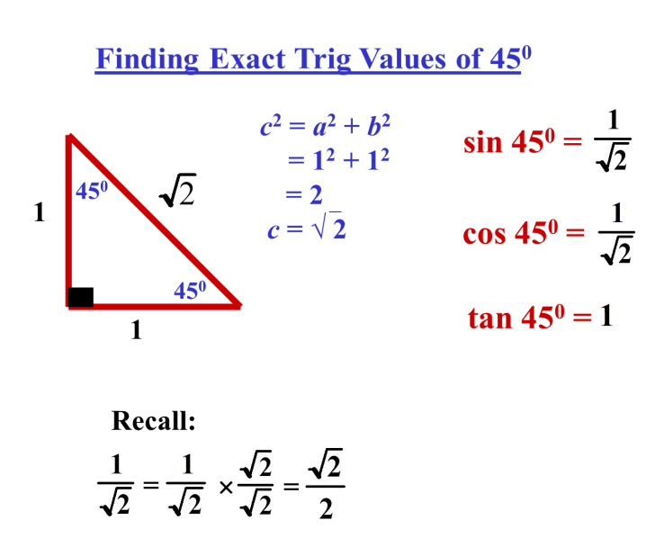

**Exact Values of Trig Ratios**

|  |  |  |  |
| --- | --- | --- | --- |
|  | sin | cos | tan |
| 30° |  |  |  |
| 60° |  |  |  |
| 45° |  |  |  |

Example 8:

State the exact value for each ratio

1. sin 30° 2) cos 45° 3) tan 45°

4) sin 60° 5) tan 60° 6) cos 30°

Example 9- Find an exact distance

Allie is learning to play the piano. Her teacher uses a metronome to help her keep time. The pendulum arm of the metronome is 10 cm long. For one particular tempo, the setting results in the arm moving back and forth from a start position of 60o to 120o.  What horizontal distance does the tip of the arm move in one beat? Give an exact answer.

**Assignment:** Pg. 83 questions 8, 10, 11 , 12, 13, 17 challenge 19