**Unit 2- Trigonometry___________________________________________**

**Lesson 2.2: Trigonometric Ratios of Any Angle**

Specific Outcome 2. Solve problems, using the three primary trigonometric ratios for angles from 0° to 360° in standard position.

**Example1 :**

Find the length of the line joining  and .

**Finding the Distance Between Points – Using a Formula**

If we were to substitute this into the Pythagorean Theorem we would get:

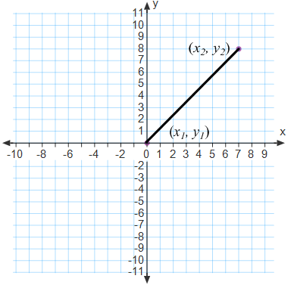 

Except, because we usually associate the letter *d* with the distance formula, we change it to look like so:



We can make one further change as well. Because we are almost always going to start with one set of coordinates at the origin, we will replace  with . The new equation will look as follows:



As we can see, this line could also be interpreted as the radius of a circle with the centre at the origin:

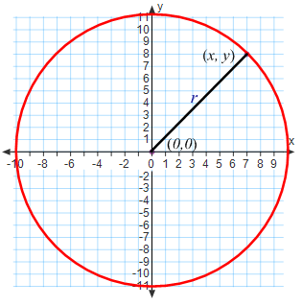 Thus, we can change the formula to look like so:

 becomes 

**Example 2:**

Find the distance between  and .

**Determining the Primary Trigonometric Ratios Given a Point**  **on the Terminal Arm**

When given an angle θ in standard position and P(*x*, *y*), which is any point on the terminal arm, the three primary ratios are defined as follows:

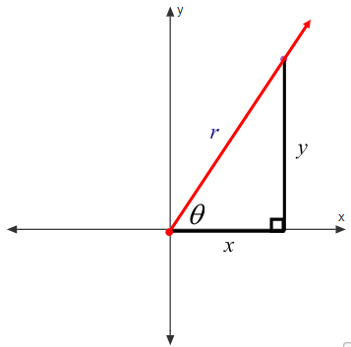 Sin θ =

cos θ=

tan θ=

**Example 3:**

The point  lies on the terminal arm of an angle  in standard position. Determine the exact value of the three primary trigonometric ratios for .

The trigonometric ratios of any angle in the first quadrant are always positive. As we have just seen, however, only the tangent value in quadrant three was positive. The following chart summarizes the signs of the trigonometric ratios in each quadrant.

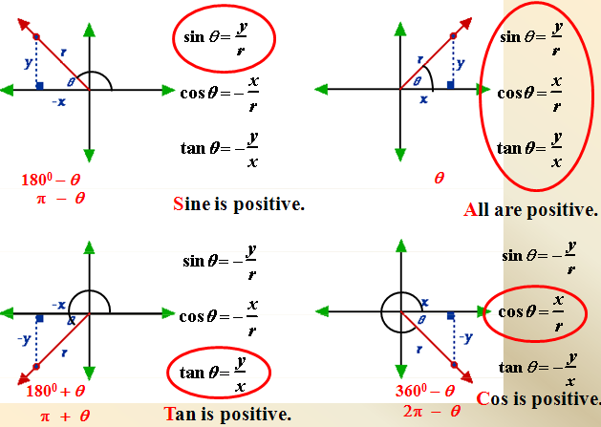

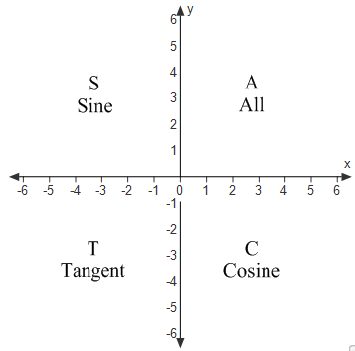The primary trigonometric ratios that are positive can be summarized in the following graph:

Some people use the mnemonic: **A**dd

**S**ugar

**T**o

**C**offee

**Example 4:**

The point  lies on the terminal arm of an angle  in standard position. Determine the exact value of the three primary trigonometric ratios for .

**Example 5:**

Given  in standard position with its terminal arm in the stated quadrant, find the exact values of the remaining two primary trigonometric ratios for .

 Quadrant II

Recall from last lesson, we talked about special triangles. We can use our knowledge of primary trigonometric ratios to help us with special triangles.

**Example 6:**

State the exact value for each ratio

1) sin 150° 2) cos 120° 3) cos 240°

4) tan 135° 5) tan 210° 6)tan 315°

**Assignment: Page 96 questions: 1b,c, 2b,c, 3b,d,4, 5a,c, 6.**

**Solving for Angles – using Exact Values**

**Example 7:**

Determine the exact value(s) of  where .

**Example 8:**

Determine the measures, to the nearest degree, of  where .

**Example 9:**

Determine the values of  when the terminal arm of  lies on the positive *y*-axis.

It is worth noting that the values for  when dealing with questions where the terminal arm lies on an axis will always be one of four solutions: 0, 1, -1, or undefined. It is also worth noting that these types of angles are known as **quadrantal angles**.

**Definition:** a **quadrantal angle** is an angle in standard position whose terminal arm lies on one of the axes.

The values for the other quadrantal angles can be found by using the following diagram:

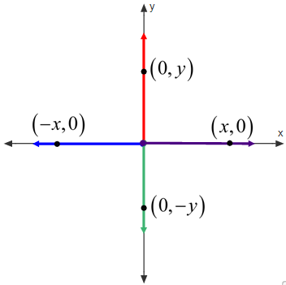

|  |  |  |  |  |  |
| --- | --- | --- | --- | --- | --- |
|  |  |  |  |  |  |
|  |  |  |  |  |  |
|  |  |  |  |  |  |
|  |  |  |  |  |  |

**Assignment: Page 96 questions: 8, 9 a,c,e, 12, 15, 18, 29**