**Unit 3- Quadractics Functions and Equations__________________**

**Lesson 3.1: Quadratic Equations in Vertex Form**

Specific Outcome **1.** Analyze quadratic functions of the form y = a(x - p)2 + q and determine the:   
• vertex  
• domain and range  
• direction of opening  
• axis of symmetry  
• x- and y-intercepts

This section of the course has a lot of terminology that we will use. It is expected that you will be able to use and understand the terminology given when answering questions. As such, it is important that you can use these terms throughout this unit.

1. **Quadratic Functions in Vertex form – Terminology**

**Definition:**

: a function f whose value of f(x)at x is given by a polynomial of degree two. For example f(x) is the simplest form of a quadratic function. The symmetrical curve of a quadratic function is better known as a . The parabola is symmetrical about the line called the .

The y – coordinate of the vertex is called the if the graph opens upward or the if the parabola opens downward.

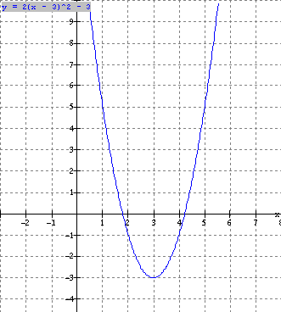

**Quadratic Function y= or f(x)= x2**

Vertex form : y = f(x) = a(x − p)2 + q; a ≠ 0

* The graph is a parabola. (label vertex, x-int, y-int, axis of symmetry x = p_)

highest or lowest point y=0 x=0 x value of vertex



Maximum function minimum function

From our investigation a quadratic function is **f (x) = a(x − p)2 + q where:**

**In general:**

* The sign of *a* defines the direction of opening of the parabola**.** Wherethe graph opens **upward** and when, the graph opens **downward.**
* The parameter *a* also defines how wide or narrow the graph is compared to the graph of f(x) = x2 (the larger the  is, the narrower the graph)
* The point (p, q) defines the vertex of the parabola.
* The equation x = p defines the axis of symmetry.

**Example 1**: Sketch graphs of Quadratic Functions in Vertex form

Find:

* vertex 2nd calc max or min
* equation of axis of symmetry x = value from vertex
* direction of opening
* width compared to y = x2 Same, Wider or Narrower
* domain & range always ,  value from vertex
* max. or min. and value vertex

|  |  |  |  |  |  |  |
| --- | --- | --- | --- | --- | --- | --- |
|  | Vertex | Axis of Sym. | Direction  Of opening | Width Compare to | Domain  And Range | Max or Min Value |
| 1. y =2( x+1)2 - 3 |  |  |  |  |  |  |
|  |  |  |  |  |  |
| 2. y = 3x2 |  |  |  |  |  |  |
|  |  |  |  |  |  |
| 3. y = −2x2 − 4 |  |  |  |  |  |  |
|  |  |  |  |  |  |
| 4. y = (x − 2)2 |  |  |  |  |  |  |
|  |  |  |  |  |  |
| 5. y = −(x + 3)2 |  |  |  |  |  |  |

**Method 1: Sketch the using Transformations**

Sketch the graph of f(x) = 2(x + 1)2 – 3 by transforming the graph f(x) = x2.

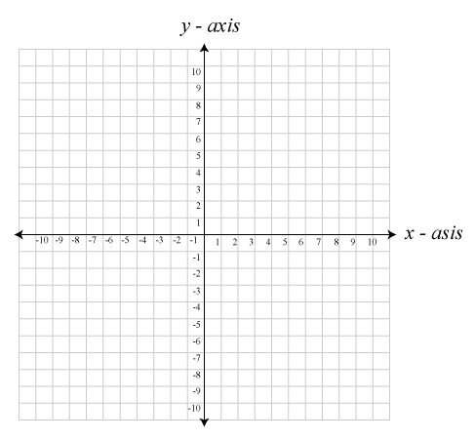**Apply the change in width**

**Translate the Graph**

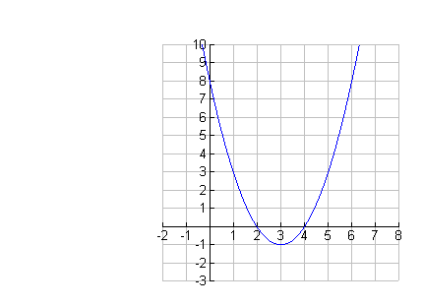**Method 2: Sketch Using Points and Symmetry**

* Plot the coordinates of the vertex, (-1, -3), and draw the axis of symmetry, x = -1
* Determine the coordinates of one other point on the parabola



**The y - intercept is a good choice for another point.**

**Let x=0**

**f(x) = 2 ( 0+1)2-3**

**f(x)= -1**

**The point is (0, -1)**

**For any point other than the vertex, there is a corresponding point that is equidistant from the axis of symmetry. In this case, the correseponding point for (0, -1) is (-2, -1).**

**Plot these two additional points and complete the sketch of the parabola.**

Example 2: Determine a Quadratic Function in Vertex Form Given its Graph.

**Method 1: Use points and Substitution**

You can determine the equation of the function using the coordinates of the vertex and on other point.



Step 1: Express the function as

f(x) = *a*(x-p)2 + q

Step 2: Choose one other point on the graph. Substitute the values of x, and y into the function and solve for ***a***.

Example 3 Determine the Number of x-Intercepts Using *a* and

a) *f(x)= 0.8x2 - 3 b) f(x) = 2(x - 1)2 c) f(x) = -3 (x + 2)2 -1*

Determine the number of x - intercepts a quadratic function has by examining

* the value of a to determine if the graph opens upward or downward
* the value of q to determine if the vertex is above, below, or on the x-axis

**a)** *f(x)= 0.8x2 - 3*

|  |  |  |  |
| --- | --- | --- | --- |
| Value of a | Value of q | Visualize the Graph | Number of x-intercepts |
|  |  |  |  |

**b**) *f(x) = 2(x - 1)2*

|  |  |  |  |
| --- | --- | --- | --- |
| Value of a | Value of q | Visualize the Graph | Number of x-intercepts |
|  |  |  |  |

***c)*** *f(x) = -3 (x + 2)2 -1*

|  |  |  |  |
| --- | --- | --- | --- |
| Value of a | Value of q | Visualize the Graph | Number of x-intercepts |
|  |  |  |  |

Example 4: Determine the x- and y-intercepts of the following equations

1. *f(x)* = 2(x + 1)2 – 3 b) *f(x)* =*2(x - 1)2 c)**f(x) = -3 (x + 2)2 -1*

Assignment: Pg 157- 158 #'s 1a,c, 2. b,c, 4.a, 5, 8. b,c 9 ad