Unit 3- Quadractics Functions and Equations__________________
Lesson 3.2 Quadratic Functions in Standard Form
Specific Outcome 2. Analyze quadratic functions of the form y=ax²+bx+c to identify characteristics of the corresponding graph, including:
• vertex
• domain and range
• direction of opening
• axis of symmetry
• x- and y-intercepts
and to solve problems.

The standard form of a quadratic function is________________________
where a, b and c are real numbers and a ≠ 0:
· ___ determines the width of the graph (large a means narrow, small a means wide)
· ____ determine which direction the parabola opens (positive a opens up, negative a opens down)
· ___ influences the position of the graph
· ____ is the y-intercept of the graph
Example 1:Identify Characteristics of a Quadratic Function in Standard Form
For each graph of a quadratic function, identify the following:
• the direction of opening
• the coordinates of the vertex
• the maximum or minimum value
• the equation of the axis of symmetry
• the x-intercepts and y-intercept
• the domain and range
a) f (x) = x² b) f (x) = x² – 2x
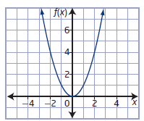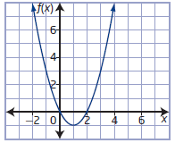

c) f (x) = –x² + 2x + 8 d) f (x) = 2x² – 12x + 25
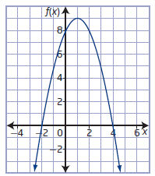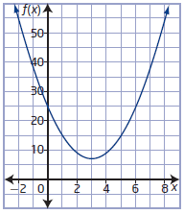

Example 1: Your Turn
For each quadratic function, identify the following:
• the direction of opening
• the coordinates of the vertex
• the maximum or minimum value
• the equation of the axis of symmetry
• the x-intercepts and y-intercept
• the domain and range

a) y = x² + 6x + 5 b) y = –x² + 2x + 3
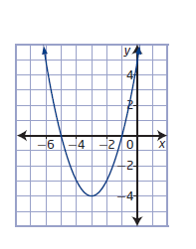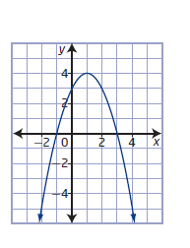
Example 2: Analysing a Quadratic Function
A frog sitting on a rock jumps into a pond. The height, h, in centimetres, of the frog above the surface of the water as a function of time, t, in seconds, since it jumped can be modelled by the function h(t) = –490t² + 150t + 25. Where appropriate, answer the following questions to the nearest tenth.

a) Graph the function using your calculator.

b) What is the y-intercept? What does it represent in this situation?

c) What maximum height does the frog reach? When does it reach that height?

d) When does the frog hit the surface of the water?

e) What are the domain and range in this situation?

f) How high is the frog 0.25 s after it jumps?

Example 2: Your Turn
A diver jumps from a 3-m springboard with an initial vertical velocity of 6.8 m/s. Her height, h, in metres, above the water t seconds after leaving the diving board can be modelled by the function h(t) = –4.9t² + 6.8t + 3.
a) Graph the function using your calculator.

b) What does the y-intercept represent?

c) What maximum height does the diver reach? When does she reach that height?

d) How long does it take before the diver hits the water?

e) What domain and range are appropriate in this situation?

f) What is the height of the diver 0.6 s after leaving the board?
Example 3:Write a Quadratic Function to Model a Situation
A rancher has 100 m of fencing available to build a rectangular corral.
a) Write a quadratic function in standard form to represent the area of the corral.

b) What are the coordinates of the vertex? What does the vertex represent in this situation?
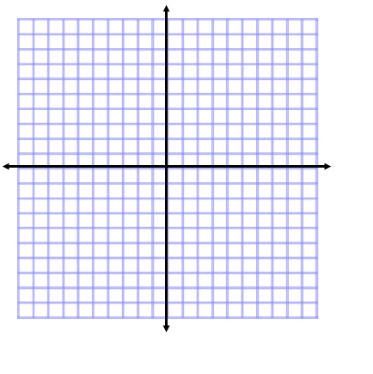

c) Sketch the graph for the function you determined in part a).

d) Determine the domain and range for this situation.

e) Identify any assumptions you made in modelling this situation mathematically.

Example 3: Your Turn
At a children’s music festival, the organizers are roping off a rectangular area
for stroller parking. There is 160 m of rope available to create the perimeter.

a) Write a quadratic function in standard form to represent the area for the stroller parking.

b) What are the coordinates of the vertex? What does the vertex represent in this situation?

c) Sketch the graph for the function you determined in part a).

d) Determine the domain and range for this situation.

e) Identify any assumptions you made.

Assignment Page 174 1, 2b, 3b, 5ad, 8, 10ad, 11bce, 12 all, 14a, 16

