**Unit 2- Trigonometry___________________________________________**

**Lesson 2.3: The Sine Law**

Specific Outcome 3. Solve problems, using the cosine law and sine law, including the ambiguous case.

Right triangle trigonometry can be used to solve problems involving right triangles. However, many interesting problems involve non-right triangles. In this lesson, you will use right triangle trigonometry to develop the *Law of Sines*. The law of sines is important because it can be used to solve problems involving non-right triangles as well as right triangles.

**The Sine Law**

The activity demonstrates a formula that can be used to solve for angles or sides of a triangle when the triangle is *not* a right triangle. The formula that we just explored is called the **sine law** or the **law of sines**.

**Definition:** The **sine law** can be used for any triangle in which *________________________________________*. The _______________ of the triangle are in the same proportion as the ____________________ of the angles opposite the sides. For , for example:

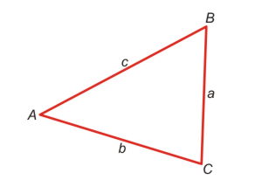



The easiest way to understand how to do Sine Law questions is to do a few examples:

**Example1**:

In triangle ABC, <B = 82.6 °, a = 53m, and <C = 25.9°. Solve for the length of “b”

We can also use the sine law to solve for an unknown angle:

**Example 2:**

Solve for :

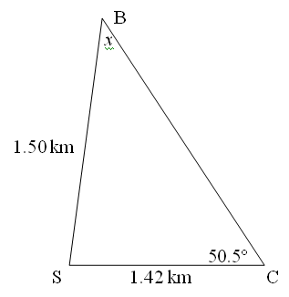

**Example 3:**

A bridge must be built to cross a river from point *A* to point *B* on the opposite bank. The surveyor marks a line along the ground from point *B* to point *C* that is 9.5 m long. The surveyor then measures that <*B* is 68° and <*C* is 75°. Find the length of the bridge (*AB*):

**Example 4:**

In , <*R* = 24°, <*S* = 61°, and *t* = 200 m. Find the area of the triangle.

**The Sine Law – the Ambiguous Case**

**T**here are occasions when the information we are given cannot be used in conjunction with the sine law in order to obtain a solution. There may also be a scenario in which it appears as though there is a solution but that requires further examination. This situation may occur when we are given two sides of the triangle and an angle *that is not located in between the two sides* (this is known as the *non-included angle*). This is sometimes known as an SSA triangle.

**Definition:** When two sides and the non-included angle of a triangle are given, the triangle *______________________________________*. It is possible that *______________________________* with the given measurements. This is known as the **_______________________.**

**Example 5:**

Draw a triangle in which one of the sides has a length of 4 cm and another side has a length of 3 cm. The angle opposite the 3 cm side is .

**Conditions for the Ambiguous Case**

In  you are given  and side *a* and *b*, as shown below:

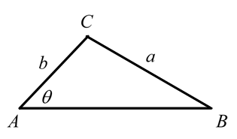 If ***a* > *b*** there is **one solution** and **one triangle**

If ***a* < *b*** then:

If  there are **no solutions** and there is **no triangle**

If  there is **one solution** and there is **one triangle (a right angle triangle)**

If  there are **two solutions** and there are **two triangles**

It should be noted that the above situations are only true if  is . If  is either greater than or equal to  then there is either one solution or no solutions.

**Example 6:**

In  solve for the unknown side, *c*, given that .

Assignment page 108 questions: 2, 3, 4b, 5d, 6,8,11,13,15