4.1 Graphical Solutions of Quadratic Equations

Specific Outcome: Solve, algebraically and graphically, problems that involve systems of linear-quadratic and quadratic-quadratic equations in two variables.

Definitions:
Roots:

Quadratic Equation:

Zero of a Function:

Example 1: Quadratic Equations With One Real Root
What are the roots of the equation –x² + 8x – 16 = 0?

Your Turn: Determine the roots of the quadratic equation x² – 6x + 9 = 0.

Example 2: Quadratic Equations With Two Distinct Real Roots
The manager of Jasmine’s Fine Fashions is investigating the effect that raising or lowering dress prices has on the daily revenue from dress sales. The function R(x) = 100 + 15x – x² gives the store’s revenue R, in dollars, from dress sales, where x is the price change, in dollars. What price changes will result in no revenue?

Your turn: The manager at Suzie’s Fashion Store has determined that the function
R(x) = 600 – 6x² models the expected weekly revenue, R, in dollars, from
sweatshirts as the price changes, where x is the change in price, in dollars.
What price increase or decrease will result in no revenue?

Example 3: Quadratic Equations With No Real Roots
Solve 2x² + x = –2 by graphing.

Your Turn: Solve 3m² – m = –2 by graphing.

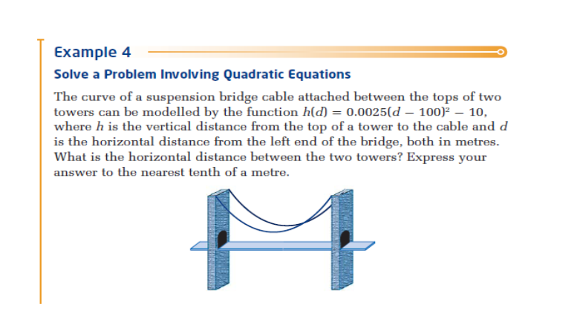

Solution
Step 1: Solve the equation for its roots when h(0) = 0.

Step 2: Subtract the two roots to determine the distances between the two.

-Key Ideas
1.One approach to solving a quadratic equation of the form ax² + bx + c = 0, a ≠ 0, is to graph the corresponding quadratic function, f (x) = ax² + bx + c. Then, determine the x-intercepts of the graph.

The x-intercepts of the graph, or the zeros of the quadratic function, correspond to the solutions, or roots, of the quadratic equation.

2. The graph of a quadratic function can have zero, one, or two real x-intercepts.
Therefore, the quadratic function has zero, one, or two real zeros, and correspondingly the quadratic equation has zero, one, or two real roots. 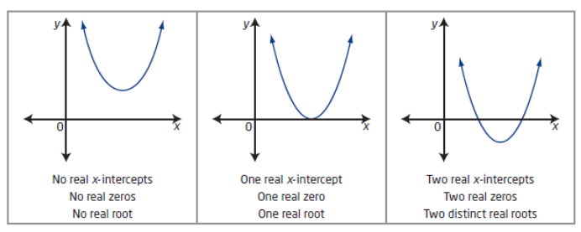

Assignment: Pg 215-217 #'s 1,2,4 acf,6,10,15

