4.4 The Quadratic Formula
Investigate the Quadratic Formula
By completing the square you can develop a formula that allows you to solve any quadratic equation in standard form
1. Describe the steps in the following example of the quadratic formula.
2x² +7x + 1 =0

Quadratic Formula

2 Repeat the steps using the general quadratic equation in standard form ax² + bx + c = 0.

3. a) Will the quadratic formula work for any quadratic equation
written in any form?

b) When do you think it is appropriate to use the quadratic formula
to solve a quadratic equation?

c) When is it appropriate to use a different method, such as graphing
the corresponding function, factoring, determining the square root,
or completing the square? Explain.
4. What is the maximum number of roots the quadratic formula will
give? How do you know this?

5. Describe the conditions for a, b, and c that are necessary for the
quadratic formula, to result in only one possible root.

6. Is there a condition relating a, b, and c that will result in no real
solution to a quadratic equation? Explain.

You can determine the nature of the roots for a quadratic equation by the value of the
.The discriminant is the expression located under the radical sign in the quadratic formula.

• When the value of the discriminant is positive, , there are distinct real roots.

• When the value of the discriminant is , , there is distinct real root, or two equal real roots.

• When the value of the discriminant is , , there are real roots.

You can see that this is true by testing the three different types of values
of the discriminant in the quadratic formula.

Example 1: Use the Discriminant to Determine the Nature of the Roots
Use the discriminant to determine the nature of the roots for
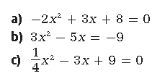
each quadratic equation. Check by graphing.

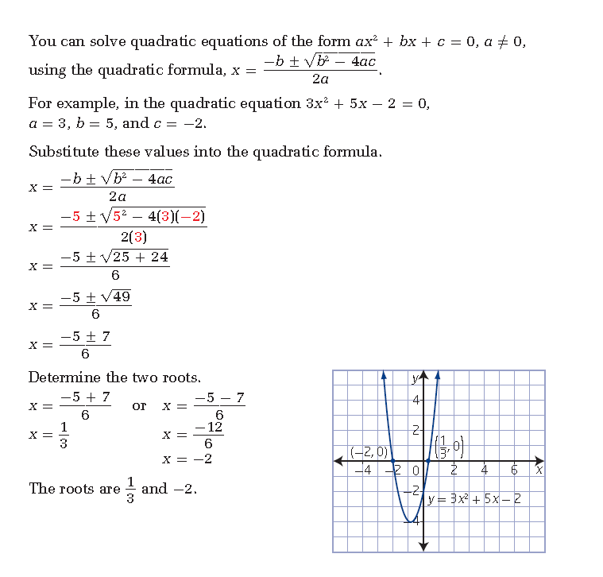

Select a Strategy to Solve a Quadratic Equation
a) Solve 6x2 - 14x + 8 = 0 by
i) graphing the corresponding function
ii) factoring the equation
iii) completing the square
iv) using the quadratic formula
b) Which strategy do you prefer? Justify your reasoning.

a) ii. Factoring

iii.Completing the Square

iv. Quadratic Formula

Which do you prefer? Why? When would you use each method?

Example 4: Applying the Quadratic Formula
A picture measures 30 cm by 21 cm. You crop the picture by removing strips of the same width from the top and one side of the picture. This reduces the area to 40% of the original area. Determine the width of the removed strips.

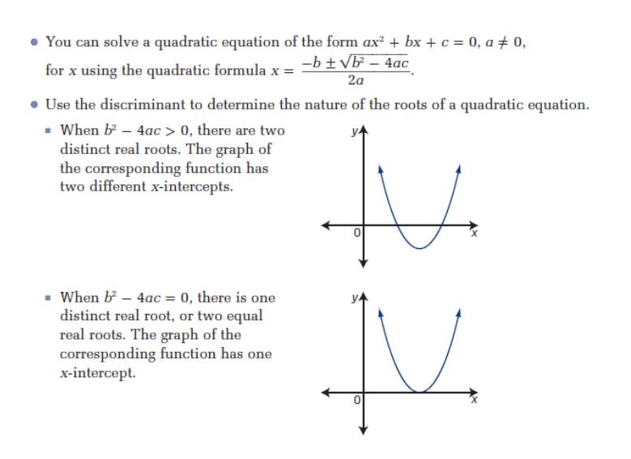
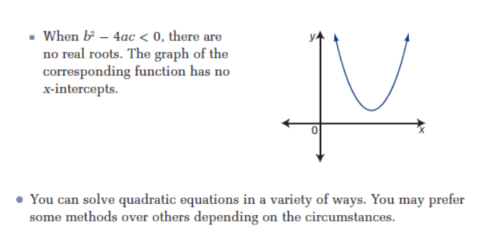
Assignment: Pg 254-257 #'s 1,2&5 (b,d,f), 9,10,12,15, 22,23

