**Unit 2- Trigonometry___________________________________________**

**Lesson 2.4: The Cosine Law**

Specific Outcome 3. Solve problems, using the cosine law and sine law, including the ambiguous case.

Mathematicians have found that the sine law is exceedingly useful when looking for the lengths of sides or the angles of certain triangles with no right angles. Unfortunately, the sine law does not work all of the time. Observe the following question:

In , . Find *b*.

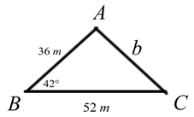If we look at the picture we will notice that, when we set up the sine ratios, we don’t have enough information to solve for anything at all because each ratio has an unknown (indicated by the question marks in bold):



**The Law of Cosines**

**Definition:** The **cosine law** is used to solve triangles that are not right angles. The *cosine law* can be used in two situations:

1. When you know _____________________________________ (this angle is known as the *included angle*) and wish to find ____________________;
2. When you know _______________________ of a triangle and wish to find __________________________.

Because the *cosine law* can be used to find either the angle or the length of a side, it may be re-arranged to look two different ways:

To find the **angle A:** To find the **length of a side *a*:**

Because we are not always asked to look for <*A* or *a*, the formula can be re-arranged so that the values we are looking for are appropriately isolated. These formulae look as follows:

To find **angle B:** To find the **length of a side *b*:**

To find **angle C:** To find the **length of a side *c*:**

**Example 1:**

In , . Find *b*.

**Example 2:**

In , . Find <*A*, to the nearest tenth of a degree.

**Example 3:**

To find the distance across a marsh, a surveyor locates point *C* as shown in the diagram below. If <*C* is , how far is it across the marsh?

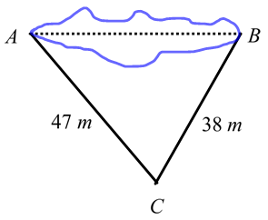

**Example 4:**

Two trains leave at the same time from the same point. One train travels at a speed of 85 km/h. The other train travels at a speed of 100 km/h. If the angle between the two trains is 54°, how far apart are the two trains after 2 hours?

**The Law of Sines and the Law of Cosines – a Summary**

It may sometimes be difficult to determine which formula to use: *sine law* or *cosine law*. It is probably helpful to remember the following:

* If you are given **two** **angles**, you will always use **sine law**
* If you are given **one angle** and are **looking for an angle**, you will always use **sine law**
* If you are given **one angle** and are **looking for the side opposite the known angle** you will always use **cosine law**
* If you are given **no angles**, you will always use **cosine law**
* When in doubt, try to use **sine law**. If none of the ratios work, try using cosine law next.

**Assignment p. 119 questions: 1 a,c, 2b,d, 3a, 5,7,10, 11,18,19**