**Unit 5- Absolute and Reciprocal Functions and Equations ________________**

**Lesson 7.4 Reciprocal Functions**

Specific Outcome 11. Graph and analyze reciprocal functions (limited to the reciprocal of linear and quadratic functions).

**Definition:**

Reciprocal:

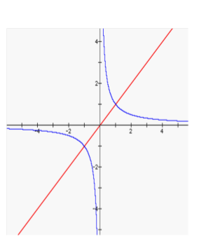

Invariant Point:

Asymptote:

Vertical Asymptote:

Horizontal Asymptote:

**Example 1: Compare the Graphs of a Function and Its Reciprocal**

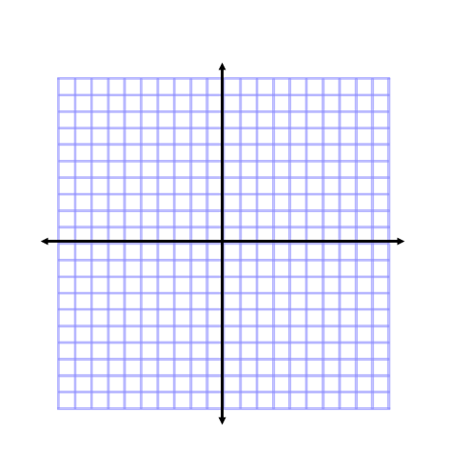Sketch the graphs of *y* = *f* (*x*) and its reciprocal function, where*f* (*x*) = *x*. Examine how the functions are related.

|  |  |  |
| --- | --- | --- |
| **Characteristic** | **y=x** |  |
| Domain |  |  |
| Range |  |  |
| End Behaviour |  |  |
| Behaviour at x=0 |  |  |
| Invariant points |  | |

**Example 2: Graph the Reciprocal of a Linear Function**

Consider *f* (*x*) = 2*x* + 5.

**a)** Determine its reciprocal function  .

**b)** Determine the equation of the vertical asymptote of the reciprocal function.

**c)** Graph the function *y* = *f* (*x*) and its reciprocal function  .

Describe a strategy that could be used to sketch the graph of a

reciprocal function.



**Example 3:Graph the Reciprocal of a Quadratic Function**

Consider *f* (*x*) = *x*2 **–** 4.

1. What is the reciprocal function of *f* (*x*)?

**b)** State the non-permissible values of *x* and the equation(s) of the

vertical asymptote(s) of the reciprocal function.

**c)**What are the *x*-intercepts and the *y*-intercept of the reciprocal function?

**d)** Graph the function *y* = *f* (*x*) and its reciprocal function 



Your Turn: Consider *f* (*x*) = *x*2 + *x* **–** 6.

**a)** What is the reciprocal function of *f* (*x*)?

**b)** State the non-permissible values of *x* and the equation(s) of the

vertical asymptote(s) of the reciprocal function.

**c)** What are the *x*-intercepts and the *y*-intercept of the reciprocal

function?

**d)** Sketch the graphs of *y* = *f* (*x*) and its reciprocal function 

**Example 4: Graph *y* = *f*(*x*) Given the Graph of** 

**a**

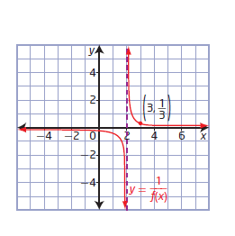The graph of a reciprocal function of the form  ,

where *a* and *b* are non-zero constants, is shown.

1. Sketch the graph of the original function, *y* = *f* (*x*).



1. Determine the original function,*y* = *f* (*x*).

Your Turn: The graph of a reciprocal function of the form



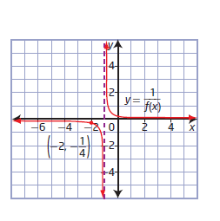where *a* and *b* are non-zero constants, is shown.

1. Sketch the graph of the original function, *y* = *f* (*x*).



1. Determine the original function *y* = *f* (*x*).

Homework page 403: 1 b,d, 2b,c, 4, 5b,d, 7a,b,8a,b,9, 10, 12, 16