**Unit 6- Systems of Equations and Inequalities ________________**

**Lesson 8.1 Solving systems of equations graphically**

Specific Outcome 1. Solve, algebraically and graphically, problems that

involve systems of linear-quadratic and quadratic-quadratic equations in two variables.

**Definitions:**

**System of linear- quadratic equations**

**System of quadratic- quadratic equations**

**Example 1: Relate a system of equations to a context**

Blythe Hartley, of Edmonton, Alberta, is one of Canada’s best spring board divers. She is doing training dices from a 3-m springboard. Her coach uses video analysis to plot her height above the water.

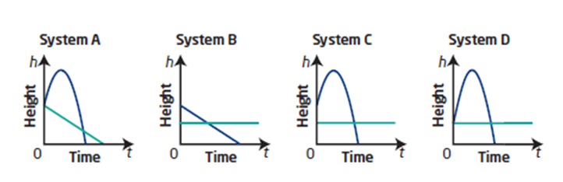

1. Which system could represent the scenario? Explain your choice and why the other graphs do not model this situation.
2. Interpret the point(s) of intersection in the system you choose.

**Your Turn:**

Two divers start their dives at the same time. One diver jumps from a 1-m springboard and the other jumps from a 3-m springboard. Their heights above the water are plotted over time. 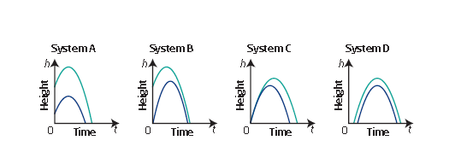

**a)** Which system could model this scenario? Explain your choice.

Tell why the other graphs could not model this situation.

**b)** Explain why there is no point of intersection in the graph

you chose.

**Example 2: Solve a System of linear-Quadratic Equations Graphically**

**a)** Solve the following system of equations graphically:

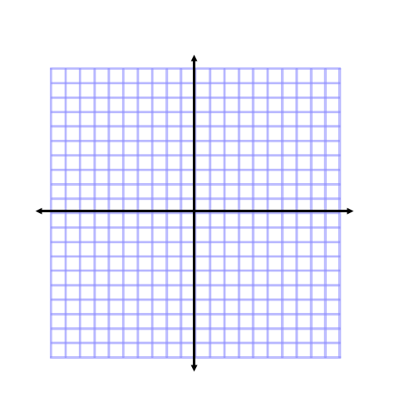 4*x* **–** *y* + 3 = 0

2*x*2 + 8*x* **–** *y* + 3 = 0

**b)** Verify your solution.



**Your Turn:**

Solve the system graphically and verify your solution.

*x –* *y* + 1 = 0

*x*2 *–* 6*x* + *y* + 3 = 0



**Example 3:** **Solve a System of Quadratic-Quadratic Equations Graphically**

**a)** Solve:

2*x*2 **–** 16*x* **–** *y* = **–**35

2*x*2 **–** 8*x* **–** *y* = **–**11

**b)** Verify your solution.

**Your Turn:**

Solve the system graphically and verify your solution.

2*x*2 + 16*x* + *y* = *–*26

*x*2 + 8*x –* *y* = *–*19

**Example 4: Apply a System of Linear-Quadratic Equations**

Engineers use vertical curves to improve the comfort and safety of roadways.Vertical curves are parabolic in shape and are used for transitions from one straight grade to another. Each grade line is tangent to the curve.



There are several vertical curves on the Trans-Canada Highway through the Rocky Mountains. To construct a vertical curve, surveyors lay out a grid system and mark the location for the beginning of the curve and the

end of the curve.

Suppose surveyors model the first grade line for a section of road with the linear equation *y* = -0.06*x* + 2.6, the second grade line with the linear equation *y* = 0.09*x* + 2.35, and the parabolic curve with the quadratic equation

*y* = 0.0045*x*2 + 2.8.



**a)** Write the two systems of equations that would be used to determine the coordinates of the points of tangency.

**b)** Using graphing technology, show the

surveyor’s layout of the vertical curve.

**c)** Determine the coordinates of the points of tangency graphically, to the nearest hundredth.

**d)** Interpret each point of tangency.

**Your Turn:**

Another section of road requires the curve shown in the diagram.

The grade lines are modelled by the equations *y* = 0.08*x* + 6.2 and

*y* = -0.075*x* + 6.103 125. The curve is modelled by the equation

*y* = -0.002*x*2 + 5.4.



a) Write the two systems of equations to use to determine the

coordinates of the beginning and the end of the vertical curve

on a surveyor’s grid.



b) Using graphing technology,

show the surveyor’s layout of the

vertical curve.

c) Determine the coordinates of

each end of this vertical curve,

to the nearest hundredth.

**Example 5:**

Suppose that in one stunt, two Cirque du Soleil performers are launched toward each other from two slightly offset seesaws. The first performer is launched, and 1 s later the second performer is launched in the opposite direction. They both perform a flip and give each other a high five in the air. Each performer is in the air for 2 s. The height above the seesaw versus time for each performer during the stunt is approximated by a parabola as shown. Their paths are shown on a coordinate grid.



1. Determine the system of equations that models the performers’ height during the stunt.



**b)** Solve the system graphically using technology.

**c)** Interpret your solution with respect to this situation.

**Your Turn:**

At another performance, the heights above the seesaw versus time

for the performers during the stunt are approximated by the parabola

shown. Assume again that the second performer starts 1 s after the

first performer. Their paths are shown on a coordinate grid.

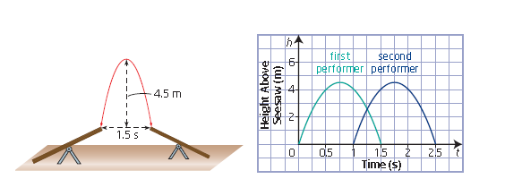

**a)** Determine the system of equations that models the performers’ height during the stunt.



**b)** Solve the system graphically using technology.

**c)** Interpret your solution with respect to this situation.

Assignment :Pg's 435- 439 #'s 1,2,3,4&5 odd letters, 8, 9,11,19,20