Unit 6- Systems of Equations and Inequalities ________________

Lesson 9.1 Linear Inequalities in Two Variables

Specific Outcome 7. Solve problems that involve linear and quadratic inequalities in two variables.

Linear Inequalities can be represented in one of the following 4 forms:

where A, B, and C are real numbers.
An inequality in the two variables x and y describes a region in
the Cartesian plane.

Definitions:

Solution Set (Solution region):

: The line related to the liner equality ____________________ , which
divides the Cartesian plane into _____ solution regions.

• may or may not be part of the solution region
• drawn as a solid line and included in the solution region if the inequality involves ≤ or ≥
• drawn as a dashed line and not included in the solution region if the inequality involves < or >

Test Point:
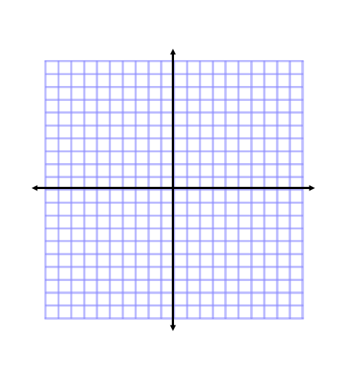

Example 1:Graph a Linear Inequality of the Form Ax + By ≤ C
a) Graph 2x + 3y ≤ 6.
b) Determine if the point (–2, 4) is part of the solution.
Method 1: Solve for y in terms of x

Method 2: Use the Intercepts

After graphing the boundary, select a test point form each region to determine which contains the solution:

b) Determine if the point (-2,4) is in the solution region.

Your Turn:
- Graph 4x +2y ≥ 10
- Determine if the point (1,3) is part of the solution

Example 2: Graph a Linear Inequality of the form Ax + By > C

10x -5y >0

Your Turn:
a) Graph 5x – 20y < 0.

Example 3: Write an Inequality Given its Graph
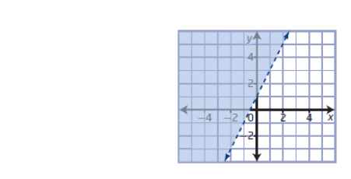

Your Turn:
Write an inequality to represent the graph.
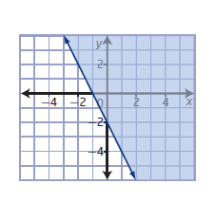

Example 4: Write and Solve an Inequality

Suppose that you are constructing a tabletop using aluminum and glass. The most that you can spend on materials is $50. Laminated safety glass costs $60/m2, and aluminum costs $1.75/ft. You can choose the dimensions of the table and the amount of each material used. Find all possible combinations of materials sufficient to make the tabletop.

Your Turn:
Use technology to find all possible combinations of tile and stone that can be used to make a mosaic. The tile costs $2.50/ft², stone costs $6/kg, and the budget for the mosaic is $150.

Assignment :Pg's 472 #1a,b, 2b, 3 a,c,e, 4a, 5a, 8 a,c, 9, 11, 12, 15

