**Unit 6- Systems of Equations and Inequalities ________________**

**Lesson 9.2 Quadratic Inequalities in One Variable**

Specific Outcome 7. Solve problems that involve quadratic inequalities in one variable.

**Quadratic Inequalities can be represented in one of the following 4 forms:**

* **ax2 + bx + c < 0**
* **ax2 + bx + c ≤ 0**
* **ax2 + bx + c > 0**
* **ax2 + bx + c ≥0**

where *a*, *b*, and *b* are real numbers and a ≠ 0.

**Example 1:** Solve a Quadratic Inequality of the Form *ax*2 + *bx* + *c* ≤ 0, *a* > 0

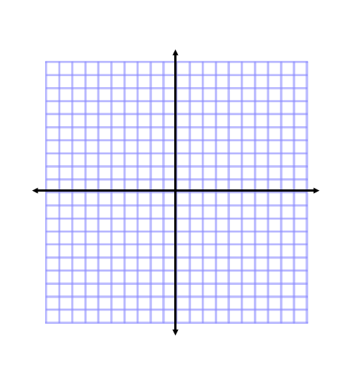Solve *x*2 – 2*x* – 3 ≤ 0.

**Method 1: Graph the corresponding function: f(x) = ____________________**

The parabola lies on the x- axis at x= and x=

The graph lies _______ the x-axis between these values. Therefore, the solution set is all real values between

or

**Method 2: Roots and test points**

Solve the related equation _______________________ to find the roots. Then, use a number line and test points to determine the intervals that satisfy the inequality.

The x axis is divided into three intervals by the roots of the equation, choose one test point from each of the regions, and then substitute into the quadratic inequality to see whether it satisfies the inequality.

Use a table to organize the data

|  |  |  |  |
| --- | --- | --- | --- |
|  |  |  |  |
|  |  |  |  |
|  |  |  |  |
|  |  |  |  |

The solution set is:

**Method 3: Case Analysis**

Factor the quadratic expression to rewrite the inequality as ( )( ) ≤ 0

The product of two factors is negative when the factors have different signs. There are two ways this can happen:

Case 1

Case 2

**Your Turn:**

Solve x2 – 10x + 16 ≤ 0 using two different methods.

**Example 2: Solve a Quadratic Inequality of the Form ax2 + bx +c < 0, a< 0**

Solve –*x*2 + *x* + 12 < 0.

**Method 1: Roots and Test Points**

|  |  |  |  |
| --- | --- | --- | --- |
|  |  |  |  |
|  |  |  |  |
|  |  |  |  |
|  |  |  |  |

**Method 2: Sign analysis**

**Your Turn:**

Solve –x2 + 3x + 10 < 0 using two methods

**Example 3:** **Quadratic Inequality in One Variable**

**Solve 2x2 – 7x > 12**

|  |  |  |  |
| --- | --- | --- | --- |
|  |  |  |  |
|  |  |  |  |
|  |  |  |  |
|  |  |  |  |

**Your Turn:**

Solve x2 – 4x > 10

**Example 4: Write and Solve an Inequality**

If a baseball is thrown at an initial speed of 15 m/s from a height of 2 m above the ground, the inequality -4.9*t2* + 15*t* + 2 > 0 models the time, *t*, in seconds, that the baseball is in flight. During what time interval is the baseball in flight?

**Your Turn:**

Suppose a baseball is thrown from a height of 1.5 m. The inequality -4.9*t*2 + 17*t* + 1.5 > 0 models the time, *t*, in seconds, that the baseball is in flight. During what time interval is the baseball in flight?



Assignment :Pg's 484 1-4 a,c, 5-7 a,c, 9 a,c, 10, 12, 13