Unit 6- Systems of Equations and Inequalities ________________

Lesson 9.3 Quadratic Inequalities in Two Variables

Specific Outcome 7. Solve problems that involve linear and quadratic inequalities in two variables.

Example 1: Graph a Quadratic Inequality in Two Variables With a < 0

- Graph y < –2(x – 3)² + 1.
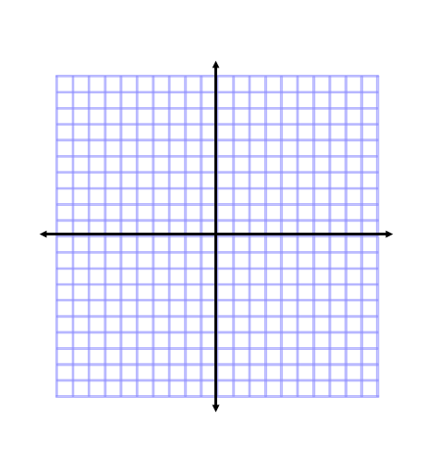

- Determine if the point (2, –4) is a solution to the inequality.

Example 1 : Your Turn

- Graph y > (x – 4)² – 2.

b) Determine if the point (2, 1) is a solution to the inequality.
Example 2: Graph a Quadratic Inequality in Two Variables With a > 0

Graph y ≥ x² – 4x – 5.

Example 2: Your Turn

Graph y ≤ –x² + 2x + 4.

Example 3: Determine the Quadratic Inequality That Defines a Solution Region
René, a journalist, is using a parabolic microphone as he covers the Francophone Summer Festival of Vancouver. Describe the region that René can cover with his microphone if the reflector has a width of 50 cm and a maximum depth of 15 cm.

Example 3: Your Turn
A satellite dish is 60 cm in diameter and 20 cm deep. The dish has a parabolic cross-section. Locate the vertex of the parabolic cross-section at the origin, and sketch the parabola that represents the dish. Determine an inequality that shows the region from which the dish can receive a signal.

Assignment page 496 questions 1a, 2a, 3, 6a,b, 7a, 8a, 9, 13

