Mitosis vs Meiosis

- Produces body cells (somatic) | - Produces sex cells (gametes)
- Occurs all through the body | - Occurs only in the Gonads
- Short Prophase | - Longer Prophase because of crossover
- 1 nuclear division / cycle (PMAT) | - 2 Nuclear divisions / cycle (PMAT I & II)
- Chromosome pairs replicate in S-phase | - Chromosome pairs replicate in S-phase (of Interphase I)
- 2 identical DAUGHTER cells are produced | - 4 un-identical TETRADS are produced
- Mitotic products are capable of further mitotic divisions | - Meiotic products are NOT capable of further divisions
- Genetic content of the Daughters is identical! | - Genetic content of Tetrads is scrambled due to crossing-over!
- Start with Diploid cells | - Start with diploid cells
- End up with Diploid cells! | - End up with Haploid cells!
- Products are cells necessary for growth & repair! | - Products are cells necessary for reproduction!

Alternation Of Generations!
Alternation of generations is when multi-cellular organisms alternate chromosome count throughout their lives where a portion of their life is when they are haploid and another is when they are diploid.
This is typical in plants such as ferns. In plants the haploid gamete producing generation is called a gametophyte, the diploid, spore-producing generation is called a sporophyte.
The sporophyte diploid individual produces spores as a result of meiosis. These spores do not function as gametes but instead undergo mitotic division to become another form called a gametophyte.
The gametophyte eventually produces gametes, which will fuse to form a diploid individual called a sporophyte, which begins the life cycle all over again.
In mosses and ferns the gametophyte (haploid individual) is dominant, meaning the moss or fern spends most of its time in this form.
Q. In the sentences above place n or 2n above the appropriate bold faced term

Alternation of Generations Diagram!
Gametophyte generation (haploid, n)

Sporophyte generation (2n)
Zygote (diploid, 2n)
Sperm (n)
Eggs (n)
Spores (n)

Gametogenesis
Spermatogenesis:
    - Production of sperm
    - Results in four haploid sperm from each diploid cell that undergoes meiosis.
- Undifferentiated cells called spermatogonia (diploid) undergo mitosis to produce daughter cells called primary spermatocytes.
- The primary spermatocytes undergo meiosis 1 to produce haploid secondary spermatocytes in a duplicated state.
- The sister chromatids of each chromosome separate from each other during meiosis II. The daughter cells are haploid spermatids.
- The spermatids will then eventually mature into functional sperm cells.
- Sertoli cells provide the cells with nourishment and molecular signals.

Oogenesis:
    - A normal baby girl had about 2 million primary oocytes in her ovaries.
    - By 7 years old about 300,000 remain, her body reabsorbed the rest.
- Primary oocytes have already entered meiosis I, but the nuclear division is arrested in a genetically programmed way.
      - Meiosis will resume in one oocyte at a time, starting with the first menstrual cycle.
      - Only about 400 to 500 oocytes will be released during her reproductive years.
      - Follicle – primary oocyte and nourishing cell layers around it.
- Stimulated by hormones the follicle continues to grow and the primary oocyte completes meiosis I. Resulting in the formation of a secondary oocyte (ends up with most of the cytoplasm) and the first of three polar bodies.
- Ovulation then occurs releasing the secondary oocyte and the polar body.
- Penetration of the sperm induces the secondary oocyte and the first polar body to complete meiosis II. There are now three polar bodies and one mature egg or ovum.
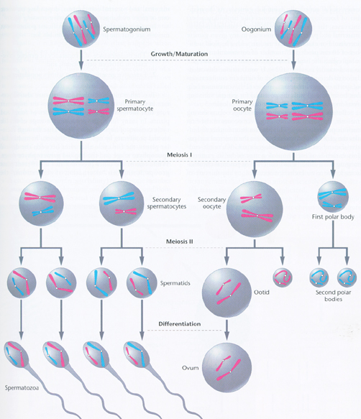
- As the sperm and egg nuclei fuse, their chromosomes restore the diploid number for a brand new zygote.

