**Muscles**

9.4

Pgs. 298 – 304

**Types of Muscles**

**Cardiac Muscle**

* Muscle that ______________________________________
* Found only in the heart
* Controlled by ______________________________________________________ (involuntary)

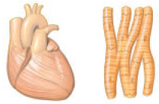

**Smooth Muscles**

* Found in the ______________________________________________________________________________________________________________
* Contraction is ______________________________________

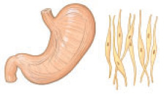

**Skeletal Muscle**

* Muscles that are ______________________________________________
* Under __________________________________________(voluntary)
* Attached to ________________________________________

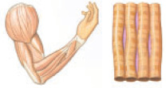

**Muscles**

* ____________________________________________, lengthen when ________________________________________
* Many skeletal muscles are arranged in _______________________________________________________ to make a joint move – called_________________________________________________.
* Flexor – muscle that must __________________________________
* Extensor – muscle that must ___________________________________________________

**Central Nervous System**

* Ensures that the biceps and triceps do not attempt to _______________________________________________
* _________________________________________that cause the triceps to contract are accompanied by ___________________________________________that cause the biceps to relax.

**Skeletal Muscles**

* Composed of several bundles of cells called _________________________.
* Muscle cells _________________________________________
* Fibres are enclosed within a membrane called ____________________________________________________
* Within muscle fibers are tiny ______________________________________________________

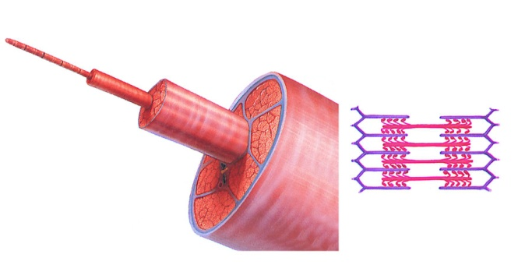

**Two Kinds of Myofilaments**

Composed of different contractile proteins

**Actin** – ______________________________________________

**Myosin** – ____________________________________________

* Overlap to produce a _________________________________appearance

**Sliding Filament Theory**

* Muscles cause movement ___________________________________
* Actin filaments ________________________________________
* __________________________move closer together when muscle fibers ___________________________________
* Knoblike projections on the __________________________________________form cross-bridges on receptor sites of the _____________________________________
* These cross-bridges ______________________________________________________________________________________________________________

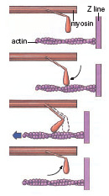

**Energy for Contraction**

* Energy for muscle contraction ________________________________
* In the ________________________________________________
* Rigor mortis – __________________________________________________________________________________________________________________

**Did You Know?**

Rigor mortis may last for up to 60 hours after death

C:\Documents and Settings\mcaine\Local Settings\Temporary Internet Files\Content.IE5\EN6NSZ01\MCj01981840000[1].wmf

**Muscle Contraction**

* A muscle twitch, ____________________________________, occurs when _______________________________________________________
* After the contraction phase, the ___________________________________________and the muscle begins to relax.
* Tetanus –_______________________________________________________ caused by sustained nerve impulses
* Muscle spasms – are caused by _______________________________________________________

(often caused by a pinched nerve)

**Motor Systems Injuries**

* Muscles require _______________________________________________________ to remain healthy
* Astronauts in zero gravity show significant ___________________________________________due to lack of muscle use and exercise
* Muscle, ligament or tendon injuries can be repaired using small incisions and an _______________________________________.

Questions #2-4 pg 304

C:\Documents and Settings\mcaine\Local Settings\Temporary Internet Files\Content.IE5\EN6NSZ01\MCj02925660000[1].wmf