**Quadratics Review**

1. Factor the following questions

**a)** 6*x*2 – 150 **b)** 0.81x2 – 0.25y2

**c)**  **d)** 2(x + 2)2 + 3(x + 2) -20

**e)** 25 (x+2)2 – 36 (y-3)2

1. Determine the x-intercept and the y-intercept for the equation y=-2(x + 3)2 +2
2. For the below graph, identify the following:

* 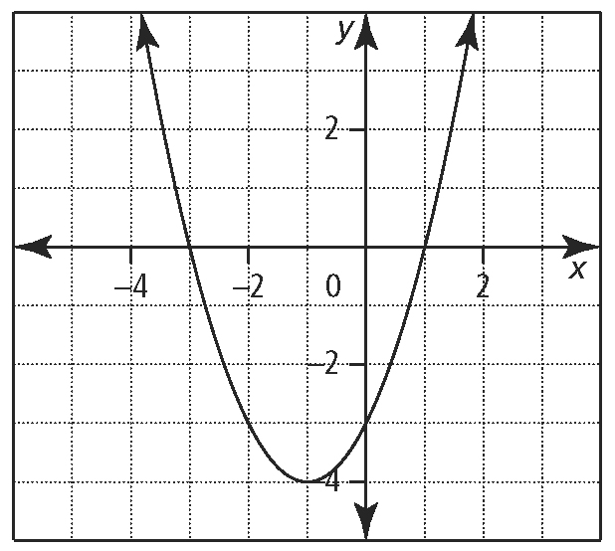the coordinates of the vertex are___________
* the equation of the axis of symmetry is ___________
* the *x*-intercept(s) _________and *y*-intercept__________
* the direction of opening____________
* the maximum or minimum value_______________
* the domain_____________ and range______________
* the quadratic function in Standard form

1. Determine the axis of symmetry for the following equation

y = 4x2 + 16x

1. Use the quadratic formula to solve each quadratic equation. Express answers as exact values in simplest form.

**a)** *x*2 – 10*x* + 23 = 0 **b)** 2*x*2 – 4*x* + 10 = 0

1. A triangle has a hypotenuse of 15. If one leg of the triangle is 3cm longer than the other leg, determine the lengths of both legs.
2. The length of a poster is three times its width. If the area of the poster is 2352 cm2, then what is the length of the poster?
3. Change the equation  into the form . What is the maximum of this equation?
4. If a graph has a maximum of ( 4 ,5 ) and has x-intercepts of (0, 0) and (8, 0) state the equation in the form 