Systems of Equations and Inequalities Review
- Solve each system of equations by substitution. Verify your solutions.
a) y = 2x + 1 b) y = −x² − 3x + 14
y = x² − 5x + 13 y = 3x² + 5x − 18

- Solve each system of equations by elimination. Verify your solutions.
- 6x² -3x = 2y – 5 b) 4x + y + 5 = x²
2x² = x + y - 4 x² − 5x −2y =0

- The perimeter of the right triangle is 60cm. The area of the triangle is 10y cm².

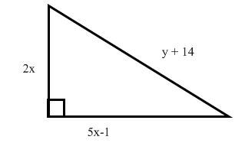
- Write a simplified expression for the triangle’s perimeter in terms of x and y.

- Write a simplified expression for the triangle’s area in terms of x and y.

- Write a system of equations and solve the system for x and y.

- Determine the inequality that corresponds to each graph.
- b)

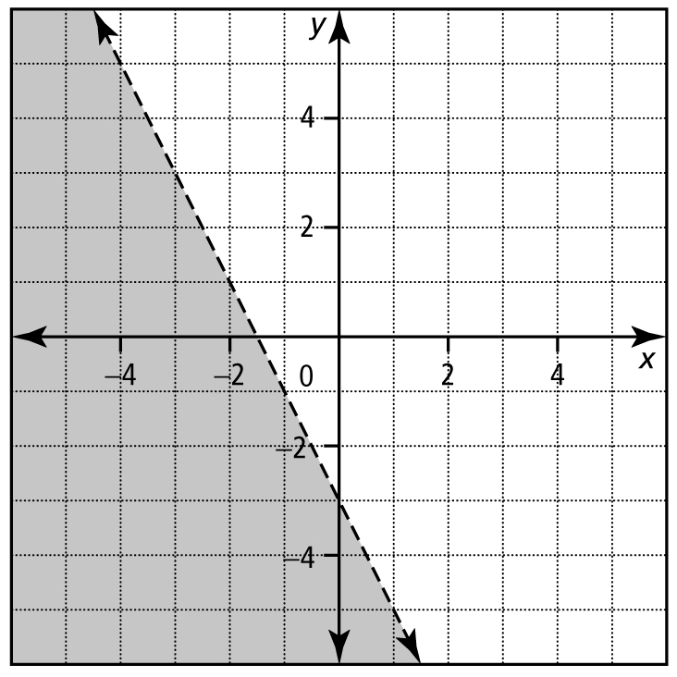
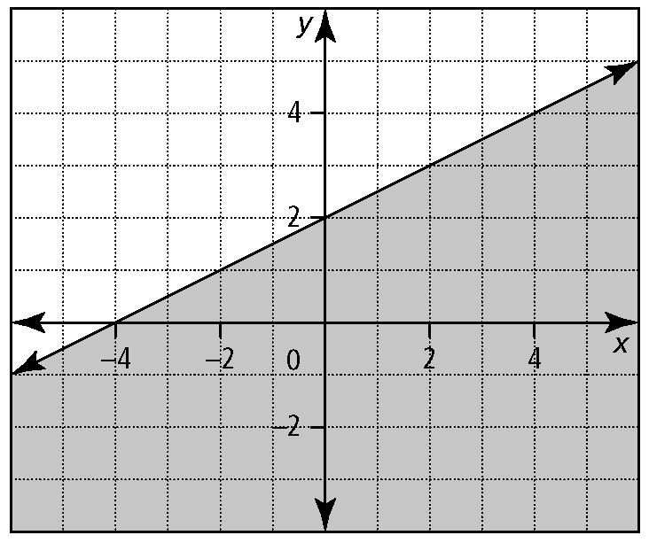

- For the graph of f (x) = −x² − 5x − 6, determine each solution.

- −x² − 5x − 6 = 0

- −x² − 5x − 6 > 0

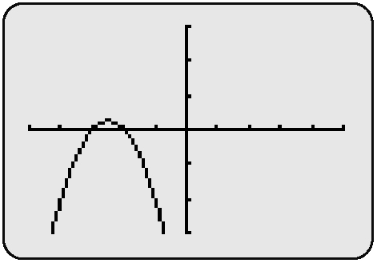
c) −x² − 5x − 6 < 0

4. Determine algebraically the solution to each inequality.
a) (x − 1)(x + 5) > 0 b) 4x² + 18 > 17x

5. Graph each quadratic inequality.
a) y < (x − 5)² + 4 b) 3y ≤ (x − 1)² + 6

