**The Immune System**

* The immune system is composed of
  + _________________________________
  + _________________________________
  + _________________________________
  + _________________________________
  + ________________________________
  + ________________________________

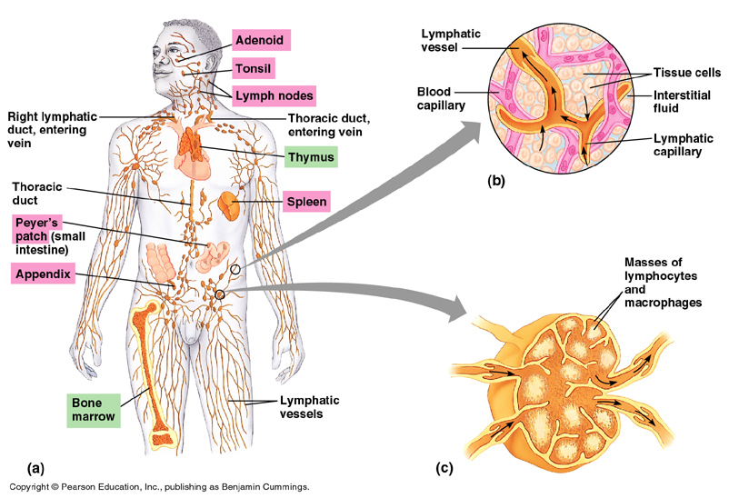

The Immune Response

* The immune response consists of both __________________________________________________________kinds of defense
* The non specific response acts in a _____________________________________against all invaders
* The specific response is very, very selective. It only responds to a ______________________________________________________________________________

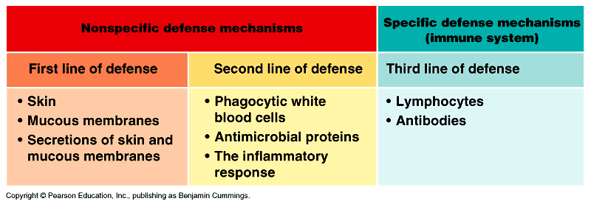

**Non-Specific Defenses Against Infection**

**First Line of Defense**

* ______________________- virtually impenetrable if unbroken
* _____________________________________________have fluids that contain lysozymes that destroy cell walls of bacteria
* Respiratory system has ________________________________________________
* _____________________________________secretes acidic gastric juices
* Normal _____________________________________________compete with invaders
* PHYSICAL LINE OF DEFENSE

**Second Line of Defense**

* Can be mobilized if the invader takes up residence within the body.
* ____________________________________________, or white blood cells, may engulf invading microbes or produce antibodies
* Nonspecific defence mechanisms rely mainly on the process of ______________________________________________________________________________

**Macrophages**

* When a foreign particle penetrates the skin through an injury, special leukocytes, known as________________________________, migrate from the blood into the tissues, where they form _______________________________________________________________
* They extend long protrusions, called________________________________, that attach to the surface of the invading microbe, ___________________________________________________

**Neutrophils**

* Another phagocytic response, white blood cells called neutrophils____________________________________________________________________________________________________________________________________________.
* Neutrophils squeeze out of ____________________________________________________________________________
* Neutrophils____________________________________________________________________.
* The remaining fragments of ______________________________________________________________________________are called pus

**Inflammatory Response**

* Initiated due to physical injury (nonspecific response)
* Results in __________________________________________________________________
* Injured cells emit ________________________________________________________________________

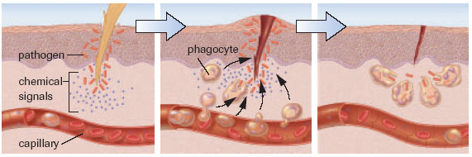

**Fever**

* When your body is invaded by infectious organisms (cold or flu), neutrophils and macrophages digest the invaders and _________________________________________________________
* This signals the _________________________________________________________________to a higher temperature –about 40 C making it difficult for harmful bacteria to survive
* A fever of above 41 C can become dangerous and human cells can not survive temperatures above 43 C

**White Blood Cells**

* There are five types of white blood cells
  + neutrophils
  + basophils
  + esinophils
  + lymphocytes
  + monocytes
  + ALL work together to attack general invaders within our body

**Specific Defense Against Infection**

**Third Line of Defense**

* __________________________________Immunity
* ________________________________________________________are plasma proteins that help defend against invading microbes by

_____________________________________________________________________________

_____________________________________________________________________________

_____________________________________________________________________________

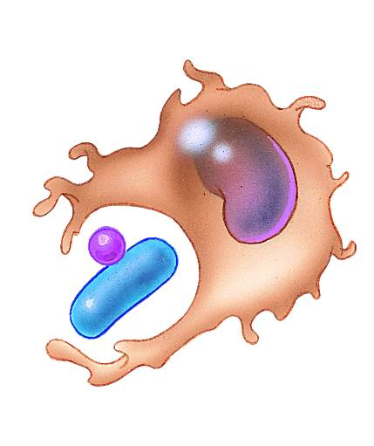

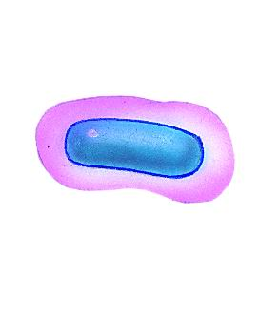



**Lymphocytes**

* ______________________________________are a type of white blood cell that produces _______________________________________________
* An antibody is a ____________________________________________________________________________
* All cells have special markers located on their cell membranes
* Cell membranes of bacterium and the outer coat of a virus contain many different _______________________________________

**Antigen – Antibody Reactions**

* Antibodies are ______________________________________________________________________________
* Antibodies are specific (example: an antibody produced against the influenza virus is not effective against HIV)

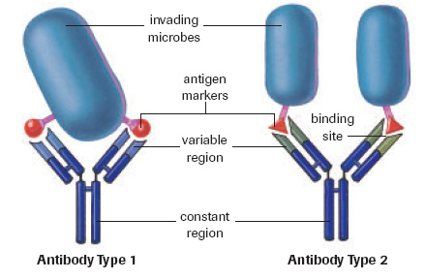

**T cells**

* There are four types of T-cells in our bodies
  + ____________________________________
  + ____________________________________
  + ____________________________________
  + _____________________________________

**Helper T-cell**

* Produced in the________________________________________________________________________, giving its name
* It travels in the blood acting as a sentry ______________________________________________________________________
* Once identified another ___________________________________________releases a chemical called _______________________________to call other WBC into action and __________________________________________________________

**Killer T-cells**

* If cells are infected by bacteria or viruses, the killer T will _____________________________________________________________________________
* A small sacrifice is made for the good of all
* Often involved when we ___________________________________________________________

**Suppressor T-cells**

* This cell signals the immune system to _______________________________________
* The helper T & suppressor regulates and maintains a balance of antibodies & responses to contain invaders by ______________________________________________________________

**Memory T-cells**

* Remain around to _____________________________________________________________if antigen re-enters body
* _____________________________________________________________________________ so that when you are infected again the immune response is immediate
* this forms the basis __________________________________________________
* Any ideas how vaccines would work?

**B cells**

* Are activated in the presence of _____________________________________________to begin making ________________________________________________________________________
* Antibodies only bind to ______________________________________and will______________________________________________________, making the invader easier for detection and engulfment by phagocytic cells (macrophages)

**Additional Help**

MCj02933920000[1]

* Antibiotics- _____________________________________________________
* Vaccinations- here we are given __________________________________________________________so that our body can create B and T cells that will help us out if we ever really do contract the disease.

**Production of Antibodies**

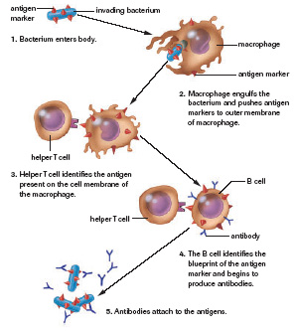

Things that can go wrong

**Immunodeficiency Diseases**

* + individuals are unable to __________________________________________________

**Autoimmune Diseases**

* + body has difficulty identifying ___________________________________________so body will attack its own cells
  + may be genetic or environmental
  + _______________________________________________________________________________________________________________________________________________

**Allergies**

* + Occur when your immune system mistakes harmless _____________ for harmful invaders.
  + hypersensitivity to environmental antigens
  + cause sneezing, runny nose, coughing, even anaphylactic shock

**Human Immunodeficiency Virus (HIV)**

* Outside layer is very similar to those of _______________________________________
* Virus enters by _____________________________________________________________
* Once inside of the t cells, it makes_____________________________________________, later rupturing, releasing the copies to infect____________________________________________.
* HIV attaches to sites on the membrane of cells.
* This prevents the from identifying it’sand then from making an .
* The virus hides inside the very cells that are supposed to be on the lookout for invading antigens.
* **Textbook Questions pg. 366 - #1-9**

