Trigonometry Review

1. An angle of 280°, when drawn in standard position, would
2. terminate in quadrant ______________.
3. have a reference angle of _________.
4. The terminal arm of angle θ passes through the point R(–15, –8).

**a)** Determine the distance from the origin to point R.

**b)** Determine the exact value of sin θ to the nearest tenth of a degree?

1. Determine the exact value of

a)cos 210° b)sin 45° c)tan 300°

1. Given cos θ = , the largest value of θ where 0° ≤ θ < 360° is _____ degrees
2. The point N(4, –8) is on the terminal arm of angle θ. What is the exact value of sin θ?
3. Solve the triangle by determining the unknown side and angles.

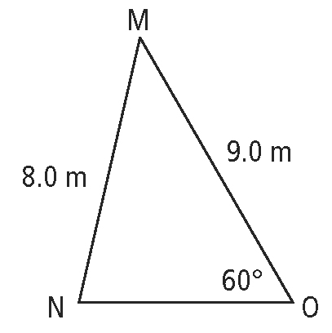

1. Determine the length of the unknown side and the measure of the unknown angles.

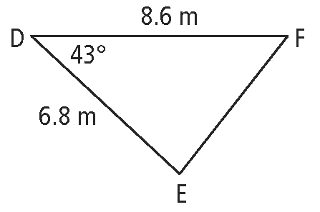

1. In the diagram, the length of y, to the nearest tenth of a centimetre, is _________.

