**Math 10C**

**Unit 4**

**Chapters 8 & 9**

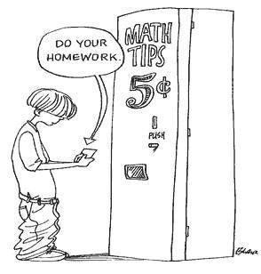

Name:

**9.1 Solving Systems of Linear Equations by Substitution**

**Activity:** In the following balance diagrams, each block is identical in mass.Each cone is identical in mass.

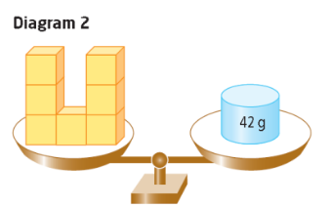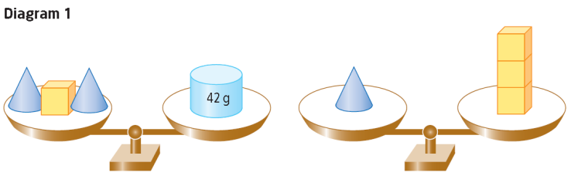

1. a) Describe how Diagram 2 relates to Diagram 1.
2. Describe how you could determine the mass of one block from Diagram 2. What is the mass of one block?
3. What is the mass of one cone? How did you determine your answer?
4. Write an equation for each balance scale in Diagram 1. Remember to state what your variables represent.
5. Write an equation for Diagram 2.
6. **Reflect and Respond** Use diagrams to explain how to determine the mass of a single pyramid and the mass of a single cylinder for the following scenario.

• Five pyramids and three cylinders have a mass of 44 g.

• Two pyramids have the same mass as one cylinder.

1. Use algebra to determine the mass of one pyramid, *p*, and the mass of one cylinder, *c*.
2. Describe a situation where using a diagram is less effective than using algebra.

The skill of substituting algebraic expressions is used regularly in math and science. The **substitution method** can provide a quick solution to a linear system.

**Example 1**

Solve the following linear system.



**Solution**

First, solve for *y* in 3*x* = *y* - 9.

Substitute 3*x* + 9 for *y* in 4*x* + 5*y* = 26.

4*x* + 5(3*x* + 9) = 26

Substitute -1 for *x* in 3*x* = *y* - 9.

**Steps for the Substitution Method**

**Step 1**: Solve one equation for one variable

**Step 2**: Substitute into the other equation and solve for the one variable.

**Step 3**: Substitute into an original equation and solve for the second variable.

**Example 2 Solve a System of Linear Equations by Substitution**

Admission to the 2009 Abbotsford International Airshow cost $80 for a car with two adults and three children. Admission for a car with two adults cost $50. Use algebra to determine the cost for one child and the cost for one adult. There was no charge for the vehicle or parking. Determine the admission prices.

**Solution**

**Example 3 Isolate a Variable Before Solving by Substitution**

At a dance recital, there were 220 people. Tickets cost $9 for an adult and $6 for a child. The dance school collected $1614 in ticket sales. How many adults and how many children attended the recital?

**Solution**

**Your Turn**

Solve the following linear systems algebraically using substitution. Check your solution.



**Homework:** Page 474 #1-4, 6-7, 9-14, 16, 17

**9.2 Solving Systems of Linear Equations by Elimination**

You can solve a system of linear equations using the **elimination method**. To do this, a variable in both equations must have thesame or opposite coefficient. It is often necessary to multiply oneor both equations by a constant.

For example, solve the following linear system:

In order to eliminate variable *a*, you need to multiply the first equation by -2. Multiply the second equation by 3. Now, when we add the terms together the variable *a* will be eliminated ().

**Example 1 Solve a System of Linear Equations by Elimination**

Connor downloaded two orders of games and songs. The first order consisted of five games and four songs for $26. The second order consisted of three games and two songs for $15. All games cost the same amount, and all songs cost the same amount. Write a system of linear equations. Then, determine the cost of one song and the cost of one game.

**Solution**

**Your Turn**

A group of people bought tickets for a University of Alberta basketball playoff game. Two student tickets and six adult tickets cost $102. Eight student tickets and three adult tickets cost $114. What was the price for a single adult ticket? What was the price for a single student ticket?

**Example 2**

A crop farmer has contracted with the Pacific Carbon Trust (PCT) to convert some of her cropland into woodland. This will create a carbon sink that is used to offset the production of carbon resulting from her farm activities. The farmer has 500 ha of cropland. She earns approximately $220/ha from the crops. The PCT will pay her $60 for every hectare of cropland that she converts. She would like a minimum revenue of $90 800 that year. Using the elimination method, determine the number of hectares that she needs to convert to woodland. How many hectares of cropland would be left?

**Solution**

Let *c* represent the number of hectares of cropland.

Let *w* represent the number of hectares of woodland.

Organize the information in a table.

|  |  |  |  |
| --- | --- | --- | --- |
| Type of  Land | Revenue Generated  Per Hectare($) | Number of  Hectares | Revenue  Generated ($) |
| Cropland | 220 | *c* |  |
| Woodland | 60 | w |  |
| Total |  |  | 90 800 |

Write an equation to show the total number of hectares.

Write an equation to determine the revenue created.

Determine which variable to eliminate. One strategy is to examine each variable in both equations. Then, identify the coefficient, other than 1, that is closest to zero.

*c* + *w* = 500

220*c* + 60*w* = 90 800

Multiply the first equation by -60 so that there are opposite terms.

Add the two equations to eliminate the *opposite terms*.

Solve for the remaining variable, *w*, by substitution.

Check:

**Your Turn**

During lunch, the cafeteria sold a total of 160 muffins and individual yogurts. The price of each muffin is $1.50. Each container of yogurt is $2.00. The cafeteria collected $273.50. Set up and solve a linear system in order to determine the number of muffins and the number of yogurts sold.

**Example 3**

The perimeter of a rectangular garden is 17.00 m. Triple the length is 2.46 m longer than five times the width. Sketch and label a diagram. Create a system of linear equations to determine the dimensions of the rectangle. Solve the system using elimination.

**Solution**

**Your Turn**

A rectangular parking pad for a car has a perimeter of 12.2 m. The width is 0.7 m shorter than the length. Use a linear system to determine the dimensions of the pad.

**Homework:** Page 488 #1-13, 21

**9.3 Solving Problems Using Systems of Linear Equations**

**In groups of 2-3, discuss a method to solve the problems and then solve them.**

1. A sample price for a hybrid car is $28 000. The price of a similar car powered by gas is $21 500. The hybrid vehicle costs $0.18 per kilometre to operate. The non- hybrid vehicle costs $0.22 per kilometer to operate.
2. Write a linear system of equations that models the total cost for each vehicle in relation to the distance travelled.
3. Solve the linear system using a graphing calculator. After how many kilometers will the hybrid car be more cost efficient?
4. Solve the same system of equations from part a) algebraically. Use either substitution or elimination. Explain why you chose the method you did.
5. At the Métis People Pavilion, visitors can enjoy bannock and buffalo stew. A recent sale of three orders of stew and two orders of bannock cost $13.50. A second sale of four orders of stew and five orders of bannock cost $21.50.Use a system of linear equations to determine the price of one order of bannock and the price of one order of stew. **Solve the system algebraically**.

**Homework:** Page 498 #1-3, 5-9, 12

**8.1 Systems of Linear Equations and Graphs**

**Investigate Ways to Represent Linear Systems**

How can you compare and analyse cell phone plan options?

* Plan A costs $0.30 per minute.
* Plan B costs $15 one time plus $0.10 per minute.

1. Create tables of values to show the cost of each option for up to 100 min. Use intervals of 10 min. Graph the data from both tables.

|  |  |  |  |  |  |  |  |  |  |  |  |  |
| --- | --- | --- | --- | --- | --- | --- | --- | --- | --- | --- | --- | --- |
|  |  |  |  |  |  |  |  |  |  |  |  |  |
|  |  |  |  |  |  |  |  |  |  |  |  |  |
|  |  |  |  |  |  |  |  |  |  |  |  |  |
|  |  |  |  |  |  |  |  |  |  |  |  |  |
|  |  |  |  |  |  |  |  |  |  |  |  |  |
|  |  |  |  |  |  |  |  |  |  |  |  |  |
|  |  |  |  |  |  |  |  |  |  |  |  |  |
|  |  |  |  |  |  |  |  |  |  |  |  |  |
|  |  |  |  |  |  |  |  |  |  |  |  |  |
|  |  |  |  |  |  |  |  |  |  |  |  |  |
|  |  |  |  |  |  |  |  |  |  |  |  |  |
|  |  |  |  |  |  |  |  |  |  |  |  |  |
|  |  |  |  |  |  |  |  |  |  |  |  |  |
|  |  |  |  |  |  |  |  |  |  |  |  |  |

Plan A Plan B

|  |  |
| --- | --- |
|  |  |
|  |  |
|  |  |
|  |  |
|  |  |
|  |  |
|  |  |
|  |  |
|  |  |
|  |  |
|  |  |
|  |  |

|  |  |
| --- | --- |
|  |  |
|  |  |
|  |  |
|  |  |
|  |  |
|  |  |
|  |  |
|  |  |
|  |  |
|  |  |
|  |  |
|  |  |

1. From the graph, explain the cost of each plan as the number of minutes increases.
2. What is the significance of the point of intersection of the lines? Explain the connection between this point on the graph and the tables of values you created.
3. Which cell phone plan do you think is the better option? Justify your choice.

**Link the Ideas**

A is often referred to as a linear system. It can be represented graphically in order to make comparisons or solve problems. The point of intersection of two lines on a graph represents the _____________________to the system of linear equations.

**Example 1 Represent Systems of Linear Equations**

Nadia has saved $16, and her sister Lucia has saved $34. They have just started part- time jobs together. Each day that they work, Nadia adds $5 to her savings, while Lucia adds $2. The girls want to know if they will ever have the same amount of money. If so, what will the amount be and on what day?

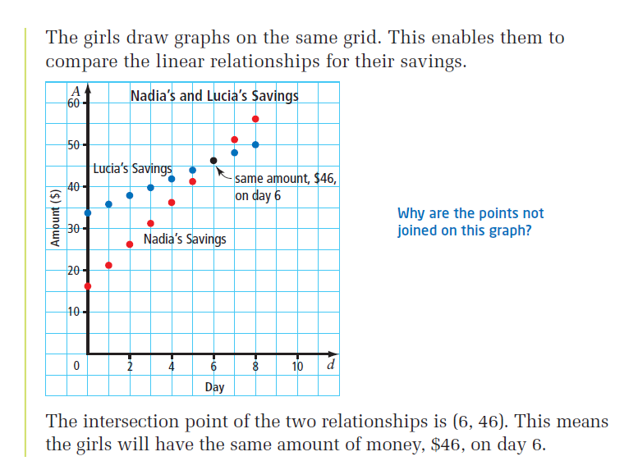**Use a Graph**  **Verify the Solution Algebraically**

A = 5d + 16 A = 2d + 34

**Your Turn**

Julie earns $ 40 plus $ 10 per hour. Carmen earns $ 50 plus $ 8 per hour.

|  |  |  |  |  |  |  |  |  |  |  |  |  |
| --- | --- | --- | --- | --- | --- | --- | --- | --- | --- | --- | --- | --- |
|  |  |  |  |  |  |  |  |  |  |  |  |  |
|  |  |  |  |  |  |  |  |  |  |  |  |  |
|  |  |  |  |  |  |  |  |  |  |  |  |  |
|  |  |  |  |  |  |  |  |  |  |  |  |  |
|  |  |  |  |  |  |  |  |  |  |  |  |  |
|  |  |  |  |  |  |  |  |  |  |  |  |  |
|  |  |  |  |  |  |  |  |  |  |  |  |  |
|  |  |  |  |  |  |  |  |  |  |  |  |  |
|  |  |  |  |  |  |  |  |  |  |  |  |  |
|  |  |  |  |  |  |  |  |  |  |  |  |  |
|  |  |  |  |  |  |  |  |  |  |  |  |  |

1. Represent the linear system relating

the earnings graphically.

1. Identify the solution to the linear system

and explain what it represents.

**Example 2 Solve a Linear System Graphically**

1. Consider the system of linear equations  and . Identify the point of intersection of the lines by graphing.
2. Verify the solution.

**Solution**

1. **Method 1: Use Slope- Intercept Form**

Rearrange each equation into slope- intercept form by isolating y. Identify the y- intercept and slope to draw the graph.



1. **Verify** the solution
2. Verify the solution (3, –4) **by substituting** the values of x and y into each equation.

In 2x + y = 2: In x – y = 7:

Left Side Right Side Left Side Right Side

2 7

Left side = Right side Left side = Right side

Since the ordered pair (3, –4) satisfies both equations, it is the solution to the linear system.

1. **Verify using technology**

**Your Turn**

For each system of linear equations, verify whether the given point is a solution. Explain what the results would show on a graph.

1.  b) 

 

 

**Example 3 Solve a Problem Involving a Linear System**

The Skyride is a red aerial tram that carries passengers up Grouse Mountain in Vancouver, BC. The Skyride travels from an altitude of about 300m to an altitude of 1100m. The tram can make the trip up or down in 5 min and can carry 100 passengers.

There is also a blue tram that can carry 45 passengers. This tram is approximately 8 min to travel up or down the mountain. Each tram travels at a constant speed.

1. Create a graph to represent the altitudes of the trams if the red tram starts at the top and the blue tram starts at the base.
2. Explain the meaning of the point of intersection.

**Solution**

**a) Organize the information before graphing**.

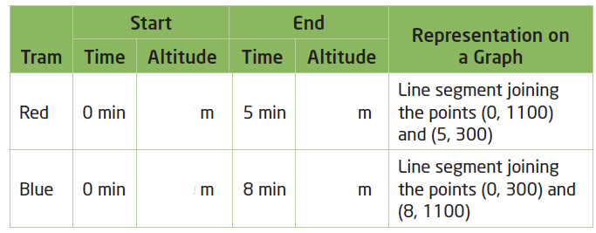

Label time from 0 min to 10 min on the horizontal axis. Label altitude on the vertical axis, up to

1200m. Graph a line segment for each tram using the start and end points

**b)**

**Homework**: Page 426 #3, 5, 7- 11, 15, 17, 20

**8.2 Modelling and Solving Linear Systems**

**Example 1 Model a Linear System Algebraically and Graphically**

People can rent ski and snowboard equipment from two places at Winterland Resort.

* Option A charges a one-time $30 fee and then $8 per hour.
* Option B charges $14 per hour.

1. Create a system of linear equations to model the rental charges.
2. Solve the linear system graphically. What does the solution represent?



**Your Turn**

During a stage performance by a theatre company, the main act was on stage for 3 min less than twice the time of the opening act. Together, the two acts performed for 132 min.

1. Write a system of linear equations to represent the length of time each act performed.
2. Using technology find the solution to this linear system. What does the solution represent?

**Example 2**

Two fish tanks are being filled at constant rates.

* Tank A contains 15 L of water and is filled at a rate of 5 L/min.
* Tank B is empty and is filled at a rate of 10 L/min.

Let *V* represent the volume of water in the tanks, in litres, and *t* represent the time, in minutes.

1. Determine the equation that models the volume of water in Tank A.
2. Determine the equation that models the volume of water in Tank B.



1. Graph the system of linear equations that models the filling

of the two tanks and determine the solution to the system.

**Your Turn**

Two pools start draining at the same time. The larger pool contains 54 675 L of water and drains at a rate of 25 L/min. The smaller pool contains 35 400 L of water and drains at a rate of 10 L/min.

1. Model the draining of the pools algebraically using a system of linear equations.
2. Represent the linear system graphically. Describe how the information shown in the graph relates to the pools.

**Example 3 Model and Solve a Problem Involving a Linear System**

A movie theatre charges $11 for an adult ticket and $8 for children’s or seniors’ tickets. Suppose 240 people attended the early movie and ticket sales totalled $2370.

1. The box office manager wants to know how many adults attended the early movie. What system of linear equations could help the manager determine the answer?
2. How many adults attended the early movie?

**Homework**: Page 440 #1, 3, 5, 7, 8, 10, 14, 16, 24

**8.3 Number of Solutions for Systems of Linear Equations**

When two lines are graphed on the same grid, they do not always have exactly one point of intersection as seen in sections 8.1 and 8.2.

do not intersect at all. So, a system of parallel lines has .

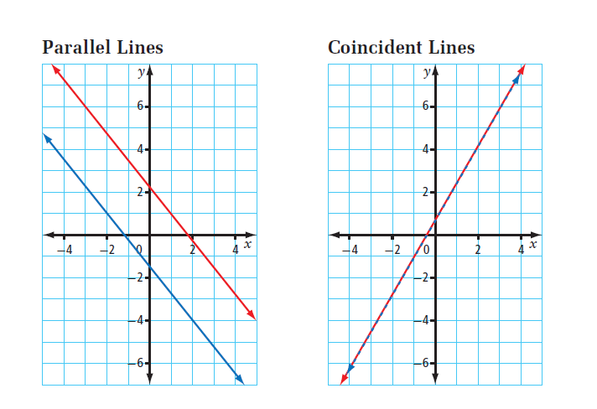 have an of solutions because the lines are equivalent. They overlap.

Reducing the equation to lowest terms may help you identify whether the equations are equivalent. If they are equivalent, then they must have an infinite number of solutions.

**Example 1 Predict and Check the Number of Solutions**

Predict the number of solutions for each system of linear equations. Explain your reasoning, and then check each answer by graphing the linear system.

1. b) c)





**Your Turn**

Predict the number of solutions for each system of linear equations. Justify your answers.

1. b) c)



**Example 3 Identify Zero and Infinite Solutions by Comparing Coefficients**

Sabrina’s teacher gives her the following systems of linear equations and tells her that each system has either no solution or an infinite number of solutions. How can Sabrina determine each answer by inspecting the equations?

1. b)



**Solution**

1. b)

**Your Turn**

Determine, by inspection, whether each linear system has an infinite number of solutions or no solution. Explain your reasoning.

1. b)



**Homework:** Page454 #1-3, 6, 8, 9, 11, 12, 14