* Mathematics 20-1
* Unit Five
* Absolute Value and Reciprocal Functions and Equations
* Unit 5 Worksheet

Name_______________

Date________________

Solve for the following questions in the space provided. Marks will be given for work shown so be sure to show your work at all times.

**Section 7.1**

**1.** Order the set of numbers from greatest to least.



**2.** Evaluate each expression.

**a)** | − 4  10 | **b)** 

**c)** | ( 2)3  23 | **d)** ( | 32  42 | ) 2

**Section 7.2**

**1.** Use the graph of *y*  *f* (*x*) to sketch the graph of *y*  | *f* (*x*)|.

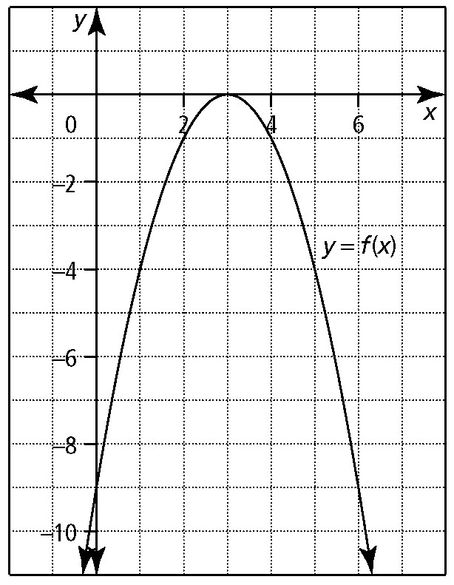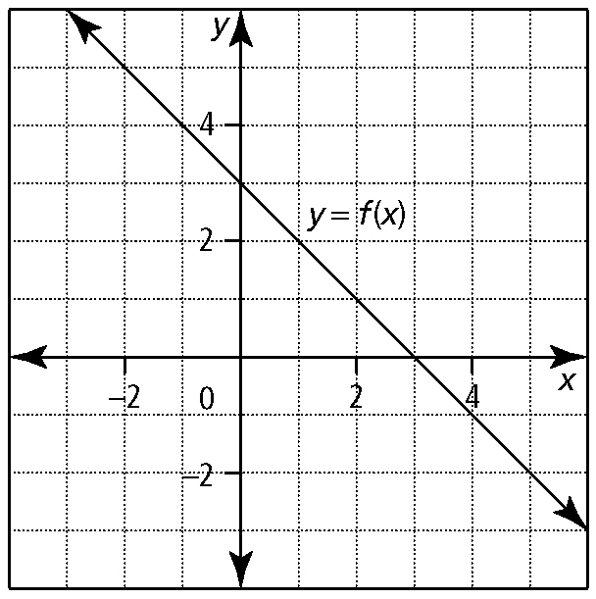**a) b)**

**2.** Express each function as a piecewise function.

**a)** *y*  | 5*x*  1 | **b)** *y*  | 2(*x*  2)2  8 |

**Section 7.3**

**1.** Solve each absolute value equation.   
Verify the solution.

**a)** | *x*  1 |  2 **b)** | 3*x*  2 |  6  12

**c)** | *x*  5 |  *x*  5 **d)** 3  | 4*x*2  8*x |*

**e)** | 2(*x*  4)2  5 |  3

**2.** Mark and Chloe each solve | *x*  12 |  *x*2. Mark solves the equation algebraically, while Chloe solves the equation graphically. Who is correct? Explain your reasoning.

*Mark’s solution:*



*Chloe’s solution:*

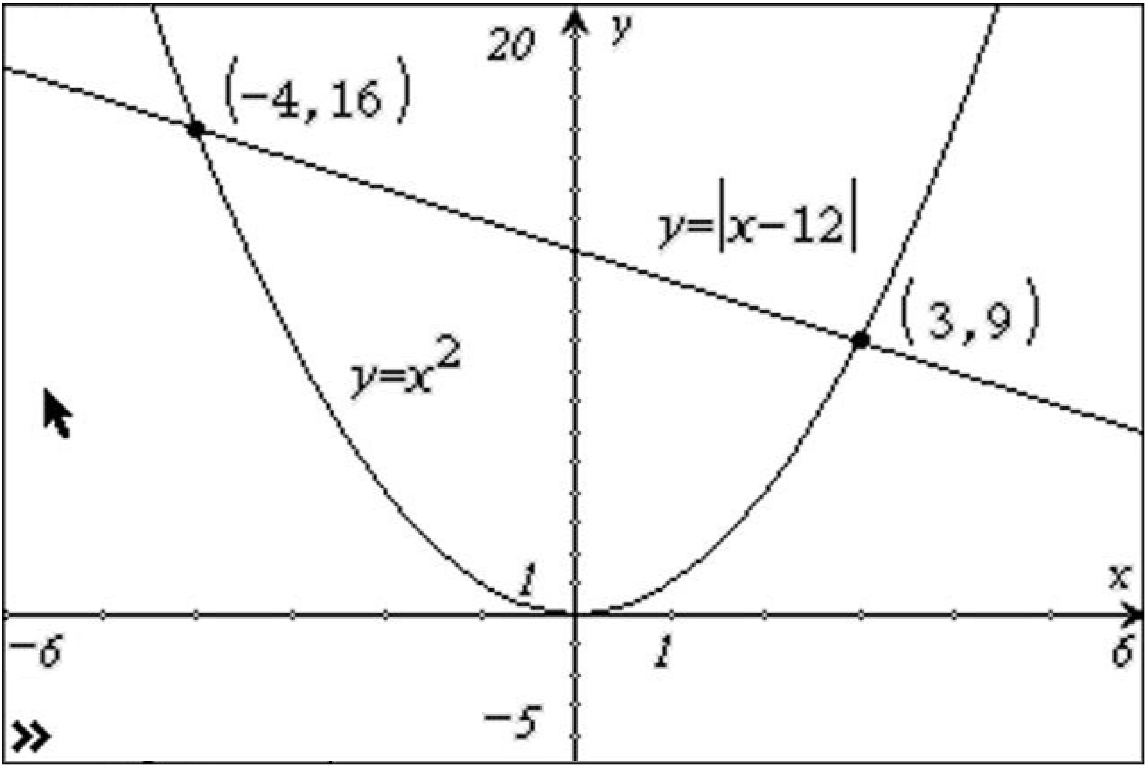

**Section 7.4**

1. For each function,

**i)** state the zeros  **ii)** write the reciprocal function

**iii)** identify the non-permissible values of the corresponding rational expression

**iv)** state the equation(s) of the vertical asymptote(s)

**a)** *f* (*x*)  3  *x* **b)** *h* (*x*)  (*x*  2)(*x*  3)

2. State the equation(s) of the vertical asymptote(s) and the *x*-intercepts and *y*-intercepts for each function.

**a)** ** b) **

**3.** Copy the graph of *y*  *f* (*x*), and sketch the graph of the reciprocal function, 

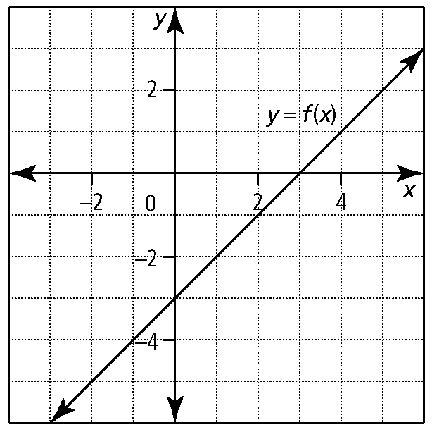

**4.** Copy the graph of  and sketch the graph of *y*  *f* (*x*).

