- Mathematics 20-1
- Unit Six
- Systems of Equations and Inequalities
- Unit 6 Worksheet

Name_______________
Date________________

Solve for the following questions in the space provided. Marks will be given for work shown so be sure to show your work at all times.
Section 8.1
1. Use the graph to solve the system of equations. Then, write the system of equations represented in each graph.
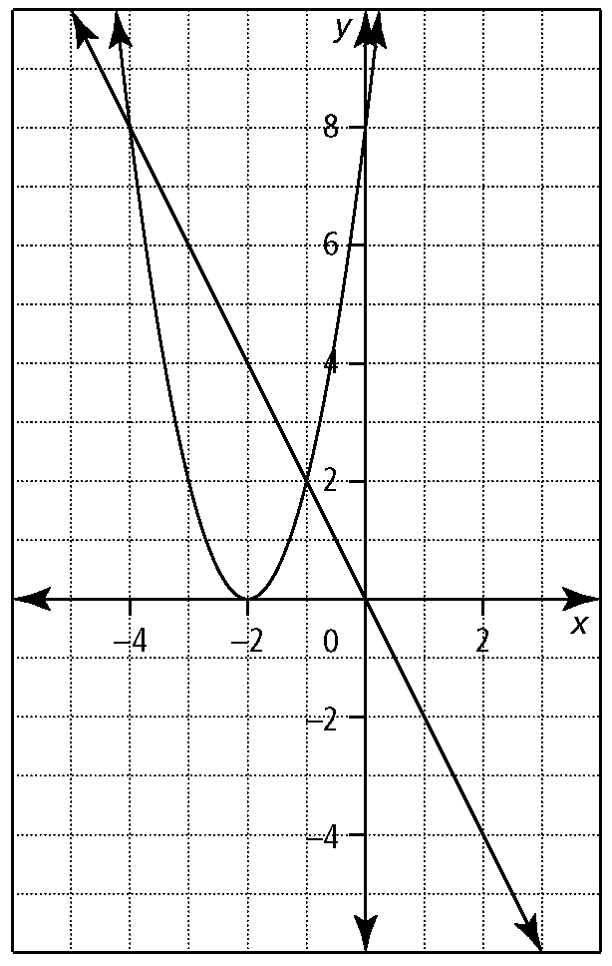
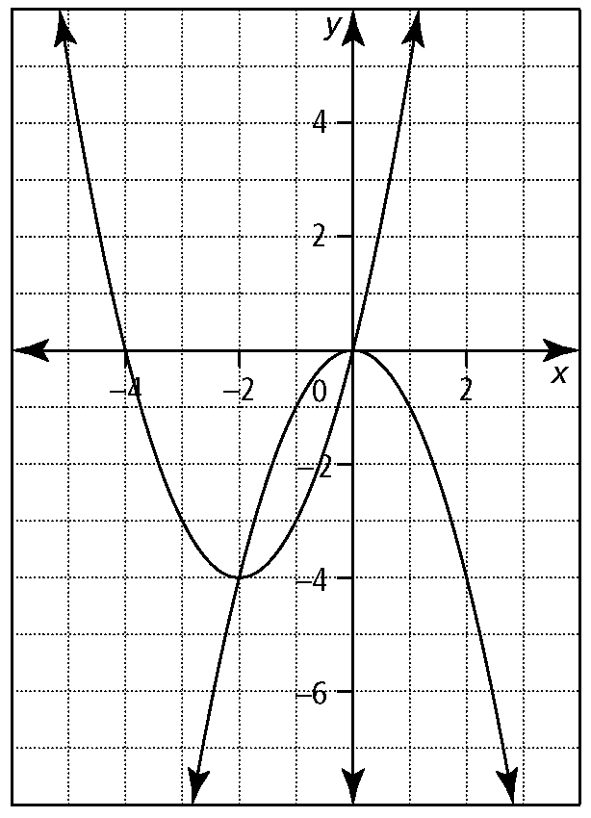
a) b)

2. Solve each system of equations by graphing. Express answers to the nearest hundredth.
a) x² + 8x − y = −12 b) y = 2x² − x + 1
x² − y = 8 y = x² + 9x − 8

3. The ages of Max and his father add up to
35 years. Max’s father’s age is the same as five more than the square of Max’s age.
a) Write a system of equations to represent this situation. Define your variables.

b) Solve the system graphically. Are all possible solutions meaningful? Explain.

c) How old are Max and his father?

Section 8.2

1. Solve each system of equations by substitution. Verify your solutions.
a) 3x + y − 4 = 0 b) y = −x² − 3x + 14
2x² − 4x − y − 2 = 0 y = 3x² + 5x − 18

2. Solve each system of equations by elimination.
a) 3x² + x − 3y = −8 b) y = 2x² − x + 1
x + 3y = 9 2y = 2x² − x − 1

3. Consider the following system of equations.
x² + 6x + y + k = 0
3x + y + k = 0
- Determine the value of k if a solution
is (−3, 2).

b) Determine the second solution.

Section 9.1
1. Which ordered pairs are solutions to each given inequality?
a) x − 3y < 18

A (3, −5) B (0, 0) C (−5, 3) D (5, −5)

b) 0 < 2x − 5y
A (5, 2) B (2, 5) C (−5, 2) D (2, −5)

2. Consider each inequality.
i) Express y in terms of x. Identify the slope and the y-intercept.
ii) Indicate whether the boundary should be a solid line or a broken line.
iii) Use technology to graph the inequality.
a) 2x − 7y ≥ 14 b) 5 − x + 3y < 0

3. Ben is buying snacks for his friends. He has $10.00. The choices are apples for $0.80 and muffins for $1.25.
a) Write an inequality in two variables to model this situation. Define your variables.
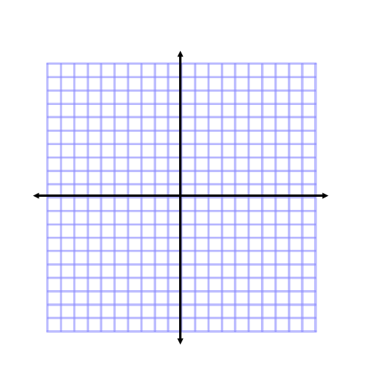

- Graph the inequality.

c) Why is (5, 4.8) not a solution?

4. Determine the inequality that corresponds to the graph.
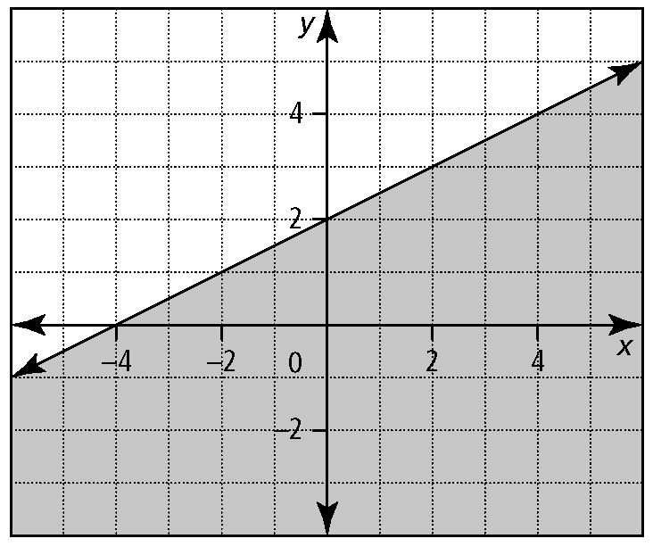

Section 9.2
1. Given the graph of f (x) = (x − 1)(x + 7), solve the following.
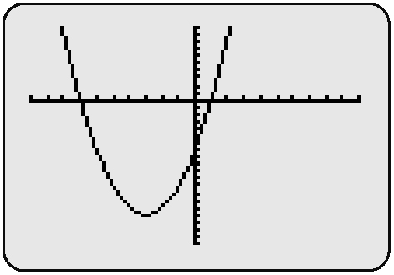
a) (x − 1)(x + 7) = 0 b)(x − 1)(x + 7) > 0 c)(x − 1)(x + 7) < 0

2. Is the value of x a solution to the given inequality? Show your work.
a) x² + 3x > −5, x = 0 b) (x − 4)(x + 3) < 7, x = 0

3. Determine the solution to each inequality.
a) (x − 1)(x + 5) > 0 b) −8x² + 2x + 15 ≥ 0

.
c) x² + 4x + 3 > 2x²

4. Given the function f (x) = x² + 6x,
a) determine the zeros of the function

- solve the inequality f (x) > 0

c) solve the inequality f (x) ≤ −5
Section 9.3

1. Which ordered pairs are solutions to the given inequality?
a) y > −x² + 4x − 3
A (2, 1) B (0, 0) C (3, −2) D (1, 1)
b) y ≥ x² + 6x − 4
A (−2, −7) B (0, 0) C (2, 5) D (−7, 2)
2. Write an inequality to describe each graph. The given equation for each boundary is part of the solution.
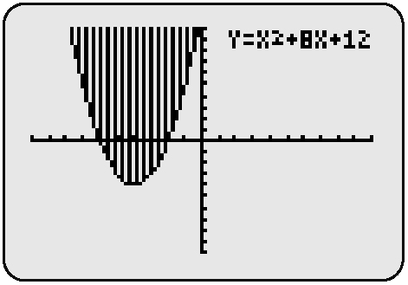
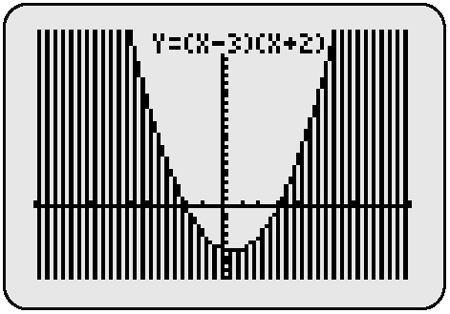
a) b)

3. Graph each quadratic inequality.
a) y < (x − 5)² + 4 b) y > (2x + 1)²

