* Mathematics 20-1
* Unit Two
* Trigonometry
* Unit Worksheet

Name_______________

Date________________

Solve for the following questions in the space provided. Marks will be given for work shown so be sure to show your work at all times.

1. Determine the reference angle θR, for each angle θ. Sketch θ in standard position and lavel the reference angle θR.
2. θ= 335° θR = ________________

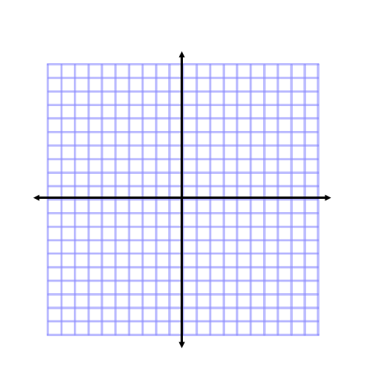

1. θ= 260° θR = _________________



1. Determine the measures of the three other angles in standard position, 0°< θ<360°, that have the given reference angle.
2. 70° b) 89°
3. Find the exact area of an equilateral triangle with a height of 9 units.
4. Point P(-3, 4) is on the terminal arm of an angle θ in standard position. Write the primary trigonometric ratios of θ?
5. Determine the exact values of the sine, cosine and tangent ratios for the angle 210°.
6. Solve each equation, for , 0°< θ<360°, using a diagram involving a special right triangle.
7. cos θ = $\frac{1}{2}$ b) sin θ = - $\frac{\sqrt{3}}{2}$
8. Solve for the unknown value in each of the following questions to two decimal places by using the sine law.

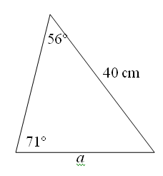

1. In , <*J* = 31.9°, *j* = 20.5 cm, and <K = 75.4°. Find *k* to the nearest tenth.
2. In  solve for the unknown side, *c*, given that.
3. Solve for the unknown in the following:

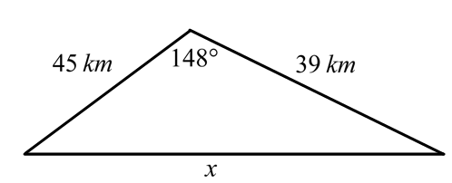

1. In a molecule of water, the two hydrogen atoms and one oxygen atom are bonded in the shape of a triangle. The nuclei of the atoms are separated by the distances shown below. Calculate all of the bond angles to the nearest tenth of a degree.(Note that the symbol Å refers to a small unit of length known as an *Angstrom*.)

